Get Familiar with the New Course Experience

Skillsoft’s new course experience player provides instant access to crucial resources at your moments of need.

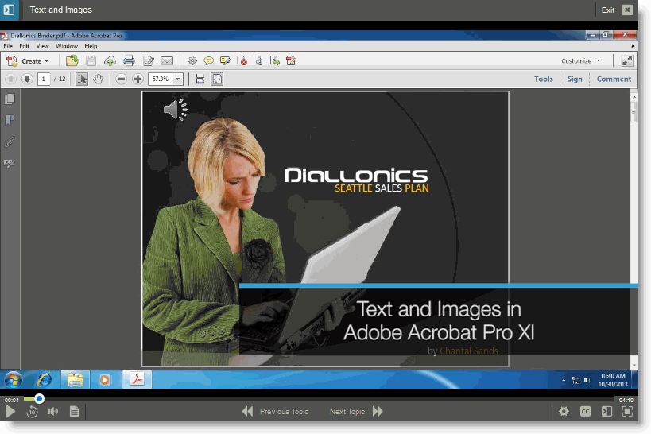
Micro-sized Learning, Right at your Fingertips
Our video-based courses put video front and center in learning!
Available on tablets and desktops, video viewing is designed to meet your various needs and personal preferences, with full screen viewing and flexible controls.
Use the slide-out menu (shown below) to gain access to additional valuable supporting resources to practice or reinforce skills on the job.

Note: See the Differences Document for information on how traditional courses display in the new player.

A Redesigned Interface Supports Continuous Learning

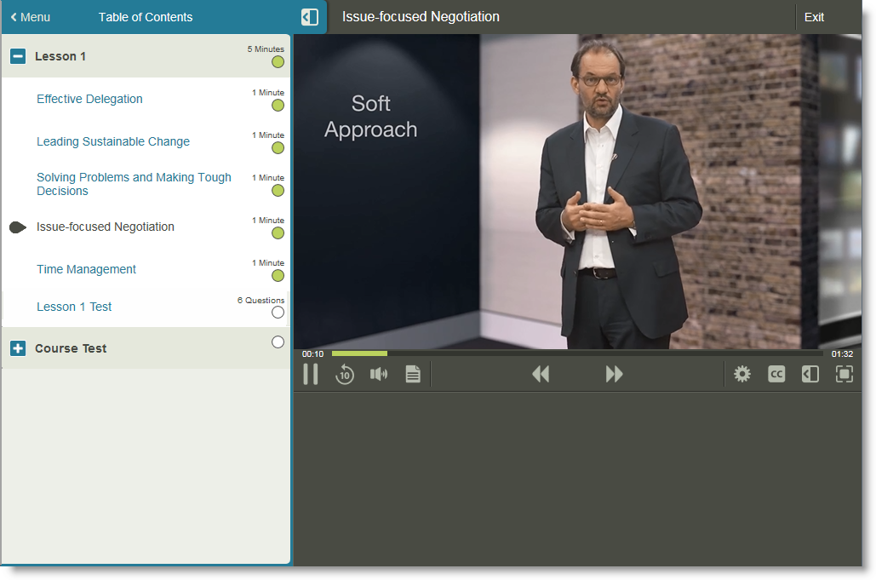
Access the content you need, when you need it.
Video windows and controls allow you to set viewing size, playback speeds and captions, tailoring the video to your needs.

Launch topics of interest or be guided through the suggested optimal order. Flexible access to content allows you to decide how much learning is right for you.
Slide-out menu provides instant access to course content and assessments, with duration and status information.

Check your Progress
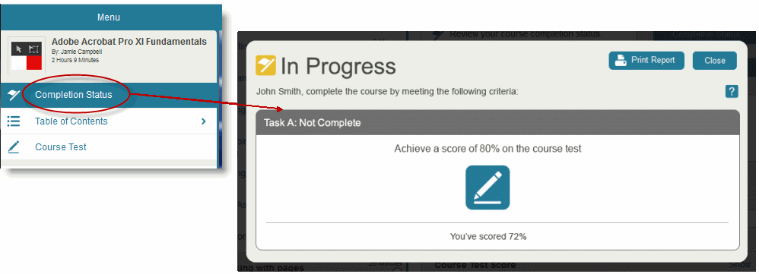
Quickly see progress and test results at any time. Return to the course to continue learning whenever you’re ready.

View task status to determine what still needs to be done to meet completion criteria. Click the icon to launch right back into the course to continue your progress.
Select Completion Status to see clear progress information.

Accelerate Mastery and Completion

Practice exercises, testing, and remediation are built in to your learning experience for success and mastery.
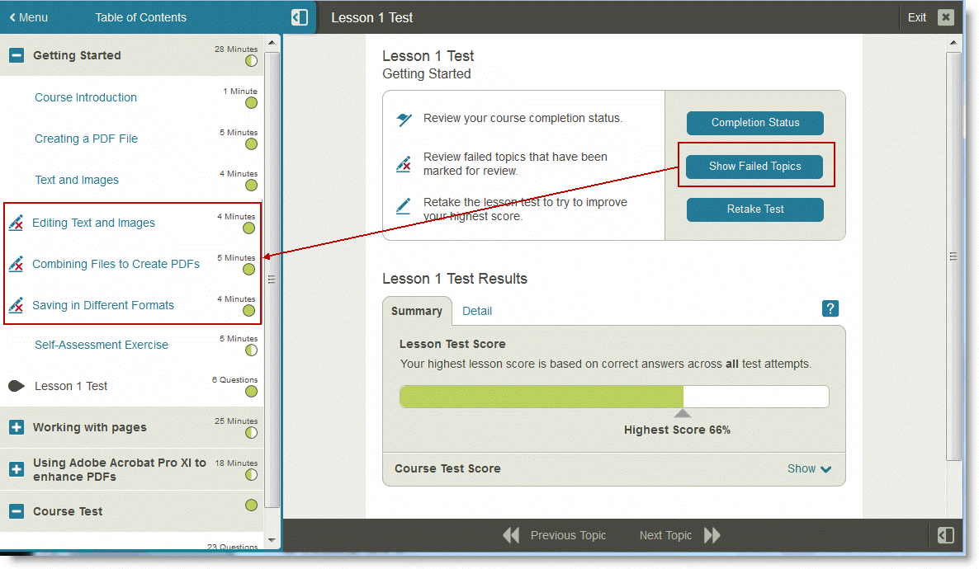
Access practice exercises and assessments seamlessly during the learning process.
Retake tests, either the entire test or just questions answered incorrectly, to accelerate subject mastery and completion.
Check your completion status to understand what tasks still remain to be completed.
Review failed topics to facilitate remediation and mastery.

