Skillport® Book Viewer Quick Reference for Learners

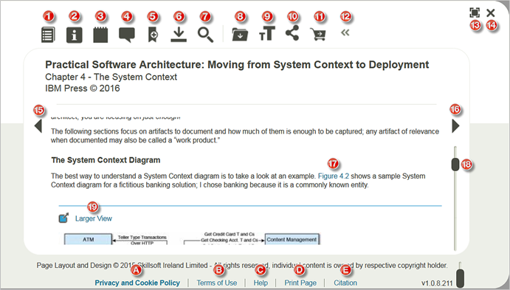

Launch a title
After gaining access to Skillport, select the launch link for a title to open it in the Book Viewer. Skillsoft books and videos utilize the Book Viewer interface.
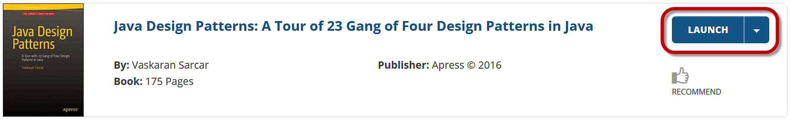

Viewer Controls
Maximizes or minimizes the reading screen.
Closes out of the Book Viewer.

Toolbar
Opens the Table of Contents in the Book Viewer.
Provides back cover and related information, such as author’s bio, in an overlay window.
Adds a personal note at the top of the page or inline below a paragraph.
Adds a community note at the top of a page or inline below a paragraph.
Adds or removes a bookmark to the page.
Downloads the current chapter, video, summary, companion files or other materials.
Searches just the title’s content, personal notes, community notes or code sections.
Saves the title to your Learning Plan.
Increases or decreases the text size.
Obtains the page URL or sends the page URL via email.
Purchases the title.
Expands or collapses the toolbar.

Page Navigation
Move backward a section using the stationary arrow buttons.
Move forward a section using the stationary arrow buttons.
Navigate up and down the page using the scroll bar.

Content
Text and graphics reflow to the size of the window, and can be copied and pasted from the screen.
Select Larger View near a graphic to zoom into it.
Deep links in the text jump you directly to figures, footnotes, tables, etc.

Footer Links
Opens a page to the Skillsoft Privacy Policy and Cookie Statement.
Opens a page to the Skillsoft Terms and Conditions of Use.
Opens an overlay window containing links to the Knowledge Base -- a help documentation portal, a Request a Title form and the Skillsoft Customer Support page.
Prints the entire current page.
Opens an overlay window showing a title citation that can be copied and pasted. Choose from three different citation formats: MLA, APA and Chicago Manual of Style. Subscribers with a RefWorks account can select the ‘Export to RefWorks’ link to export the reference into their account.

