**SIGN IN:** Click the link provided, or type your Skillport 8 URL in a browser. Enter your username and password and click **Sign In**.

**Skillport® 8**

**Quick Reference Card**

**for Learners**

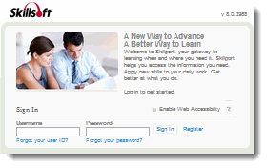

If configured on your site, may be able to register yourself.

(continued inside)



Skillsoft Ireland Limited

www.skillsoft.com

(placeholder for LC contact info)

**FIND CONTENT:** Find content of interest to you by using **Browse** or **Search**, or by selecting content presented on the page.

**VISIT COMMUNITY:** Click **Visit Community** to view comments, activity, and recommendations in your community.

**SEE RECENTLY VIEWED:** You can find a list of your most recently viewed content items by clicking **Recently Viewed.**

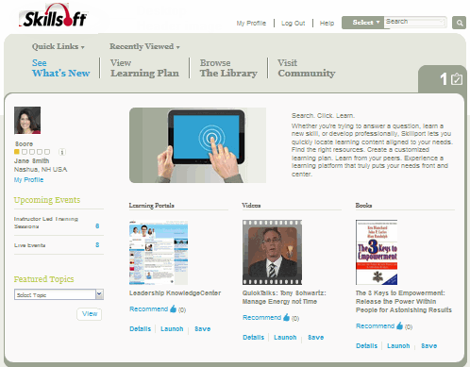

**RECOMMEND IT:** Let others know about great content by recommending it and posting comments in your Community. You can also see what content others have recommended.

**CHECK YOUR TO DO LIST:** Click the **To Do List** to find out if you have upcoming or overdue items in your learning plan.

**VIEW UPCOMING EVENTS:** Find out about upcoming Live Events and Instructor Led Training sessions under **Upcoming Events**.

**EXPLORE FEATURED TOPICS:** Content that your organization wants to feature can be listed in the **Featured Topics** dropdown. Click on a selection in the drop down to view more details.

**SAVE CONTENT:** Found some great learning content? Click **Save** to save it to your learning plan so that you can easily return to it later. You can also create sets in your learning plan to help organize your content.