Getting Started with Downloading Books and Videos
This guide provides instruction on how to:
Download chapters  Download audio books  Download summaries | Download videos and companion materials for videos  Download companion materials for books  Download LiveTables™

Downloading chapters
Chapters to Go™ is a feature available for subscribers of select Skillsoft Books collections. Chapters to Go lets you download entire book chapters in PDF, Kindle-ready mobi and EPUB file formats. The chapter downloads are ideal for offline reading and printing, and contain personalizations such as your bookmarks and notes. For copyright reasons, chapters downloads are watermarked with your email and a link to the membership agreement.

You are allotted 15 chapter downloads which are refreshed every 90 days on the anniversary of your first login – regardless of whether they have been used or not. You are not penalized for downloading the same chapter more than once.

- To download a chapter, navigate to the specific chapter (doing so necessarily opens the title in the Book Viewer). Click on the download tool at the top of the Book Viewer.
- In the Download window, select the chapter file format you would like to download.
- The Download window also includes information about the next refresh date for downloads as well as how many downloads are remaining.
- To review your Chapters to Go history, click your profile icon at the top, select My Profile and then Chapters to Go from the left frame of the My Profile page.

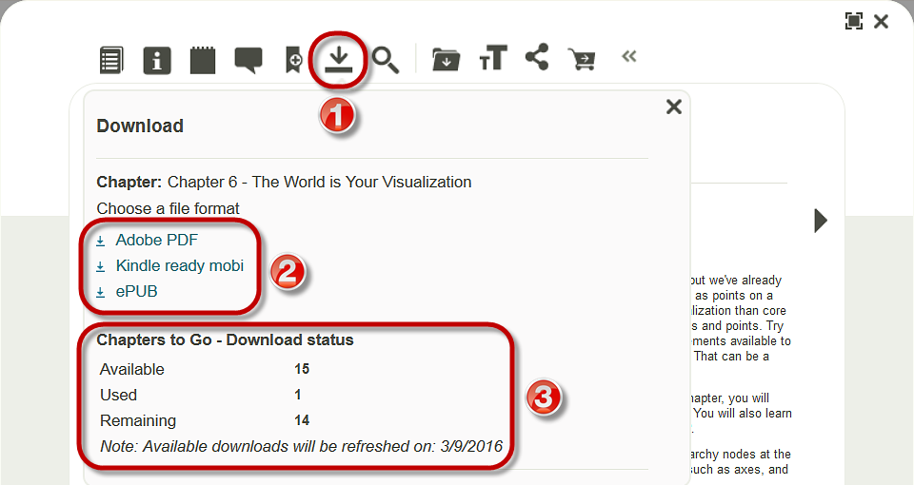

Downloading audio books
Audio books are available for subscribers of the Skillsoft Books BusinessPro™ collection.

- To find an audio book in Skillport, conduct a search.

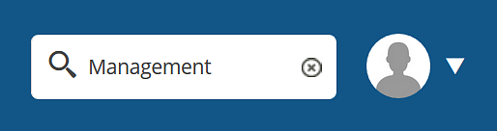

- In the search results list under the Books tab, expand the ADD FILTERS toggle.

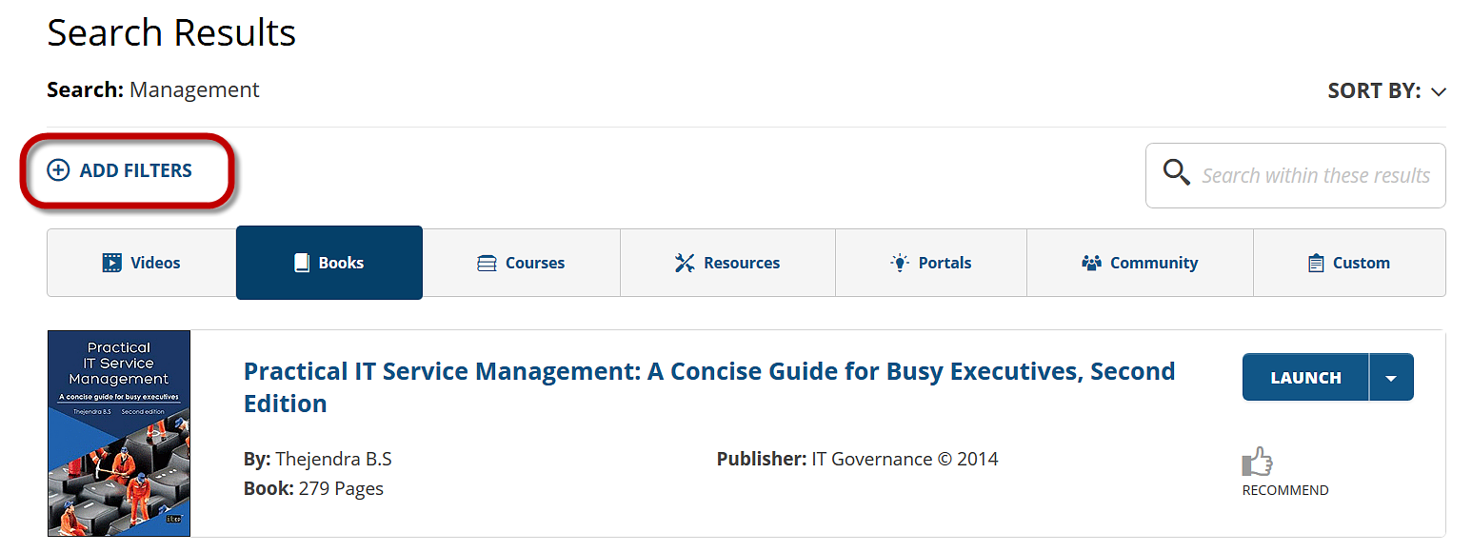

- In the ADD FILTERS overlay window, select “Audio Books” and then click the APPLY button.

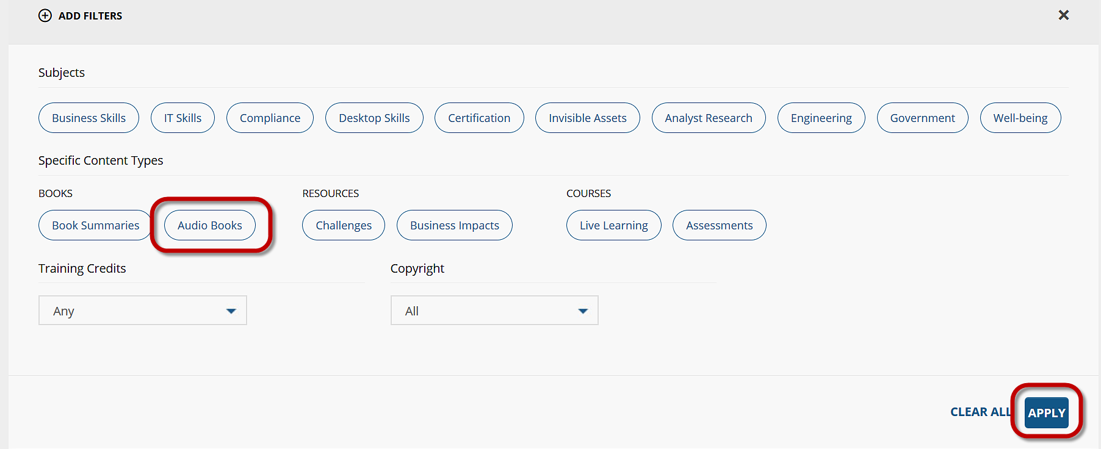

- The search results under Books will show only audio books. To exit the filter, select “Audio Books” with the beside EDIT FILTERS. To download an audio book, select the DOWNLOAD button.

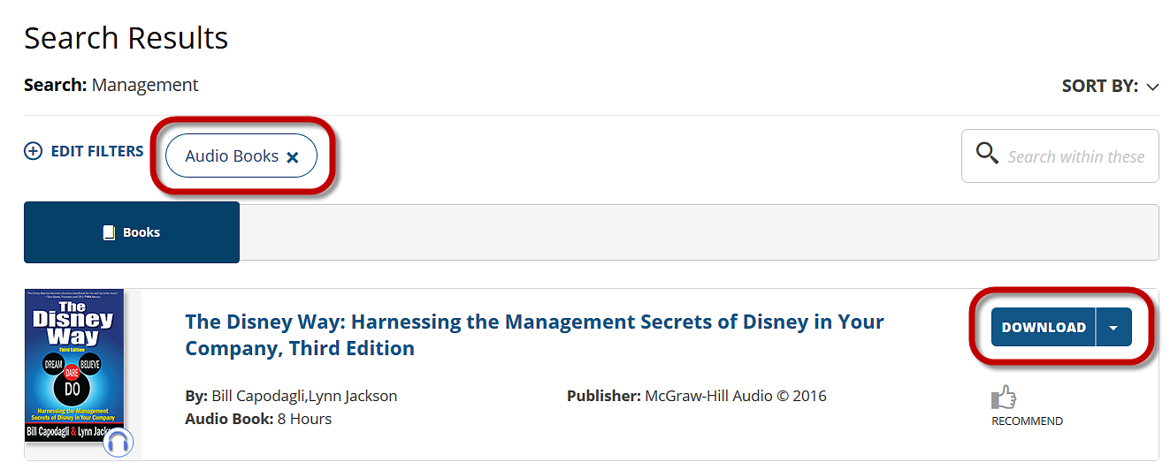

- In the Download overlay window, select the links to download the MP3 audio files. Close out of the window by clicking on .

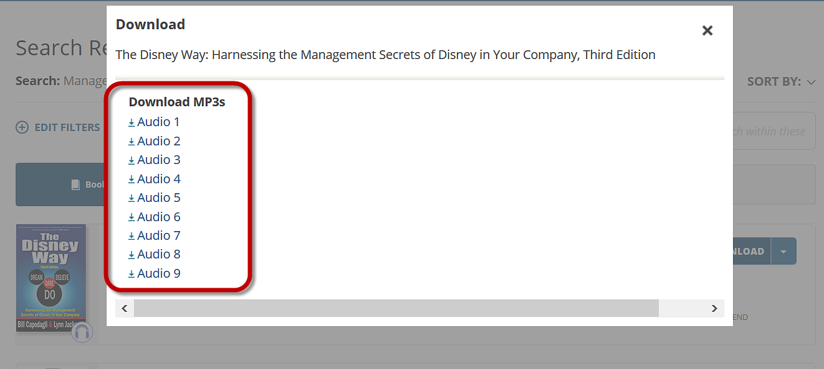

Downloading summaries
Summaries are available for subscribers of the Skillsoft Books Summaries collection.
- To find a summary in Skillport, conduct a search.

- In the search results list under the Books tab, expand the ADD FILTERS toggle.

- In the ADD FILTERS overlay window, select “Book Summaries” and then click the APPLY button.

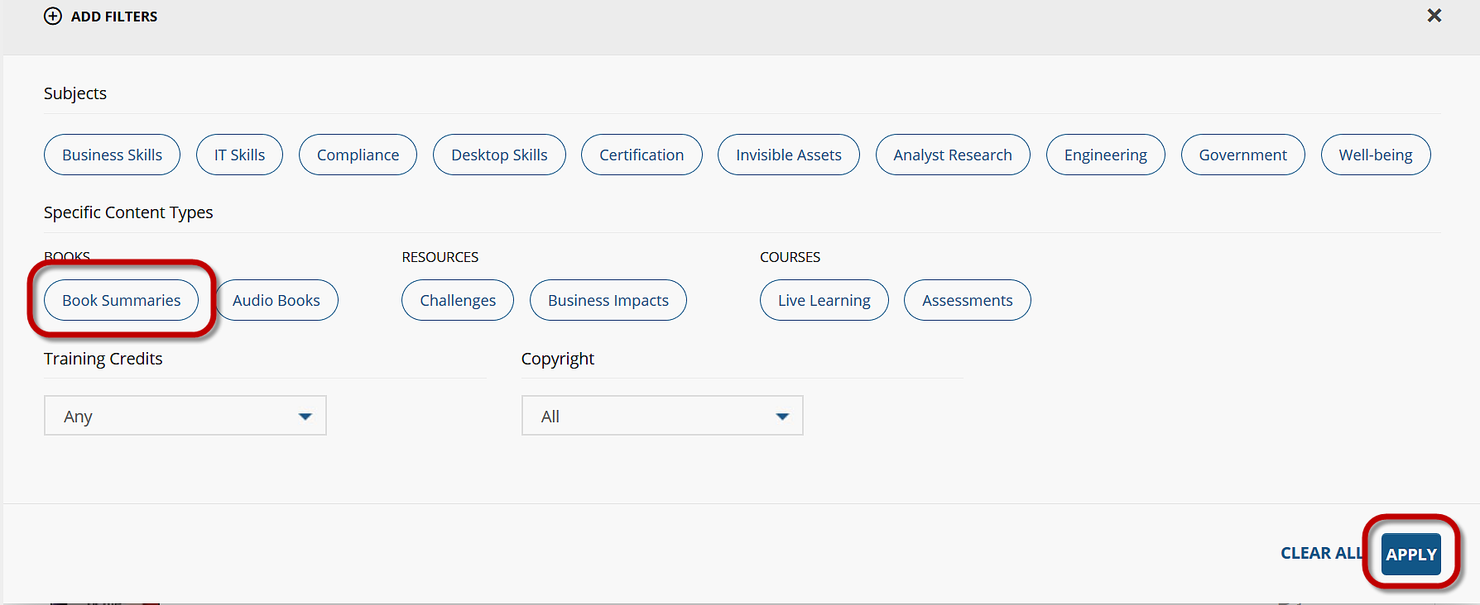

- The search results under Books will show only book summaries. To exit the filter, select “Book Summaries” with the beside EDIT FILTERS. Next, open a summary by clicking its LAUNCH button.

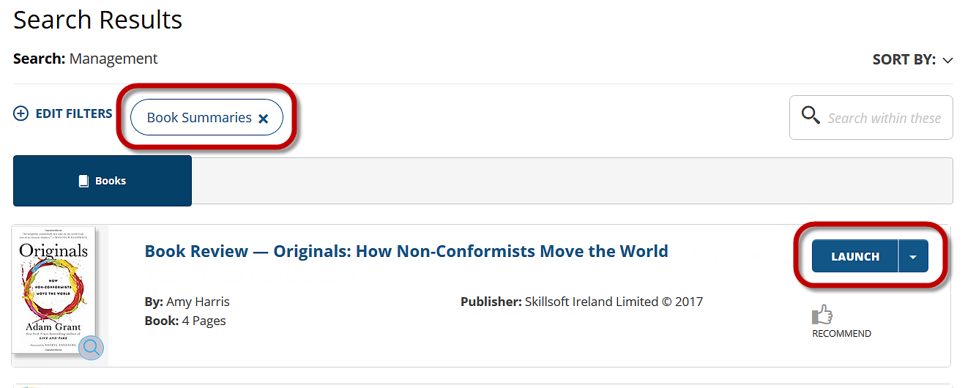

- When the Book Viewer launches, click on the download tool. Conduct the download from the Download overlay window. Close out of the window by clicking on .

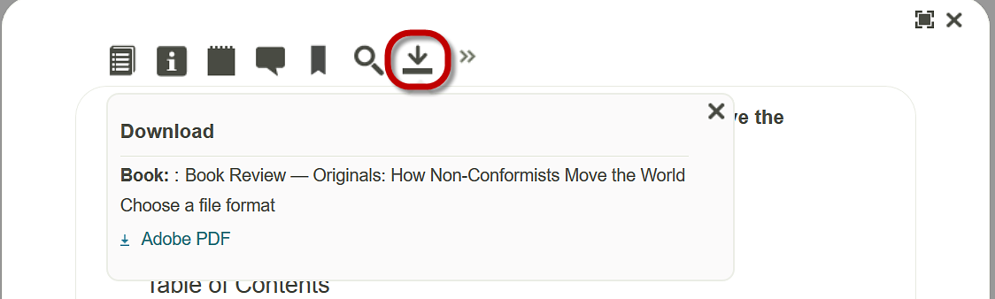

Downloading videos and companion materials for videos
The Skillsoft videos collections offer mp4 video downloads as well as companion file downloads.
To download a video, launch it in the Book Viewer. Next, click the download tool at the top. In the Download overlay window, click the MP4 Video link to download the video file or the link(s) under Companion Materials to download any companion file(s).

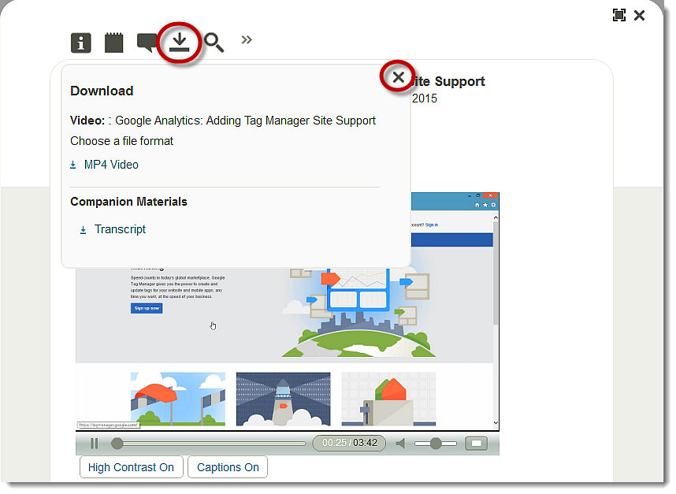

Downloading companion materials for books
Select companion materials may be available for titles. Companion materials, such as textual materials that arrive on back of book companion DVDs, may be embedded into a title for download or available on an author or publisher’s companion website.

To download companion materials embedded into a title, navigate to the Details page of a title and scroll to the bottom. Click the CD Content link at the bottom to display a CD Content page in the Book Viewer. Click the link(s) in the Book Viewer to download larger companion files.

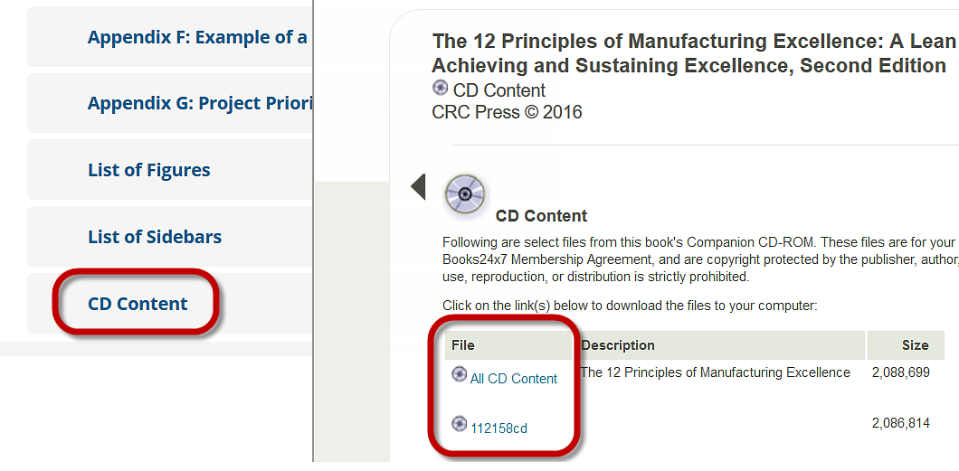
To access the companion website for a title, navigate to its Details page and click the Resources tab. On the Resources tab, click the Visit Companion Website link.
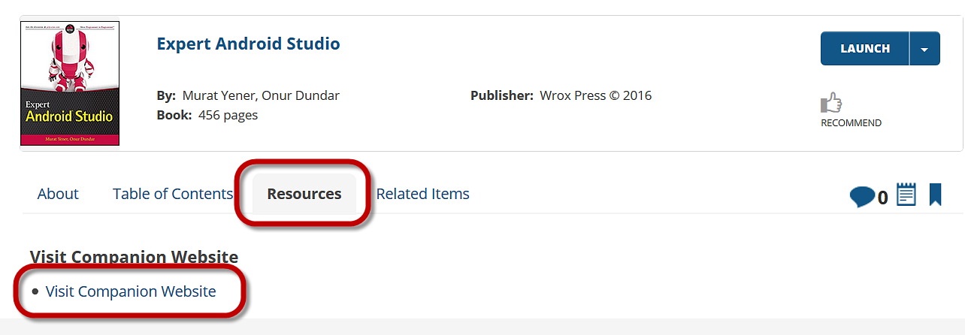

Downloading tables
LiveTables™ is a complimentary feature available for subscribers of Skillsoft Books collections. LiveTables enables you to download and save select tables in titles for personal use. Tables can be saved using any common spreadsheet application. After downloading a table, you can manipulate the information using the powerful functions provided by your native spreadsheet program.
Once on a title’s content page, LiveTables is indicated by the Open table as spreadsheet link above a table.

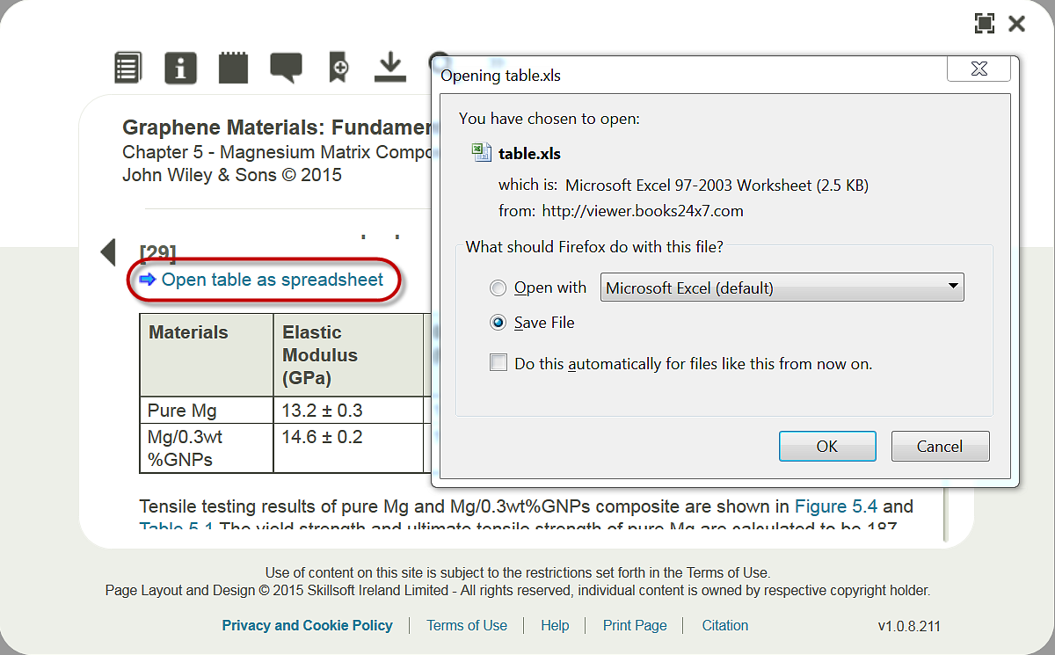

To open or save a table, click the Open table as spreadsheet link. Follow the directions provided by your browser to open or save a table. The table will be opened or saved in the native spreadsheet program installed on your system.
When a table is viewed, the entire table is displayed, including the title and table name. For copyright reasons, personalization information bearing your name and email address is included below the table along with a link to the Membership Agreement.

