Getting Started with Code Listings Search
This guide will help you conduct a Code Listings search in Skillport.

Background
Subscribers of Skillsoft Books collections can search code examples in their IT, developer, engineering and technology titles for specific pieces of code. If desired, the discovered code can be copied and pasted into a program for immediate use.

Conducting a code listings search
- Code listings search is conducted inside a book. Launch a book in the Book Viewer and select the Search this item tool.
- In the Search this item overlay window, type your code keyword terms into the box and select “Code Listings” from the pull-down menu. Click Go.

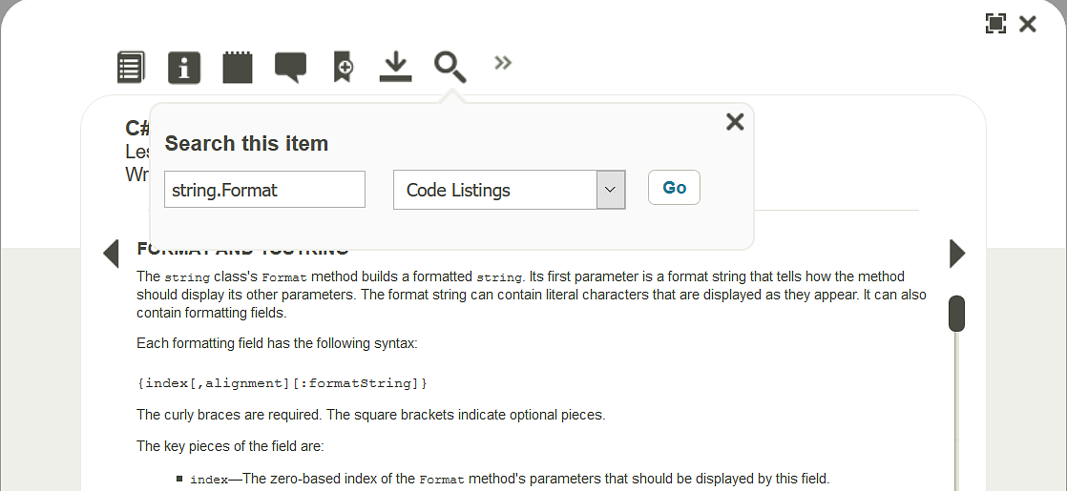

- In the search results page that displays, select a result occurrence to go to its location within the title. Note: The Back link takes you back to the last viewed page in the title.

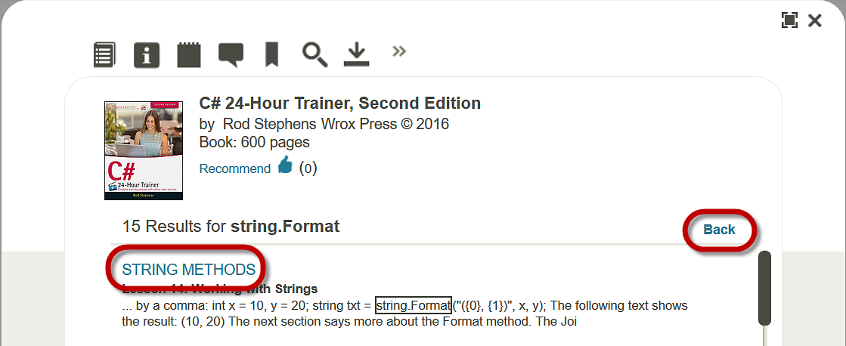

- The keyword terms will be highlighted for you.

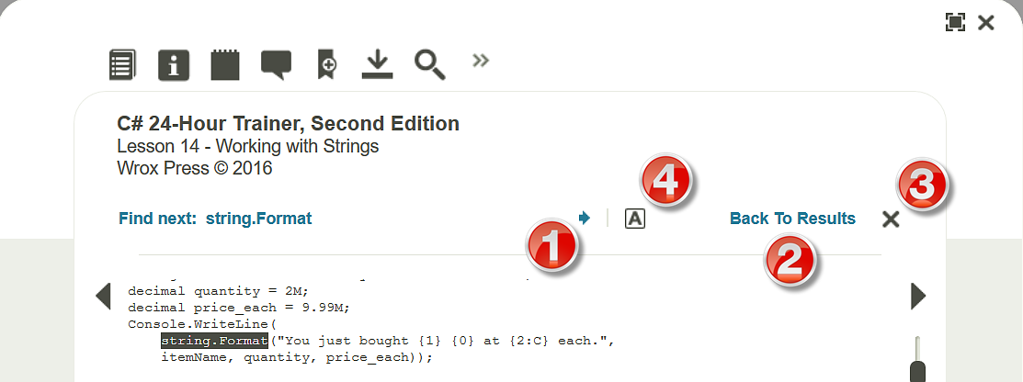

- Click the forward arrow at the top of the page to navigate to the next occurrence of the search hit in the book.
- Click Back to Results to return to the Book Viewer’s Code Listings search results page.
- Click to exit Code Listings search.
- Click to highlight or un-highlight code keyword terms.

