Getting Started with Skillport 8

This guide will help you learn about important features and functionality in Skillport 8.

Sign in to Skillport | In a browser, navigate to your Skillport Sign In page. Enter your username and password and click Sign In.  Note that passwords are case-sensitive.  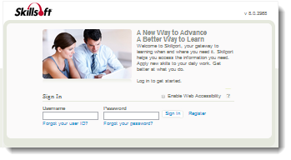
Explore the What’s New Page | Once you have signed in to Skillport, the See What’s New page displays. Depending upon your site’s configuration, you may:  - View scheduled Instructor Led Training and Live Events under Upcoming Events.  - Explore courses or other content highlighted by your organization in the Featured Topics area.  - Find messages from your organization.  - See promoted content to launch now or save to your learning plan.  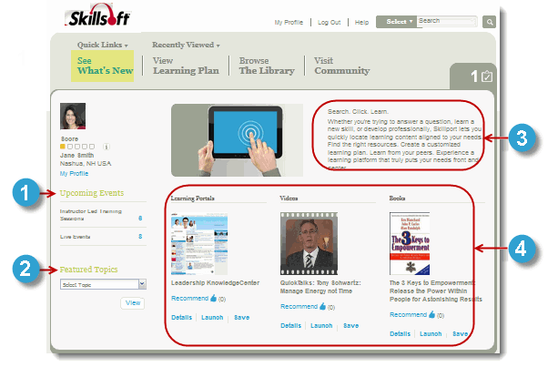

Browse the Library for Content | Find content by clicking Browse the Library and selecting a subject. Content libraries may be organized by subject area or also by job role, competencies, or other areas relevant to your organization’s training goals. Once you select a subject, you can filter your content options:  - Use the filters and refinement options on the left.  - View content options in the carousel.  - Search through newly released content, organized by content type.  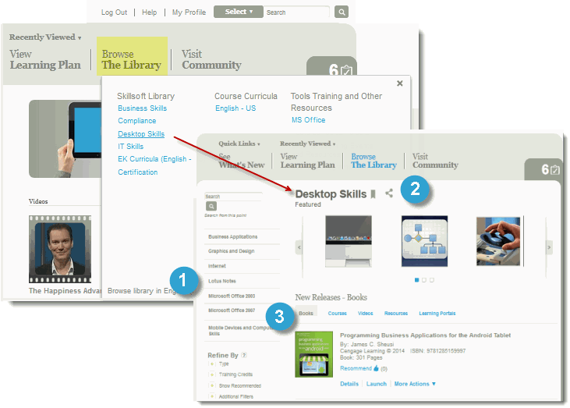
Search for Content | You can find content by using Search.  - Enter terms in Search and click . You can also:  - Select pre-search filtering options to refine your results prior to performing a search.  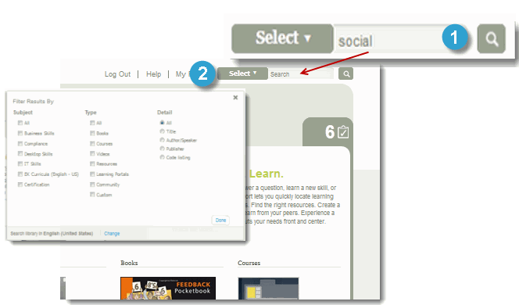

Use Advanced Search | After your initial search, you can refine your search results:  - Click Show Filter. The Refine By dialog displays.  - Select your refinements from the available options.  - Click Refine to apply your filters.  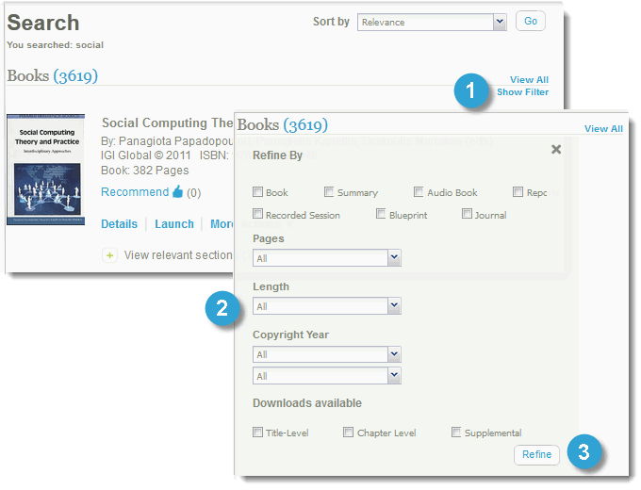
Find Recently Viewed Content | You can quickly return to content that you’ve recently viewed.  - Click Recently Viewed to see a list of recent content items.  - Click Quick Links > Learner Transcripts to view a transcript of all content that you’ve launched.  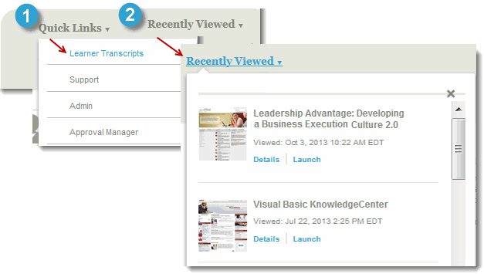
Manage your Learning Plan |  | View and manage your assignments by clicking View Learning Plan. There are two tabs in your learning plan:  - The Assigned Learning tab contains content that your manager has assigned to you. Development Plans are also found here.  - The Personal Learning tab contains content that you have saved for completion, as well as any bookmarks in the Library that you have created.  To help organize your assignments, content on both tabs is arranged in sets.  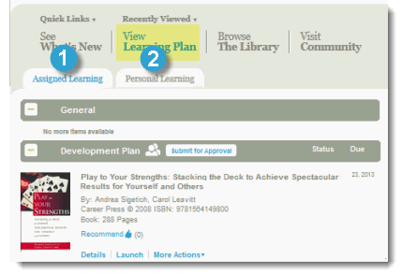
Check your To Do List |  | Use the To Do List to quickly view your upcoming and overdue content items without having to open your learning plan.  - Click the To Do List icon.  - View Upcoming and overdue items.  You can launch content directly from your To Do list, or click to close and return to Skillport.  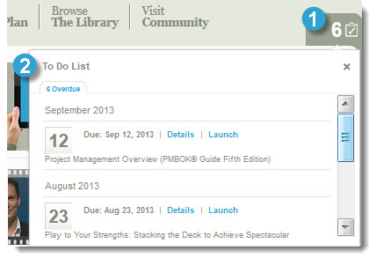
Visit Community |  | If enabled on your site, click Visit Community to view your organization’s social and collaborative place within Skillport. You can share recommendations on content, post comments, and follow people within your organization.  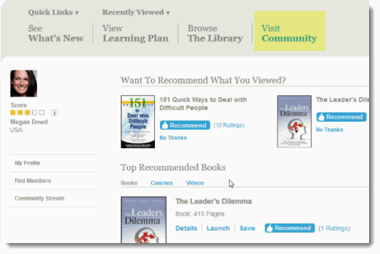  You can share information about yourself, including areas of interest and expertise, by creating a community profile.  Click My Profile > Community Profile > Edit to create or edit your profile.  Note that participation in the Community is completely optional. You do not need to have set up a community profile to participate in the Community. Recommending or commenting on content, or choosing to follow another community member, automatically joins you to the Community. You can go back and complete your profile at any time.
Learn More |  | Learn more about the features and functionality in Skillport 8 by visiting our online knowledge base. Helpful information includes:  - User Guides  - Videos  - System Requirements  - Print Documentation  http://documentation.skillsoft.com/en_us/skillport/8_0/ah  