

**Skillport 8 Reporting  
Quick Start Guide**

**Getting Started**

**Log in to your Skillport with an Admin-Level account.**

|  |  |  |
| --- | --- | --- |
|  | Note that different Admin-Level accounts have different reporting capabilities.  Admin rights can also be customized. Contact your organization’s Skillport administrator if you don’t see the Reporting options in Admin. | *A* ***Company Administrator*** *can run reports on all users, groups, and content.*  *An* ***Administrator*** *or* ***Manager*** *can run reports on the users and subgroups contained in their normal (organizational) group or advanced group. Additionally, they can report on only the assets that are entitled (available) to them in the Catalog.* |

**Access Reporting through the Admin Link**

|  |  |  |
| --- | --- | --- |
|  | Skillport Managers and Administrators will see an “Admin” link in Quick Links. In Admin, the Reports tab provides access to the reporting system. |  |



**Help** is available throughout the reporting system. In Help, detailed field definitions are available   
by navigating to: Skillport 8 for Administrators / Reports / Report Definitions. You can also access help from the [Skillport 8 Knowledge Base](http://documentation.skillsoft.com/en_us/skillport/8_0/ah/index.htm).

**Main Reporting Sections**

|  |  |  |  |  |  |  |  |  |  |  |
| --- | --- | --- | --- | --- | --- | --- | --- | --- | --- | --- |
|  | **Report Related Icons**  These icons display in the reporting section next to report and chart templates. | |  |  | | --- | --- | |  | Indicates a grid type report | |  | Indicates a chart type report | |  | Indicates the chart is currently displayed on My Dashboard | |  | Indicates a shared template | |
|  | **My Dashboard** lets you quickly see two charts. By default, the *Content Completion* and *Total Logins* charts are displayed  In the Dashboard, you can:   * **Show Parameters** for each chart displayed. * **Edit** charts to create personal chart templates. * **Replace Charts** that display on the Dashboard with any two default or personal charts.   The chart icon in the Templates tab indicates which charts are currently displayed on My Dashboard. |  |
|  | **Templates** are organized into four main categories. Click the + or double-click the folder name to expanda folder. A brief description of each template is included to help you quickly find the report you want.  You can modify and save templates as **Personal Templates.**  You can share personal templates to make them available for other Skillport Administrators.  For the owner of the template, the shared icon indicates which templates are shared.  All administrators see Shared Templates on the “Shared” tab. |  |
|  | **Schedules** give you the ability to run reports in the future.  When you save a Report as a Personal Template, you have the ability to schedule the report to run daily, weekly, monthly, or on a specific day. The **Schedules** tab shows all you all your scheduled reports and also gives you the opportunity to select a scheduled report and **Run Now**. | C:\Users\GYHART~1\AppData\Local\Temp\SNAGHTML8a18d9c.PNG |
|  | **Results** By default, results are kept for 7 days, with an option to save for 30 days.  The Results tab is refreshed every few seconds and the status changes from *Queued* to *In* *Progress* to *Completed*.  You can open Completed reports by double-clicking the report. |  |

**Reporting Workflow**

|  |  |  |
| --- | --- | --- |
|  | Until you become familiar with the various reporting features, we suggest the workflow outlined here:  Also see this suggested workflow in Chart Form on Page 5. | Select a **Template.**  **Click Preview** to see the results.  If it’s OK, Click **Save** **Template** or **Save Result**. If it’s not OK, Click **Edit** to modify the template**.**  **Preview** the results.  If it’s OK, Click **Save** **Template** or **Save Result.**  Is it a one-time need, or will you want to run this report again?  If one-time, click **Save Result.**  If you’ll need to run it again, select **Save Template** to save it as a Personal Template. You will be given the option to schedule the report. |

**Detailed Walk-through Creating a User Activity Report**

|  |  |  |
| --- | --- | --- |
| 1 | To see all types of assets (courses, books, Videos, Job Aids, etc.), select the **User > Learning Activity> Asset Activity by User** template.  Note: Learning Programs are not included in Activity Reports. See the Learning Program reports in the Content folder. |  |

|  |  |
| --- | --- |
| 2 | **Preview** the Report  C:\Users\GYHART~1\AppData\Local\Temp\SNAGHTML8be4bcc.PNG |

|  |  |  |
| --- | --- | --- |
| 3 | Select **Edit**  Note that the default **Activity Date Range** is “the previous calendar month, plus this month, to date.  Select a specific date range or explicit dates. Note that un-checking **To Date** will always report on usage for the previous calendar period(s) only. | Default Dates as of 2014-04-08 |
| 4 | By default, your report will include all users that your Admin account can see.  In the **Group/Users** tab, you can select the user(s) or group(s) you want to include in the report. Select the group(s) on the left and then click the green arrow to add them to the template. You can use Shift-click or Control-Click to select multiple groups. |  |
| 5 | **Display Options** **Display Options** are at the bottom of the screen. You can set the time zone for the report or consolidate data for users in multiple groups. By default, Access and Completion dates are shown as dates only. Selecting **Include Timestamps** will also include the time of day (in the selected Time Zone). |  |
|  | **Display Options** also lets you choose which Display Fields you would like to include in your report. Simply check or uncheck the fields. |  |
| 6 | **Filters** **Filters** let you narrow your results even further. You can filter on dates, on user profile fields, or completion status. |  |
| 7 | **Preview** the Report. |  |
| 8 | Is it OK?  Is it a one-time need, or will you want to run this report again? |  |
| 9 | If one-time, click **Save Result.** Add a meaningful **Description** that will help you determine the contents of the report in case you need to access it in the future.  If you’ll need to run it again, select **Save Template** to save it as a Personal Template. You will be given the option to schedule the report. |  |

**Suggested Reporting Work Flow**

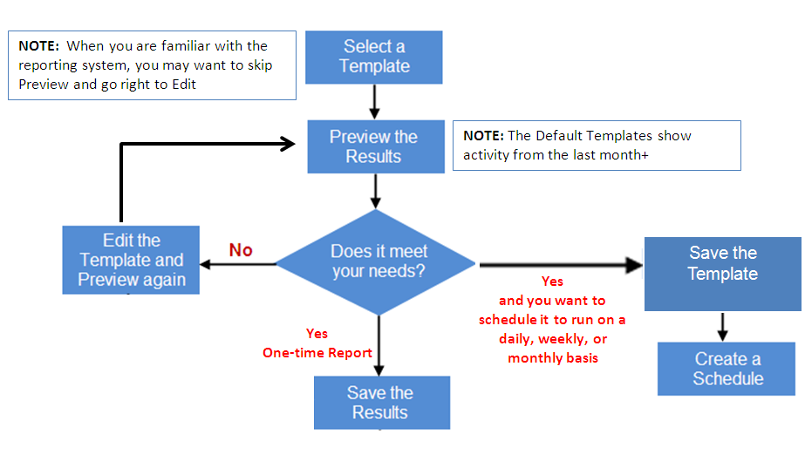

|  |  |
| --- | --- |
| **Skillport 8 Reports** | |
| **User Reports** | |
| **User Listing** | |
|  | Summary by Group |
|  | Detailed by Group |
|  | Detailed by User |
|  | Summary by Approval Manager |
|  | Detailed by Approval Manager |
| **User Privilege** | |
|  | Summary by Group |
|  | Detailed by Group |
| **User Participation** | |
|  | Total User Participation (Chart) |
|  | User Participation by Group |
|  | User Participation Summary by Group |
| **Learning Activity** | |
|  | Summary by User |
|  | Summary by Group |
|  | Asset Activity by Group |
|  | Asset Activity by User |
|  | Asset Activity by User with Lessons |
| **Learning Plan** *Note: Was “My Plan” in v7* | |
|  | User Learning Plan Detailed |
|  | User Learning Plan Summary by Content and Group |
|  | Group Learning Plan Assignment **\*NEW\*** |
|  | Development Plan |
| **User Participation** | |
|  | Total User Participation |
|  | User Participation by Group |
|  | User Participation Summary by Group |
| **inGenius** | |
|  | User Summary by Community |
|  | Detailed by Community |
|  | Most Active Users |

|  |  |
| --- | --- |
| **Content Reports** | |
| **Content Activity** | |
|  | Summary by Content |
|  | Course Activity by Content |
|  | Content Completion (Chart) |
|  | Total Duration (Chart) |
|  | Learning Event |
|  | Most Popular Titles |
| **KnowledgeCenter Access** | |
|  | Access Summary By KC |
|  | Access Summary By KC and User |
|  | Activity by KC |
| **Skillsoft Advantage Access** | |
|  | Access Summary By SA |
|  | Access Summary By SA and User |
|  | Activity by SA |
| **Business Exploration Series Access** | |
|  | Access Summary By BES |
|  | Access Summary By BES and User |
|  | Activity by BES |
| **Learning Program** | |
|  | Summary by Learning Program |
|  | Summary by Group |
|  | Summary by User |
|  | Detailed by User |
|  | Matrix by Learning Program |
| **Live Learning Program** | |
|  | Summary by Live Learning |
|  | Summary by Group |
|  | Summary by User |
|  | Detailed by User |
|  | Matrix by Live Learning |
| **Credentialing** | |
|  | Summary by Credential |
|  | Summary by User |
|  | Detail by Credential |
| **ILT Course and Session** | |
|  | Summary by ILT Course |
|  | Detailed by ILT Course and Session |

|  |  |
| --- | --- |
| **Content Reports** (*Continued*) | |
| **ILT Student Roster** | |
|  | Detailed by Session and Course |
|  | Detailed by Course and User |
|  | Detailed by user |
| **Books and Videos Subscriptions** | |
|  | Subscription Summary |
|  | Individual Usage Detail |
| **Books and Videos Content Activity** | |
|  | Summary by Asset |
|  | Detail by Asset |
| **inGenius** | |
|  | Content Summary by Community |
|  | Summary by Asset Type |
|  | Detailed by Content |
|  | Most Recommended Assets |
|  | Most Commented Assets |
|  | |
| **Training Effectiveness Reports** | |
| **Content Evaluation** | |
|  | Summary by Evaluation |
|  | Detailed by Evaluation |
|  | Linked Evaluations by Asset |
| **Executive Overview** | |
|  | User and Content Statistics |
|  | Content Usage Statistics |
|  |  |

|  |  |
| --- | --- |
| **System Reports** | |
| **Skillport User Login** | |
|  | Summary by Group |
|  | Detailed by Group |
|  | Total Logins (Chart) |
|  | User Login Activity (Chart) |
| **New Registrations** | |
|  | Skillport Registrations (Chart) |
| **Library** *Note: Skillport 7 had separate Course Catalog and Books24x7 reports.* | |
|  | Library Summary **\*NEW\*** |
|  | Library Detail **\*NEW\*** |
|  | Credential Listing  *(was Credential Catalog)* |
|  | Assignments by Group |

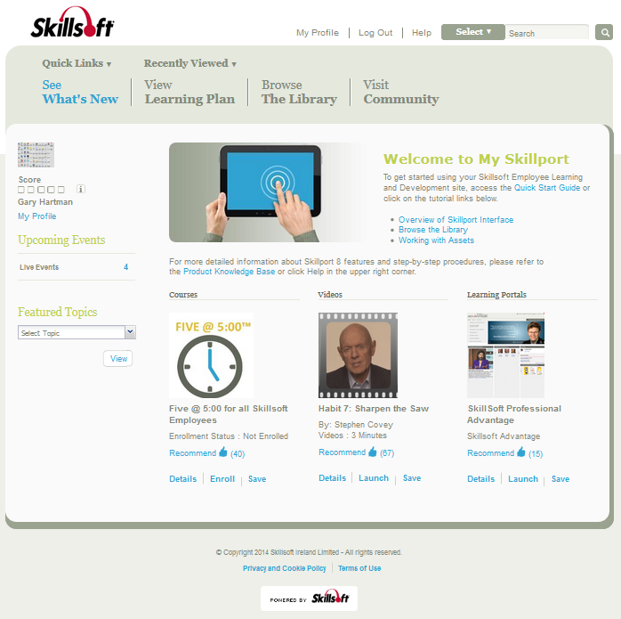

20140317