Getting Started with Skillport 8i
This guide will help you learn about important features and functionality in Skillport 8i.

Sign in to Skillport | In a browser, navigate to your Skillport Sign In page. Enter your username and password and click Sign In.  Note that passwords are case-sensitive.  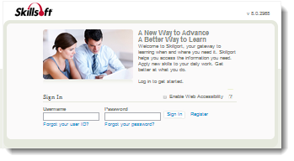
Explore the Home Page | 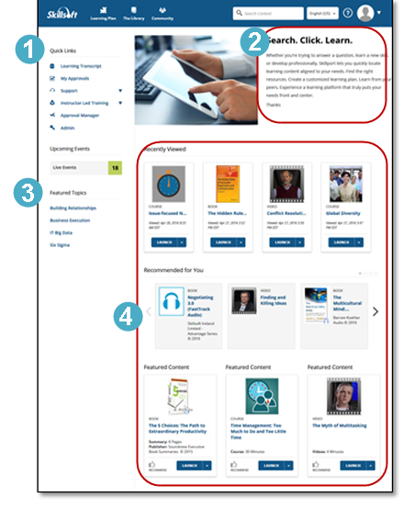  Once you have signed in to Skillport, the Home page displays. The Home page provides easy access to content and actions you use most often in Skillport:  - Access Quick Links, containing key popular options such as Learning Transcript, My Approvals, and Support.  - Find messages from your organization in this area.  - View Featured Topics, which are specific courses or content highlighted by your organization.  - See Recently Viewed items, as well as view recommended and featured content.

View The Library | Find content by clicking The Library and selecting a subject. Content libraries can be organized by whatever criteria aligns with your organization’s training goals, such as subject area, content type, or job role.  The Library contains all of the content to which you are entitled.  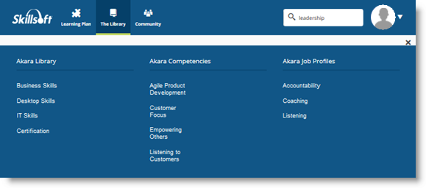
Browse The Library | Once you select a subject, content is grouped by type, such as courses, books, videos, resources, and portal. You can:  - View content options in the carousel.  - Select the tab that corresponds to the content type that you are interested in.  - Choose a category in the left-hand menu to view related content items.  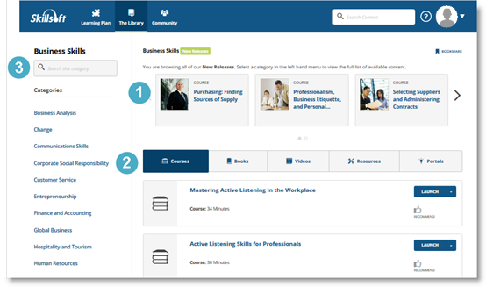

Search for Content | Use Search at the top right to quickly locate content.  - Enter terms in Search and click or press the Enter key.  - View your returned search results, organized in tabs.  - Search within the results to further refine the content displayed.  - Select Sort By to sort content alphabetically, by publish date, or by recommendations.  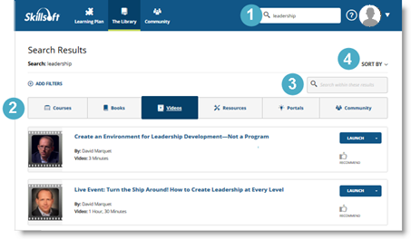
Use Filters | After your initial search, you can refine your search results by applying filters. Click Add Filters to:  - Choose certain subjects to refine your results by subject.  - Select specific content types to view. Books or courses are examples.  - Narrow your results further and filter by training credits and copyright.  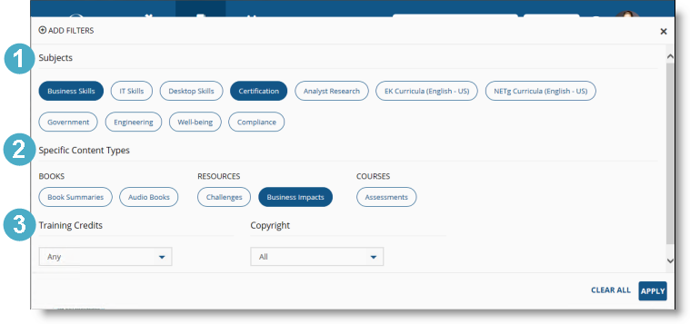
Manage your Learning Plan |  | View and manage your assignments by clicking Learning Plan. There may be two sections in your learning plan:  - Assigned Learning contains content that your manager or training administrator has assigned to you. Development Plans are also found here.  Note: This section only displays if content is assigned.  - Personal Learning contains content that you have saved for completion, as well as any bookmarks in the Library you may have created.  To help organize your assignments, content in Personal Learning can be arranged in sets.  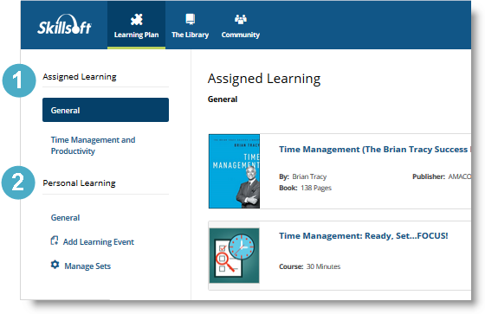
Check your My Tasks |  | Use My Tasks to quickly view your upcoming and overdue content assignments without having to open your learning plan. You can view My Tasks from:  - The left navigation bar, or  - The dropdown menu in the upper right hand corner.  You can launch content directly from My Tasks, or click to close and return to Skillport.  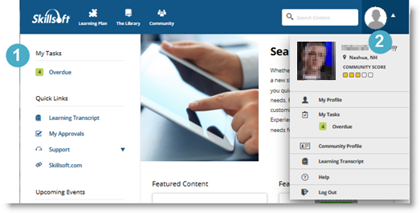
Visit Community |  | If enabled on your site, click Community to view your organization’s social and collaborative place within Skillport. You can share recommendations on content, post comments, and follow people within your organization.  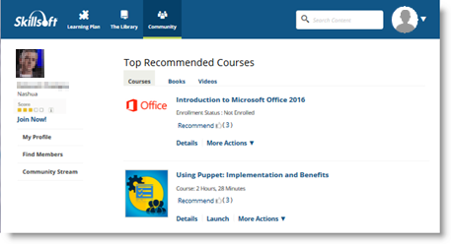  By creating a community profile, you can share information about yourself, including areas of interest and expertise.  From the dropdown menu in the upper right hand corner, click My Profile > Community Profile > Edit to create or edit your profile.  Note that participation in the Community is completely optional. You do not need to have a completed community profile to participate in the Community. Recommending or commenting on content, or choosing to follow another community member, automatically joins you to the Community. You can go back and complete your profile at any time.
Learn More |  | Learn more about the features and functionality in Skillport 8i by visiting our online knowledge base. Helpful information includes:  - What’s New in Skillport 8i for Learners  - Administrator updates  - System Requirements  