Getting Started with Skillport Mobile

This guide will help you learn about important features and functionality in Skillport Mobile.

Log in to Skillport | 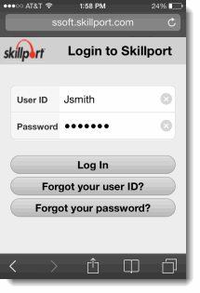  In your mobile phone browser, navigate to your Skillport login page.  To log in:  - Enter your User ID and Password. Note that passwords are case-sensitive.  - Tap Log In.  Your mobile browser must be set to allow pop-ups or to permit opening new tabs in the background.  The Search page displays by default.
View the Main Skillport Mobile Page | 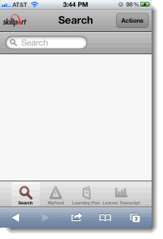  Once you have logged in to Skillport Mobile, the Search page displays. From here, you can begin searching for content immediately, or select another available option, such as:  - My Feed  - Learning Plan  - Learner Transcript  When searching for content, you can:  - Search for mobile and non-mobile content.  - Add mobile and non-mobile content to your learning plan.  - Launch only mobile content from your smartphone.

View  My Feed | 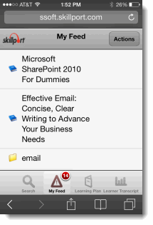  My Feed provides you with a list of up to the 20 most recent assets for which any of the following events have occurred:  - The asset has been added to your learning plan.  - The asset’s due date is approaching.  - The asset’s reminder has just expired (the reminder email has been sent).  - The asset is incomplete and its due date has just passed.
Search for Content | To search for content items, enter a term in the search field and tap return on your smartphone keyboard. By default, only mobile content types are returned. There are several ways that you can filter and modify these results:  - Tap to select a content language to refine by.  - Select Actions > Show All to view both mobile and non-mobile content items results.  - Use common search operators, such as Boolean, wild card, and proximity operators, to refine your search results.  There are no refinement options from within the content item categories. If your search returns too many results, search again using the suggestions above.
View your Search Results | 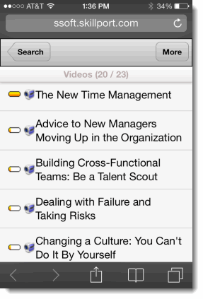  Tap a content category to view your search results. Once you have found content of interest to you, tap it to launch the content details page. From the search results page, you can:  - Scroll through the list of content items displayed.  - Tap to view the next group of results (up to 20 results display at a time).  - Tap to return to enter a new search query.  - Tap the content item to select it and launch the details page.
View the Content Item Details page | 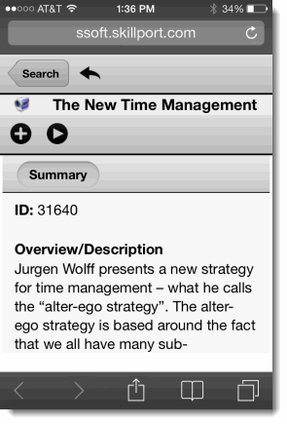  Tap on a content item to view the content details page. From here, you can:  - Scroll through the content item summary information.  - View the content ID.  - Tap to add the content to your learning plan.  - Tap to launch the content item.  - Tap to return to the search results list.  - Tap to return to the main search page and select another content category or perform another search.
View your Learning Plan | 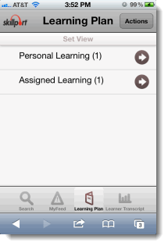  View and manage your assignments by tapping Learning Plan. There are two tabs in your learning plan:  Personal Learning: The Personal Learning tab contains content that you have saved for completion, as well as any bookmarks in the Library that you have created.  Assigned Learning: The Assigned Learning tab contains content that your manager has assigned to you. Development Plans are also found here.  To help organize your assignments, content on both tabs is arranged in sets.
Learn More | Learn more about the features and functionality in Skillport Mobile by visiting our online knowledge base. Helpful information includes:  - User Guides  - Mobile FAQs  - System Requirements  - Print Documentation  http://documentation.skillsoft.com/en_us/skillport/8_0/ah/49539.htm  