Getting Started with the Skillsoft Learning App

This guide will help you learn about important features and functionality in the Skillsoft Learning App.

Install the Learning App | 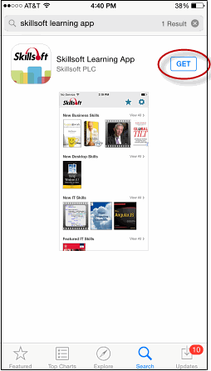 | You can install the Skillsoft Learning App on your smartphone from the appropriate app store (Apple or Google Play), or you may receive an email from your Skillport Administrator with links and instructions to install and configure the app.  To install the app via an App Store  - From the appropriate app store, search for “Skillsoft Learning App”.  - Follow steps for your particular smartphone to download and install the app.  To install the app via an email  - Open the email notification from your Skillport administrator.  - Use the links included in the email to install and configure the app.
Sign in to the app | 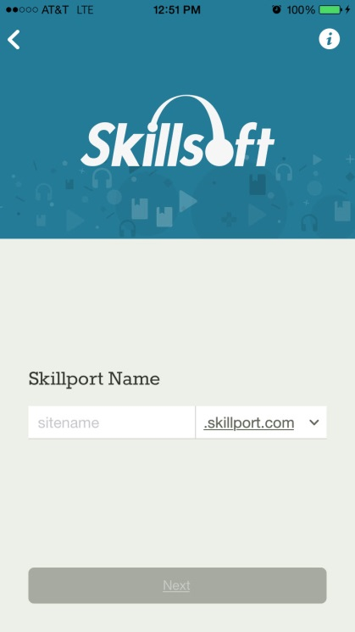 | On your smartphone, tap the app to launch it. If you are launching it for the first time, you will need to sign in.  To sign in  - Enter your Skillport 8 site name and tap Next.  - Enter you Skillport user ID and password. Note that passwords are case-sensitive.  - Tap Sign In.  Note: If you have single sign-on (SSO) configured, you may have a different login experience or login may be automatic.

Select Areas of Interest | 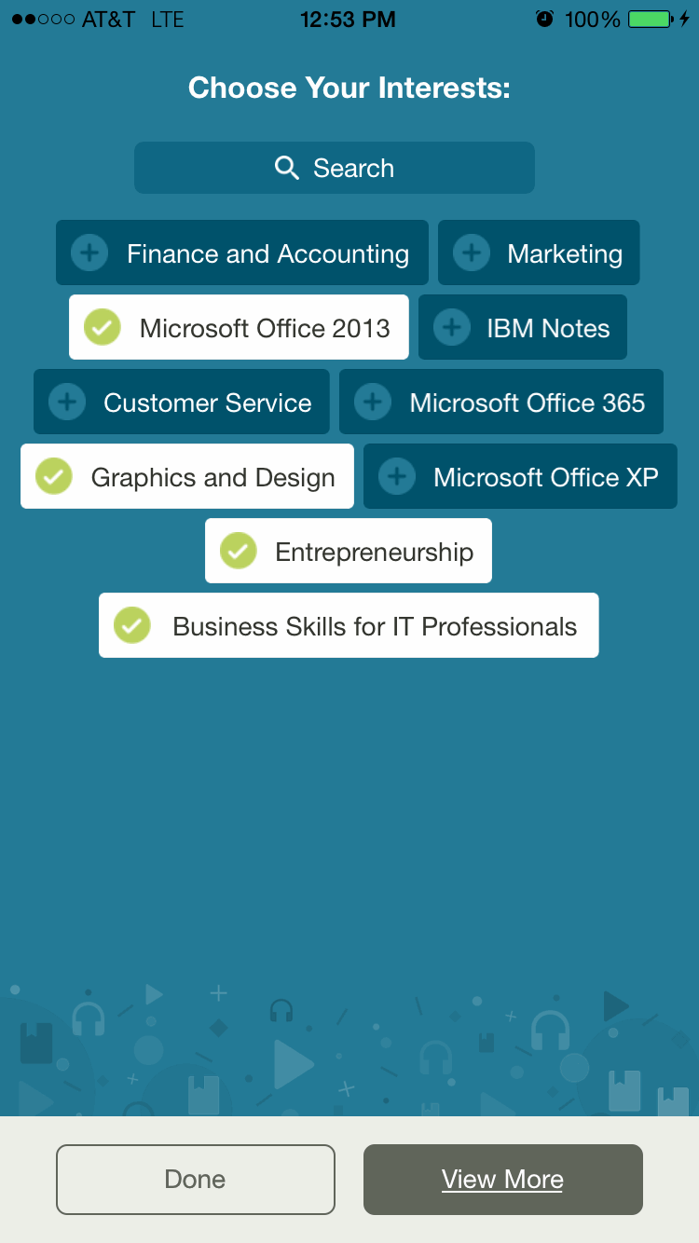 | Once you have signed in to the app, you will be prompted to select Interests. Interests are topics, or subject areas, that are of interest to you. Tap at least three Interests to automatically populate the app with Skillsoft library content that you are entitled to view on your Skillport 8 site.  Tap View More to view more Interests, then tap  Done when you are through selecting Interests.
View the Home Page | 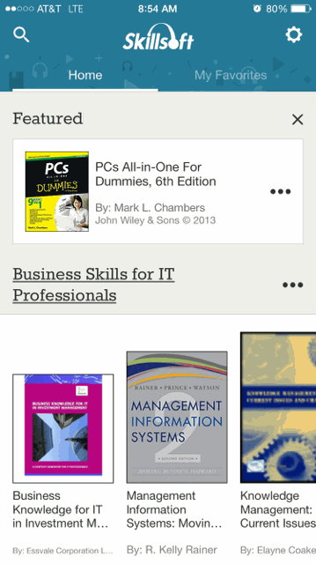 | The Home Page now displays content based on your selected Interests.  - Scroll up and down the Home Page to view all of your selected Interests.  - Tap to search across all entitled content and Interests.  - Tap … to manage your selected Interests. You can reorder, add, or remove Interests at any time.  - Tap the Interest title to view all content within an Interest.  - Tap to view Settings for the app.  - Note: Navigation options and icons may differ slightly for Android smartphones.  Featured categories contain content items that have been flagged by subject matter experts that may be of interest to you.
View a Video | 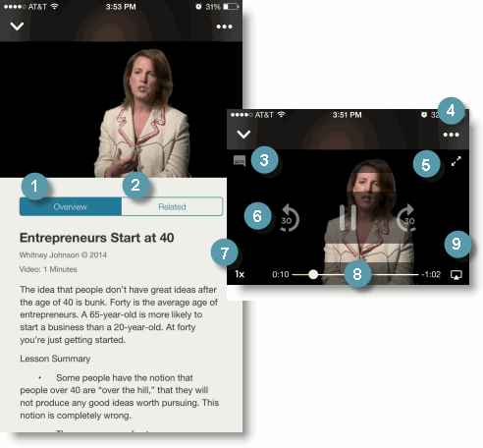 |  | Navigate the video with the following options:  - The video Overview provides a summary of the video’s contents.  - Related displays related content items.  - Tap the Closed Captioning icon to add or remove subtitles from the video.  - Add the video to My Favorites tab here.  - Expand the video to full screen mode.  - Advance or rewind the video by sliding the progress indicator along the scrubber bar.  - Tap the play speed indicator to increase or decrease the speed of video playback.  - Advance or rewind the video by sliding the progress indicator along the scrubber bar.  Note: Speed controls are not available on Android smartphones.
Launch an Audio book | 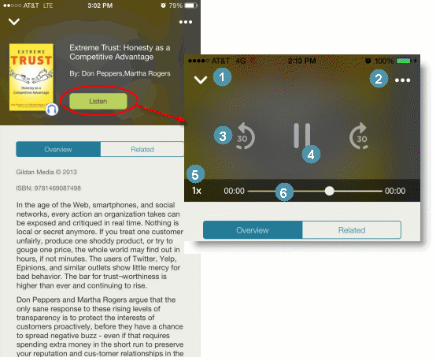 |  | Navigate an audio book with the following options:  - Tap V to return to the Overview screen.  - Add the audiobook to My Favorites by tapping ….  - Tap the play speed indicator to increase or decrease the speed of the audio playback in 30-second increments.  - Tap Play/Pause to play or pause.  - Tap the play speed indicator to increase or decrease the speed of the audio playback. You can play the audio at normal speed (1x), one and a half times (1.5x), or double speed (2x).  - Advance or rewind the audiobook by sliding the progress indicator along the scrubber bar.  Note: Speed controls are not available on Android smartphones.
View a Book | 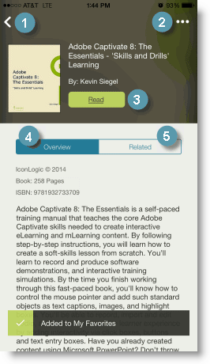 |  | Navigate Books with the following options:  - Tap < to return to the Home page (or to your Search results).  - Tap ... to mark the item as a favorite and include it on your My Favorites page. You can remove an item from My Favorites by tapping the icon again.  - Tap Read to launch the book. Use the Table of Contents to go to a specific chapter or topic within the book. Tap the name of the chapter or section you wish to read.  - View the Overview to read an introduction to the book. Overviews are a convenient way to quickly determine if a book is right for your learning needs.  - Tap Related to view a list of related content items.
Take a Course | 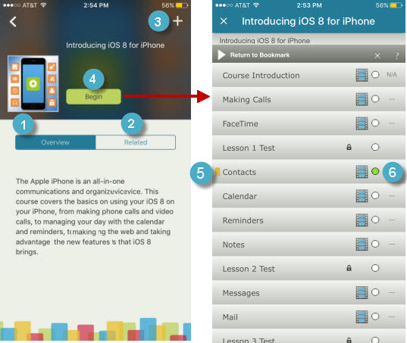 |  | Navigate courses with the following options:  - The course Overview provides a summary of the course contents.  - Related displays related content items.  - Tap + to add the course to a Set in My Favorites.  - Tap Begin to view the table of contents.  Select a course topic to view the content.  - The Bookmark shows the last place you visited in the course.  - Progress indicators show topics you’ve not started as well as those you’ve completed.  Note: Courses can be viewed in portrait and landscape mode.
Create Sets | 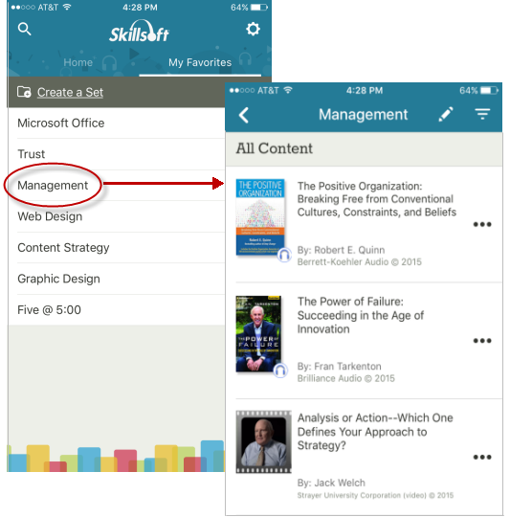 |  | Sets, or groups of content items, allow you to organize content by personal and professional learning goals. You may want to refine groupings of content further by creating subsets within your sets. You can have up to two levels of subsets within each set.  Content you add to sets in My Favorites is synced with your Skillport 8 Personal Learning tab, for easy access to your preferred learning content on all of your supported devices.  You can create and manage your sets by tapping My Favorites. Tap any set to view subsets of that set.  You can add content to sets by tapping + in the upper right corner of content Overview pages.
Learn more | Learn more about the features and functionality in the Skillsoft Learning App by visiting our online Skillport 8 Knowledge Base. Helpful information includes:  - Skillsoft Learning App Help  - System Requirements  - Video Tutorials  