
Instructor-led Training Administrator Guide
for Skillport 8

January 2015

© 2015 Skillsoft Ireland Limited
All rights reserved
Skillsoft Corporation
107 Northeastern Blvd.
Nashua, NH 03062
603-324-3000
87-Skillsoft (877-545-5763)
Information@Skillsoft.com
www.Skillsoft.com
Printed in the United States of America
The software contains proprietary information of Skillsoft Corporation; it is provided under a license agreement containing restrictions on use and disclosure and is also protected by copyright law. Reverse engineering of the software is prohibited.
Due to continued product development, this information may change without notice. The information and intellectual property contained herein is confidential between Skillsoft Corporation and the client and remains the exclusive property of Skillsoft Corporation. If you find any problems in the documentation, please report them to us in writing. Skillsoft Corporation does not warrant that this document is error-free.
No part of this publication may be reproduced, stored in a retrieval system, or transmitted in any form or by any means, electronic, mechanical, photocopying, recording or otherwise without the permission of Skillsoft Corporation.
Microsoft Word, Microsoft Office, and Windows® are trademarks of the Microsoft Corporation.
Skillsoft®, the Skillsoft logo, Ahead of the Learning Curve, Skillport®, Search-and-Learn®, SkillChoice, Skillsoft® Dialogue™, Express Guide™, Books24x7, Referenceware®, ITPro, BusinessPro, OfficeEssentials, GovEssentials, EngineeringPro, FinancePro, Summaries, Blueprints, Express Guide and Bridging the Knowledge Gap™ are trademarks or registered trademarks of Skillsoft PLC in the United States and certain other countries. All other trademarks are the property of their respective owners.

Microsoft Word, Microsoft Office, Windows®, Vista™, Windows 2000™, Windows XP™, and Windows NT® are trademarks of the Microsoft Corporation.
Dreamweaver® is a registered trademark of Adobe Systems Incorporated. in the United States and/or other countries. Adobe and PhotoShop® are either registered trademarks or trademarks of Adobe Systems Incorporated in the United States and/or other countries.
Sound Forge ® Audio Studio™ and Sound Forge ® 7.0 are trademarks or registered trademarks of Sony Pictures Digital Inc. or its affiliates in the United States and other countries."
Mozilla Firefox™ and the Firefox logo are trademarks of The Mozilla Foundation. All trademarks appearing on the Netscape Network are the property of their respective owners, including, in some instances, the Netscape Network and its affiliates, including, without limitation, Netscape Communications Corporation and America Online, Inc.
The term "Linux" is a registered trademark of Linus Torvalds, the original author of the Linux kernel.
"Sun, Sun Microsystems, Sun JVM/JRE, logos, are trademarks or registered trademarks of Sun Microsystems, Inc. in the United States and other countries."
All other names and trademarks are the property of their respective owners.
Information in this document is subject to change without notice. No part of this document may be reproduced or transmitted in any form or by any means, electronic or mechanical, including Photocopying or recording, for any purpose without the express written permission of Skillsoft Corporation.
This document is provided for information only. Skillsoft makes no warranties of any kind regarding the Skillsoft software, except as set forth in the license agreement. The Skillsoft software is the exclusive property of Skillsoft and is protected by United States and International copyright laws. Use of the software is subject to the terms and conditions set out in the accompanying license agreement. Installing the software signifies your agreement to the terms of the license agreement.

 | Table of Contents  Chapter 1  ILT for Administrators 6  Getting Started with ILT 6  Getting Started with ILT Overview 6  ILT Terms 8  ILT Roles 8  ILT Course and Session Manager 13  Dashboard 13  Courses 14  Session Manager 24  ILT Email Notifications 36  Resources 42  View Resources 42  Search Resources 43  Facilities 44  Classrooms 46  Contacts 49  Upload ILT Content 52  Upload a Batch of ILT Content 52  Contacts Template 53  Facilities Template 54  Classrooms Template 54  Courses Template 55  Sessions Template 66  Enrollments Template 68  ILT Event Journals 69  Chapter 2 ILT for Instructors 71  Sessions I am Teaching 71  Manage Enrollments 72  Enroll Learners in a Session 72  Withdraw Learners from a Session 73  Moving Learners to the Waitlist 74  View Attendance 75  Entering Results 75  Quiz Results 76  Chapter 3 ILT Configuration 78  ILT Workflow 78  Extended Attributes 79  Understanding Extended Attributes 79  View Extended Attributes 80  Create a New Extended Attribute 80  Edit an Extended Attribute 81  Reorder an Extended Attribute 81  Activate or Deactivate an Extended Attribute 82  Delete an Extended Attribute 82  ILT Site Settings 83

Chapter 1

ILT for Administrators
In This Chapter
Getting Started with ILT 7
ILT Course and Session Manager 14
Resources 43
Upload ILT Content 54
ILT Event Journals 72

Getting Started with ILT

Overview
Instructor Led Training (ILT) enriches and optimizes the learning experience of your students. By extending the Skillport platform with a wide range of ILT functionality, Skillsoft offers you a way to manage instructor-led training sessions.
With ILT, you can manage all the requirements for:
- In-house or third-party training sessions delivered in a classroom environment by an instructor to students (for example new employee orientation)
- Online training sessions delivered by an instructor using Skillsoft Dialogue Virtual Classroom or other online collaboration software.
ILT also provides tools for tracking facilities and classrooms, and for scheduling instructor-led training sessions. ILT does not track classroom or facility attributes such as projectors, printers, network connections, or other infrastructure such as availability.
Note: You cannot add ILT courses or sessions to a series. For information about which asset types can be added to a series, see Important Information about Series.
A series is a container of specifically-ordered assets used to group related assets together (for example, to obtain a certification). Series cannot have subsets.

ILT and Advanced Groups
You can create and use advanced groups on your Skillport site when you are also using ILT. This works as follows:
- ILT administration: While your ability to access non-ILT pages in Skillport Administrator depends entirely on your Skillport role, your ability to access ILT pages depends entirely on your ILT role. On the ILT pages that you can access, neither the tasks that you can perform nor the users on which you can perform them are affected by your or their existence in an advanced group. If you can perform an ILT-related task for users and groups, you can do so for all users and groups on your site, including all advanced groups.
- Reports
- ILT Event Journals: Like for other ILT-related pages, your ability to access this page depends entirely on your ILT role, and you can view event journals for all users and groups, including all advanced groups.
- Skillport Reporting: Skillport’s Reporting feature includes a large number of templates that you can use to run reports, including several ILT course and session reports and ILT student roster reports. If you do not have Admin privileges with Reporting capabilities in Skillport, you will not be able to run these reports. In addition, you will only be able to run reports on groups to which you are a member. Your ILT role has no effect on your privileges in this area. Rather, your Skillport role and how your site’s User/Group Filter Scoping setting is configured determine the specific users and groups—including advanced groups—that you can select to include in reports. For more information, see User and Admin Privileges.

ILT Terms
Skillport
Skillport is a Learning Management System (LMS) where you can personalize your elearning environment and monitor your progress toward your own learning goals. Reminders can also be e-mailed in order to complete courses and simulations.
You can also link the areas of Skillport which you use most often to the Quick Links area. These links can be Skillsoft features and any custom pages.
Course
A course is a training activity which addresses a specific topic. A course can consist of: traditional materials presented in a PowerPoint format, a recorded live session delivered by a presenter, simulations which replicate a program or environment so you can practice completing tasks, other multimedia clips that support leaning, test and assessments that verify retention of knowledge, as well as job aids, skill briefs, or other materials to support the learning activities.
ILT Course
Instructor Led Training courses are placeholders to which an ILT Administrator attaches scheduled sessions that a learner can attend at a specific time and place. A learner can select an ILT course from the Skillport Library and add it to his watch list for sessions that meets his schedule, or it can be assigned by a training administrator.
Session
A session is an instance of a course that has been scheduled for a specific date and time and will be held in a facility/classroom or virtually, with an instructor and students.
Learning Plan
Learning Plan contains items that are part of your formal learning program. You, your training administrator, or your manager can add ILT courses to your Learning Plan.

ILT Roles
The table below shows the ILT features available for the different user roles.
 | Learner | Skillport Admin | ILT Course Admin | ILT Session Admin | Session Approver | Mgr | Instructor
View ILT courses and sessions through Skillport catalog | X | X | X | X | X | X | X
Enroll in ILT sessions | X | X | X | X | X | X | X
Watch ILT courses | X | X | X | X | X | X | X
Assign user roles in ILT Admin interface |  | X
Create a course |  | X | X
Edit a course |  | X | X
Delete a course |  | X | X
Create a session |  | X | X | X
Edit a session |  | X | X | X
Delete a session |  | X | X | X
Approve session registration requests |  | X |  |  | X | X | X - Applies only when Instructor Can Manage Roster is set to Yes for the session.
Reject session registration requests |  | X |  |  | X | X | X - Applies only when Instructor Can Manage Roster is set to Yes for the session.
E-mail all learners enrolled in a session |  | X | X | X |  |  | X
Close a session |  | X | X | X
Force enroll learners into a session |  | X | X | X |  |  | X - Applies only when Instructor Can Manage Roster is set to Yes for the session.
Enter test scores/attendance for a session |  | X | X | X |  |  | X
Edit/preview an e-mail template |  | X

Assign an ILT Role to a User
To assign an ILT role to a user
- In Skillport Administrator, click Users & Groups > ILT Roles > User Role Management.
The list of users and their associated roles displays.
- Find the user you wish to assign a role to by:
- manually searching through the list of usernames for the user
- using the Search feature at the top of the page.
Note: The grid refreshes to show the search results, and a Clear Search button displays on the page. Clear Search clears the top bar search, but not the column filters or the "Group By" function.
- Select the role's check box. See ILT Roles for more information.
- Click Submit to save your changes and assign the selected role to the user.

Generate and Export a Learner Report
To manage the users and their roles with ease, you can also generate a Learner Report.
Note: The Learner Report button on the top of the ILT User Role Management screen is enabled only if one of the records in the grid are selected.
To generate and export a Learner Report
- In Skillport Administrator, click Users & Groups > ILT Roles > User Role Management.
The list of users and their roles displays.
- Click the username of the learner of whom you want to run the report.
- Click Learner Report on the top of the screen.
The Learner Report can be viewed in the resulting page.
Note: This report is generated only for the selected user.
- To export the Learner Report, click Export Report.
- The following information can be obtained from the resulting .csv document that you download:
- Session ID
- Status
- Course ID
- Course Title
- User Name
- Last Name
- First Name
- Email
- Zip
- Pass
- Attd (attendance)
- Score
- Instructor User Name
- Instructor Last Name
- Instructor First Name
- Facility ID
- Facility Name
- Classroom ID
- Classroom Name
- Start
- End
- Notes

Upload User Roles
You can use the Batch Add function to upload multiple ILT user roles from another system, spreadsheet, or data from a third party (such as an external session vendor).
To upload ILT roles
- Click Users & Groups > ILT Roles > User Role Batch Update.
The ILT User Roles screen displays:
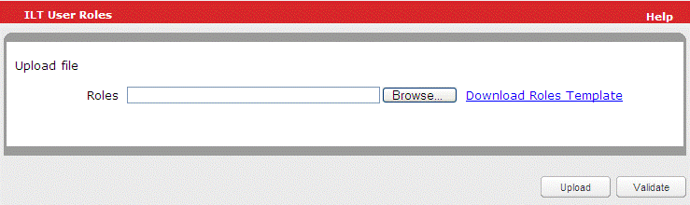
- Next to the file type that you want to upload, click Browse.
The Choose File window displays.
- Navigate to the .csv file you want to upload.
- Click the .csv file to select it.
- Click Open.
The path to your .csv file displays in the field.
- Click Validate to validate the .csv file.
- Click Upload.
The upload process begins. If you have a valid email address, an email is sent containing the URL of a status report and the date and time of the batch submission.

User Roles Template
Use the User Roles Template to upload roles for a user quickly and easily. The table below shows the correct data format for each field in the template.
Field Name | Format
Login | Required. This must be a Skillport login ID.
Administrator | Optional.  - 1: enables the role for the user  - 0 or leave blank: disables the privilege.
Instructor | Optional.  - 1: enables the role for the user  - 0 or leave blank: disables the privilege.
Session Administrator | Optional.  - 1: enables the role for the user  - 0 or leave blank: disables the privilege.
Course Administrator | Optional.  - 1: enables the role for the user  - 0 or leave blank: disables the privilege.
Session Approver | Optional.  - 1: enables the role for the user  - 0 or leave blank: disables the privilege.

ILT Course and Session Manager

Dashboard
The dashboard provides you with a summary of details related to courses and sessions.
To view the dashboard
- Click Content > ILT > Course and Session Manager on the navigation bar.
The dashboard displays under the ILT Dashboard tab.
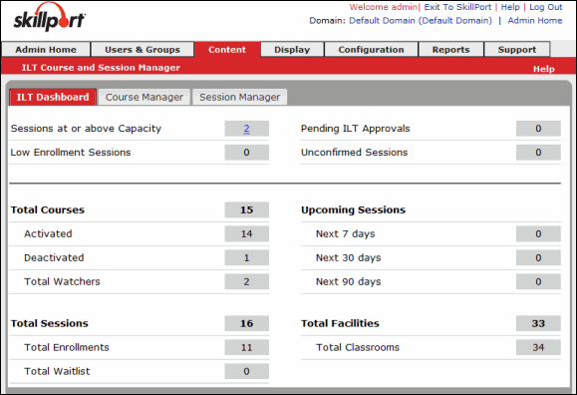
The following are the items that can be found in the dashboard.
- Sessions At or Above Capacity: Sessions that are full with 100% or more participants as determined by the Session Capacity and the site-wide default setting “Full Session Threshold”.
Note: Site Settings are controlled by the Skillport Company Admin.
- Low Enrollment Sessions: This includes the sessions that do not meet the session low enrollment criteria. The criteria is determined by the entry in the Minimum Enrollment and Low Enrollment Alert fields.
- Pending ILT Approvals: This includes the list of ILT approvals that are pending.
- Unconfirmed Sessions: This displays all sessions that have a status of Unconfirmed. From the View more in print friendly window, the Admin can select one or more sessions and click Confirm the selected sessions to mark sessions as Confirmed.
Note: If the Skillport Company Admin disables Unconfirmed in the site-wide ILT Site Settings, then no sessions will appear in this section.
- Total Courses: Displays the total number of ILT courses.
- Activated: Displays the total number of activated ILT courses.
- Deactivated: Displays the total number of deactivated ILT courses.
- Total Watchers: Total number of Watch List entries made to courses by Learners.
- Total Sessions - Displays the total number of Unconfirmed and Confirmed ILT sessions.
- Total Enrollments: Displays the total number of Pending Sessions and Confirmed enrollments.
- Total Waitlist: Displays the total number of Learners on all Waiting Lists.
- Upcoming Sessions: Lists all future sessions including sessions for the day. Clicking the value of the link Next 7 days, Next 30 days or Next 90 days on the dashboard tab brings you to the Session Manager.
- Total Facilities: Displays the total number of ILT Facilities.
- Total classrooms: Displays the total number of ILT Facilities.

Courses

View Courses
The Course Manager displays the available course list (by course ID and course title) and the sessions.
To view courses
- Click Content > ILT > Course and Session Manager on the navigation bar.
- Click Course Manager.
The ILT courses display.
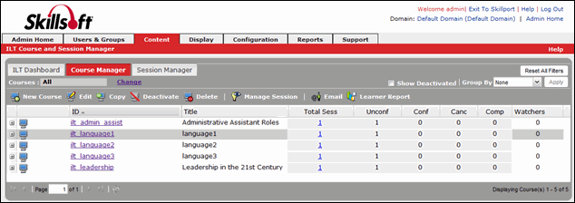
- Sort the courses:
- Click a column header to sort in ascending or descending order.
- Use the Group by field to sort by group by Title, Spoken Language, or Cost.
- Optionally, you can select the Show deactivated check box to include deactivated courses in the Course Manager.

View ILT Course Details
The Course Details page provides additional information related to a specific course, such as the course ID, title, mastery level, cost, and duration. Use this view to change and modify the details.
To view course details
- Click Content > ILT > Course and Session Manager on the navigation bar.
- Click Course Manager.
The ILT courses display.
- To view course details without navigating away from the Course Manager, click next to the course you want to view.
- Click next to Course Information, or click next to Course Administration.
The course details display below the course listing:
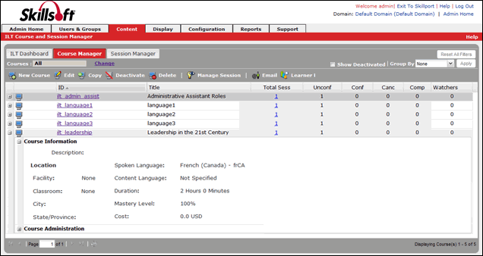
- To open the course details on the View Course Details page (to allow edits), click the course ID you wish to view.
The View Course Details page opens, and you can review your ILT course:
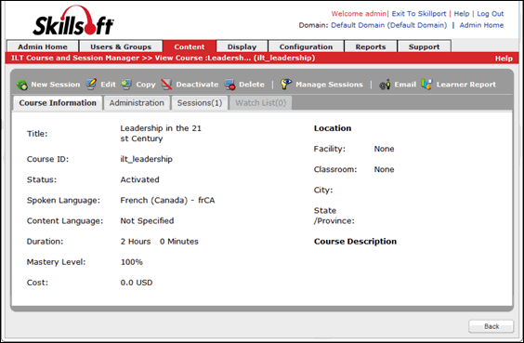

Create a New ILT Course
Use this process to create and enter details of a new ILT course.
To create a new course
- Click Content > ILT > Course and Session Manager on the navigation bar.
- Click Course Manager.
- Click New Course.
The New Course window displays:
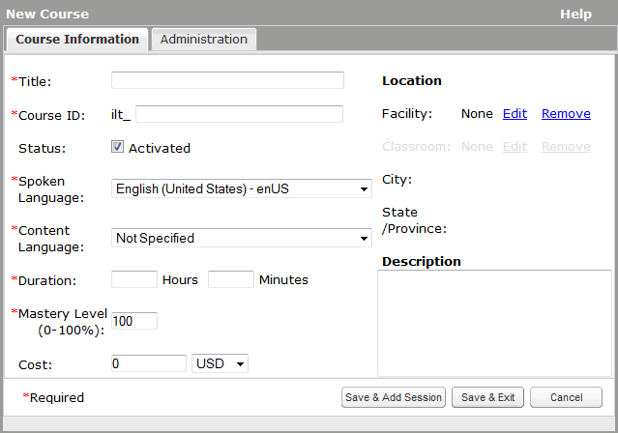
- Enter the Course Information. Items with an asterisk (*) are required:
- Title*: The title of the course as presented to learners. This does not need to be unique.
- Course ID*: All course IDs begin with ilt_ and are always unique. Once the course ID is saved, it cannot be changed.
- Status: This option activates or deactivates the course; by default the status is active. Active courses display on the View Courses page. The deactivated courses display on the View Courses page if the Show Deactivated check box on the View Courses page is selected.
- Spoken Language*: The spoken language of the course (for example, the language spoken by the instructor or the learners).
- Content Language:* This setting determines where the ILT course displays when a user searches or browses within a selected language. Select Not Specified to ensure it displays in all searches regardless of a learner's selected content language, or select a language to include it only when a learner searches within that language.
For example:
An admin, Joe, creates an ILT course about leadership and sets the content language to Spanish. A learner, Kim, searches for an ILT course about leadership, but her content language in Skillport Learner is set to English (United States). Kim won't see the ILT course because it isn't marked as English (United States). If Joe sets the content language to Not Specified, Kim would be able to see the ILT course regardless of her set content language.
- Duration: Enter the duration of the course. This is the length of time required to complete a course. This field has a default value.
Note: There is no correlation or checking of this value with the actual schedule information applied to a session.
- Mastery Level (0-100%): The percentage score a learner must obtain to complete the course. The Mastery Level default value is 100. If you submit the course with a blank value, it is considered zero (0).
- Cost: The cost and currency of the course.
Note: Skillport does not bill learners. This is a notification to the learner that the course costs money.
- Location: The location of a course, whether it is to be held in a physical classroom or online.
Note: Extended Attributes display if enabled. Classrooms can be added only after a facility is added. For information on adding a facility, refer to Add a Facility to a Course. For information on adding a classroom, refer to Create a New Classroom.
- Description: The description of the course.
- Add the administration details.
- Click Save & Add Sessions to save the course and navigate to the New Sessions window. Alternatively, click Save & Exit to save the course and return to the Course Manager screen. Cancel dismisses the window without any changes saved and gets back to the main screen in the previous state.

Add Administration Details to a Course
Additional details regarding administration can be added to a course while creating a new course. These details can also be set at the session level or overwritten at the session level. If they are set at the course level the session will automatically default to the settings.
To add administration details to a course
- View Courses.
- Click New Course or select the course from the list of courses and click Edit Course if you are editing the administration details.
- Click the Administration tab.
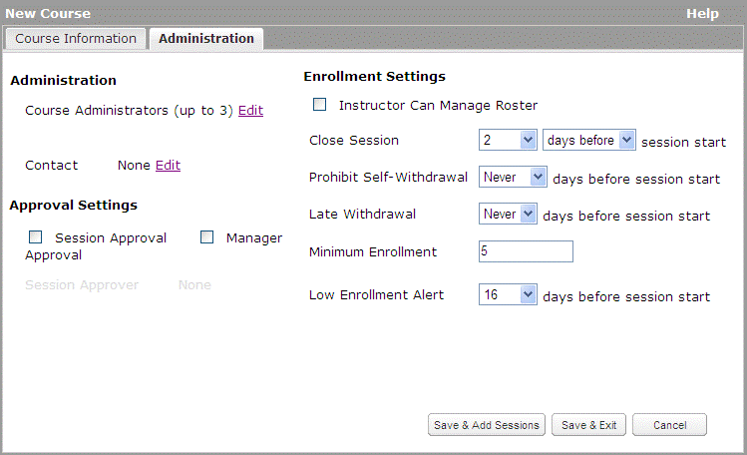
- Fill in the Administration, Approval Settings and Enrollment Settings.
- Course Administrators: Select up to three course administrators.
- Contact: You can edit or remove a contact.
- Session Approval/Manager Approval: Select whether Session Approval or Manager Approval is required for this course.
- Instructor Can Manage Roster :Select this checkbox to allow an Instructor to manage the course roster.
- Close Session: Select when you wish to close the session to new enrollment by selecting the relevant entries from the drop-down.
- Prohibit Self-Withdrawal: Select if and when to prohibit self-withdrawal from a session from the options in the drop-down.
- Late Withdrawal: Select if and when a late withdrawal is possible from the options in the drop-down.
- Minimum Enrollment: Enter the minimum number of enrollments possible.
- Low Enrollment Alert: Select when you want to get an alert if there is low enrollment by selecting an option from the drop-down. This field does not display if Minimum Enrollment is zero.
- Click Save & Add Sessions to save the course and navigate to the Add Sessions page. Alternatively, click Save & Exit to save the course and return to the Course Manager screen.
Note: Cancel will enable you to exit the New Course window without saving.

Select a Facility for a Course
You can associate a facility to a course or replace the association.
To add/edit a facility to a course
- View Courses.
- Click New Course.
- Click Edit next to Facility. The Select 1 Facility window displays.
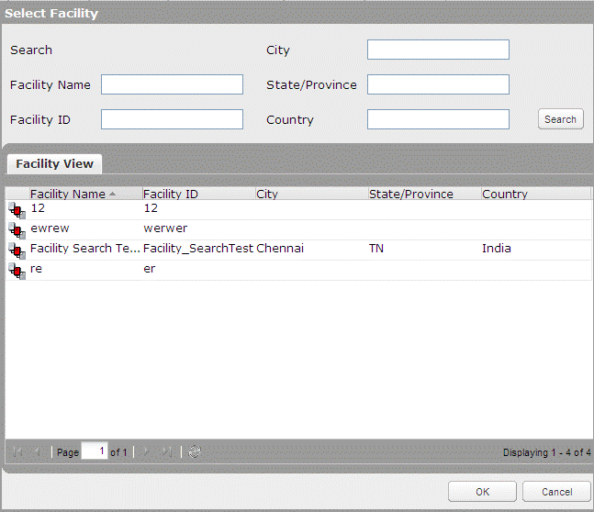
- Select a facility from the list or use the search to list the required facilities.
Note: You may search for the facility using the Facility Name, Facility ID, City, State/Province or Country.
- Click OK.

Select a Classroom for a Course
Once you have added a facility to a course, you can add a classroom. You can also edit an existing classroom.
Note: You can search for a classroom only if it exists within the selected facility.
To add/edit a classroom to a course
- View Courses.
- Click New Course.
- Click Edit next to Classroom. The Select 1 Classroom window displays.
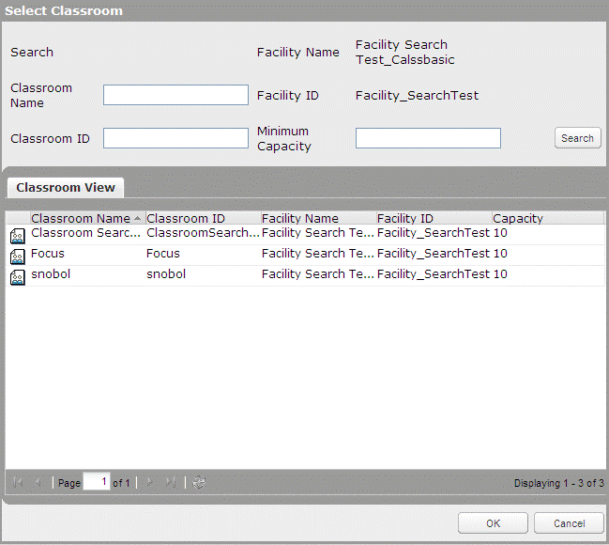
- Select a classroom from the list or use the search to list the required classrooms.
Note: You may search for the facility using the Classroom Name, Classroom ID, Facility Name, Facility ID or Maximum Capacity.
- Click OK.

Edit a Course
You can edit the details of a course if any changes are required.
Note: The option to edit a course on the Course Manager tab is enabled only if there is a course selected in the list of courses found in the Course Manager screen.
To edit a course
- View Courses.
- Click the course ID you wish to view.
The View Course window displays.
- Click Edit.
- Edit the course details. For more information on course details, refer to Create a New ILT Course.
Note: Course ID cannot be edited. Course Title can have HTML tags, but those tags will remain as text. In Description field, the HTML tags can be applied.
- Click Save. The Course Summary displays the updated details for the course, and it is automatically republished to the Skillport Library.

Copy an ILT Course
If you want to create multiple courses with similar attributes, you can copy an existing course. This is a quick and efficient method for creating a series of related courses. All the details and field settings will be copied to the new course and you can edit fields as needed. While copying the course the course ID changes automatically.
Note: To enable the copy button, you must select a course on the Course Manager grid. Only course details can be copied, not the sessions associated with the course.
To copy a course
- Click Content > ILT > Course and Session Manager on the navigation bar.
- Click Course Manager.
The ILT courses display.
- Click a course name to select it.
- Click Copy.
Note: You can also copy a course by viewing the ILT course details and clicking Copy.
The Copy Course dialog box displays:
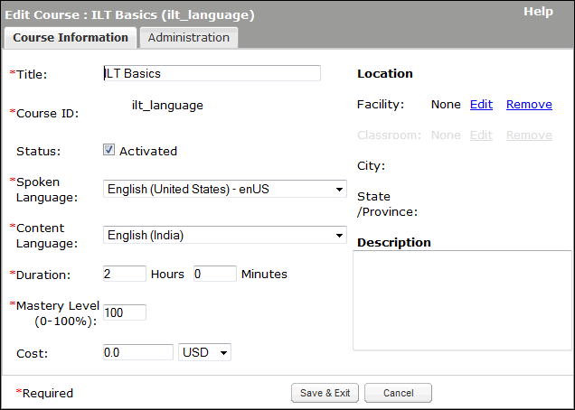
- Edit the information:
- Title*: The title of the course as presented to learners. This does not need to be unique.
- Course ID*: All course IDs begin with ilt_ and are always unique. Once the course ID is saved, it cannot be changed.
- Status: This option activates or deactivates the course; by default the status is active. Active courses display on the View Courses page. The deactivated courses display on the View Courses page if the Show Deactivated check box on the View Courses page is selected.
- Spoken Language*: The spoken language of the course (for example, the language spoken by the instructor or the learners).
- Content Language:* This setting determines where the ILT course displays when a user searches or browses within a selected language. Select Not Specified to ensure it displays in all searches regardless of a learner's selected content language, or select a language to include it only when a learner searches within that language.
For example:
An admin, Joe, creates an ILT course about leadership and sets the content language to Spanish. A learner, Kim, searches for an ILT course about leadership, but her content language in Skillport Learner is set to English (United States). Kim won't see the ILT course because it isn't marked as English (United States). If Joe sets the content language to Not Specified, Kim would be able to see the ILT course regardless of her set content language.
- Duration: Enter the duration of the course. This is the length of time required to complete a course. This field has a default value.
Note: There is no correlation or checking of this value with the actual schedule information applied to a session.
- Mastery Level (0-100%): The percentage score a learner must obtain to complete the course. The Mastery Level default value is 100. If you submit the course with a blank value, it is considered zero (0).
- Cost: The cost and currency of the course.
Note: Skillport does not bill learners. This is a notification to the learner that the course costs money.
- Location: The location of a course, whether it is to be held in a physical classroom or online.
Note: Extended Attributes display if enabled. Classrooms can be added only after a facility is added. For information on adding a facility, refer to Add a Facility to a Course. For information on adding a classroom, refer to Create a New Classroom.
- Description: The description of the course.
- Add the administration details.
- Click Save & Exit.
- Optionally, using the email template that displays, send an email to the enrolled learners to inform them of the change.

Activate or Deactivate a Course
You can activate or deactivate a course if required. You can deactivate the course when the course has no sessions or the course has canceled and completed sessions. If the course has unconfirmed/confirmed sessions, it cannot be deactivated.
Note: Sessions cannot be created under the deactivated course.
To deactivate a course
- View Courses.
- Click on a course to select it.
- Click Deactivate. This deactivates the course.
Note: The deactivate button is enabled only when the selected course has no sessions or canceled/completed sessions.

To activate a course
- View Courses.
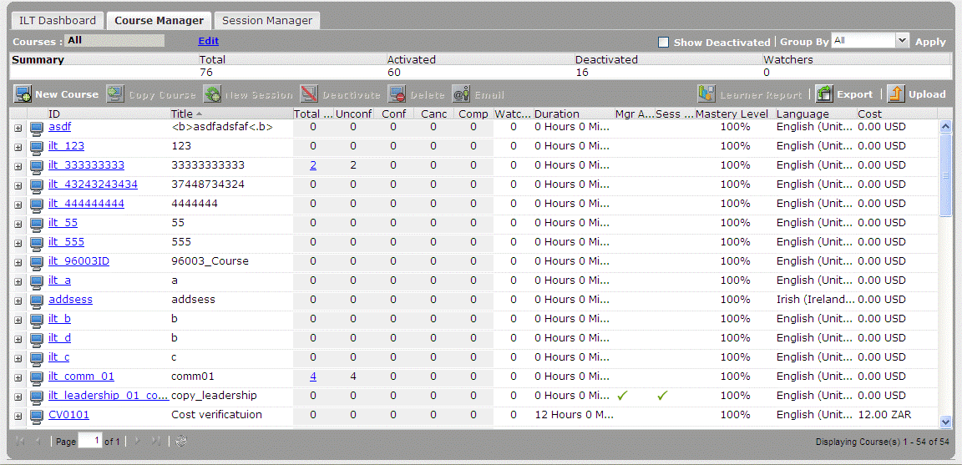
- Select the Show Deactivated check box.
- Click on the deactivated course to select it.
- Click Activate. This activates the course.

Delete a Course
Deleting a course removes all history and any results that have been posted in association with this course. By following this procedure, all course results can be deleted and the course is removed from the courses list. A course cannot be deleted if there are sessions associated with it.
Note: The option to delete a course on the Course Manager tab is only enabled if a course is selected in the list.
To delete a course
- View Courses.
- Click on a course to select it.
- Click Delete.
- Click OK.
Note: You can also delete a course by opening the course details and clicking the Delete button. For more information on viewing the course details refer to View Course Details.

Session Manager
ILT sessions display in the Upcoming Events section on the What's New page in Skillport Learner.
Once a session is created, and learners are entitled to the parent course, the session displays in the learner's Upcoming Events list on their What's New page in Skillport Learner. The Upcoming Events section displays all entitled sessions up to 12 months from the current date.

View Sessions
A session is a specific instance of a course, held in a facility, classroom, or virtually with an instructor and students.
The Session view displays the available sessions for all available courses.
To view sessions
- Log in to Skillport and navigate to the Admin area.
- Click Content > ILT > Course and Session Manager on the navigation bar.
- Click Session Manager. The available sessions display.
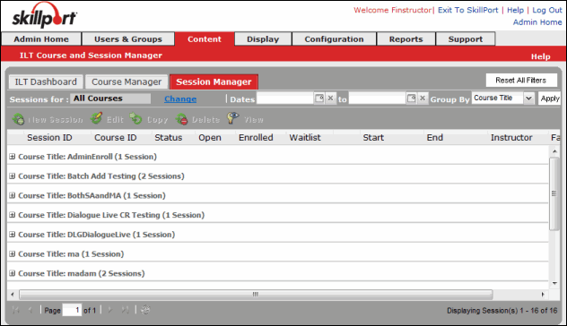
- Sort the session list by clicking the column headers to sort in ascending or descending order.
- Use the Group by field to group sessions. The sessions can be grouped by:
- Course ID
- Course Title
- Status
- Open
- Start Date
- Instructor
- Facility
- City
- Country
- Select the Date Range by selecting the start and end date.

View Session Details
The session details view displays the details of a selected session for an available course.
To view sessions
- View Sessions.
- Click the Session ID you wish to view.
The View Session window displays.
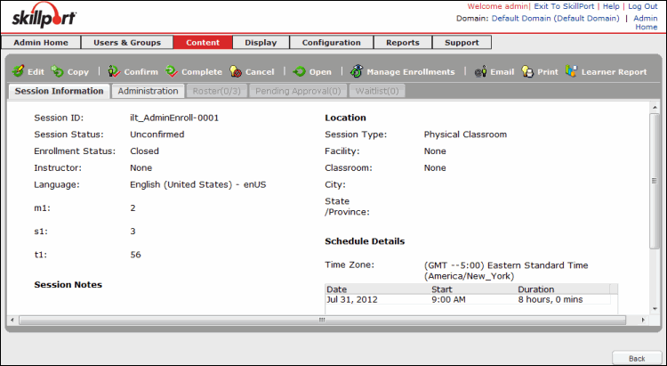

Create a New Session
Use this process to create and enter details of a new Instructor Led Training (ILT) session for a specific course.
Note: ILT Course records contain many attributes that are attributes of a course's sessions (such as cost, facility, classroom, and enrollment rules). These are set at the course level as defaults for convenience, representing the most common values that are set in sessions. When a new ILT session is created, those values from the parent course record are auto-populated into the new session record. All inherited values can be overridden at the session level.
To create a new session
- View Sessions.
- Click the course for which you wish to create a session.
- Click New Session.
The New Session window displays:
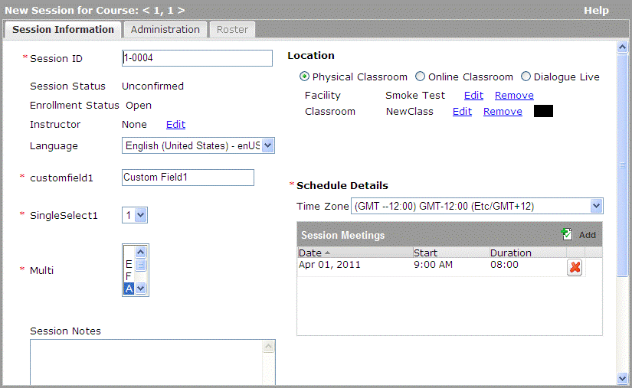
- Enter the following information:
- Session ID: This is auto generated from the course ID and the session sequence. You can modify the session ID.
- Language: Select the session language using the options in the drop-down.
- Location: Select a session location:
Physical Classroom: A physical facility, or a classroom within a selected facility, where the session is held.
Online Classroom: A virtual classroom where learners use a website to attend the session.
Dialogue Live: A virtual classroom where learners access Dialogue Live to attend the session.
- Session Notes: Notes to learners that display wherever the session is viewed.
- Schedule Details: Select a time zone from the drop-down.
Note: Facilities and classrooms are inherited from the course. Different locations can result in different facilities and classrooms. For information on editing a facility or classroom, see Add a Facility for a Course and Add a Classroom to a Course.
- Add Administration Details to a Session.
- Do one of the following:
- Click Save & Add Another to save the session and open another New Session window.
- Click Save & Exit to save the course and return to the Session Manager screen.
- Click Cancel to exit the window without saving your changes.
Note: Once a session is created, and learners are entitled to the parent course, the session displays in the learner's Upcoming Events list on their What's New page in Skillport Learner. The Upcoming Events section displays all entitled sessions up to 12 months from the current date.

Add Administration Details to a Session
Additional details regarding administration can be added to a session while creating a new session. This is part of the process of creating a new session. They can also be added later if need be.
To add administration details to a session
- View Sessions.
- Click the course for which you wish to create a session.
- Click New Session.
The New Session page displays.
- Click the Administration tab.
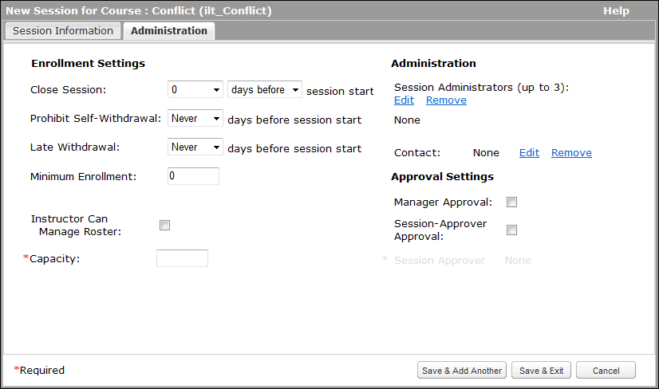
- Enter the Administration, Approval Settings and Enrollment Settings information.
- Session Administrators: Select up to three session administrators.
- Contact: Edit or remove an existing contact.
- Session Approval/Manager Approval: Enable or disable Session Approval or Manager Approval for the session.
- Session Approver: Select a contact to approve session enrollment requests. Enabled when Session Approval is selected.
- Instructor Can Manage Roster: When selected, the session Instructor can determine enrollments and withdrawals.
- Close Session: Determine the time frame when you wish to close the session using the options in the drop-down.
- Prohibit Self-Withdrawal: Allow or prohibit self-withdrawal from a session using the options in the drop-down.
- Late Withdrawal: Allow or prohibit late withdrawal using the options in the drop-down.
- Capacity*: (Required field) Enter the required capacity (number of students) in the session.
Note: The session capacity value determines when the session is full. Skillsoft recommends changing this value to your specific capacity.
- Minimum Enrollment: Enter a minimum number of enrollments.
- Low Enrollment Alert (not shown): If a session has low enrollment, select this to enable email alerts. Choose notification options using the drop-down.
- Click Save & Add Another to save the session and navigate to the New Session window. Click Save & Manage Roster to save the session and manage the roster. Alternatively, click Save & Exit to save the course and return to the Session Manager screen.

Confirm a Session
You can confirm a session as soon as you create it or when you have enough people enrolled in this session.
The confirmation process varies based on the policies and procedures of your company. The following are the ways the confirmation works:
- If you confirm as soon as you create a session, when an end user enrolls they only get one email with an Outlook calendar invite confirming their registration.
- If you confirm as soon as you create a session, and you do not get the minimum required, the course may be canceled and a notification sent.
- If you do not confirm the session until later, the end user will get one email indicating that they enrolled, and a second email with an Outlook calendar invite saying the session is confirmed after the session actually gets confirmed.
To confirm a session
- View Sessions.
- Click the Session ID you wish to confirm.
- Click Confirm.

Open/Close a Session to Enrollment

To open a session to enrollment
- View Sessions.
- Click the Session ID you wish to open for enrollment.
- Click Open.

To close a session to enrollment
- View Sessions.
- Click the Session ID you wish to close for enrollment.
- Click Close.

Edit a Session
You can edit the details of a session if any changes are required.
To edit a session
- View Sessions.
- Select the session you wish to edit.
- Click Edit. The Edit Session dialog box displays.
- Edit the session details. For more information on session details, refer to View Session Details.
Note: Enrollment Status and Session Status cannot be modified in the Edit Session window.
- Click Save.

Copy a Session
If you want to create multiple sessions with similar attributes, you can copy an existing session. This is a quick and efficient method for creating sessions. All the details and field settings are copied to the new session and you can edit fields as needed. The Session ID is auto generated with the sequence for the last session in the selected course. The Enrollment Status and Session Status are not inherited from the original session.
Note: To enable the copy button, you must select a session on the Session Manager grid.
To copy a session
- View Sessions.
- Click on a session to select it.
- Click Copy. The Copy Session dialog box displays.
Note: You can also copy a session by opening the session details and clicking Copy. For more information on viewing the session details refer to View Course Details. The Copy Session window replicates all the information found in the session. However, the button Save & Add Another Copy should display in place of Save & Add Another.

Cancel an ILT Session
When you cancel an ILT session, the following occurs:
- All enrolled learners with a valid email address receive an email notifying them that the session is cancelled.
- The cancellation email includes an iCalendar attachment to remove the session from the learner's calendar.
- The status of all enrolled learners changes from Enrolled to Withdrawn.
- The ILT course the session is associated with is placed in all enrolled students' ILT Watchlist to ensure they are notified of newly-scheduled sessions of the course.
- Record of the cancelled session remains in the ILT Event Journal.
Note: Session cancellations must be performed individually. Batch cancellations are not allowed.
To cancel an ILT session
- In Skillport Administrator, click Content > ILT > Course and Session Manager.
The Course and Session Manager displays.
- Click the Course Manager tab.
The Course Manager page displays.
- Click the name of the course containing the session you wish to cancel.
- Click the Sessions tab.
- Click the name of the session you wish to cancel.
The following message displays:
Cancelling the session will un-enroll all students, including those on the waiting list. You may later confirm this session will take place, but all students must re-enroll at that time.
Do you really want to cancel this session?
- Click OK to confirm the cancellation.

Delete a Session
You can delete a session if required. To be deleted, the session must have a status of Unconfirmed, Canceled, or Completed. The delete option is not available if the session has a status of Confirmed. To delete a confirmed session, you must cancel the session or mark the session as complete. Canceling the session will remove all learners from the roster, wait list and pending approval list and send a session cancelation notification to the learners.
Note: To enable the Delete button, you must select a session on the Session Manager grid.
Important: If you delete a session with a status of Unconfirmed before canceling the session, all learners will be removed from the roster, wait list and pending approval list, but they will not receive a notification that the session has been deleted. Therefore, it is strongly recommended that you first cancel the session before deleting it. All learners will then receive a session cancellation notification.
To delete a session
- View Sessions.
- Click the session you wish to delete.
The Delete button enables.
- Click Delete.
- When the confirmation message displays, click Yes.

Print a Session
This enables you to print the session details. This option creates a printable version of session information. An HTML version of the report opens in a new browser window and displays all the information on the session details page. You can print the report or save it to your computer.
To print a session
- View Sessions.
- Click on the session you require.
- Click Print. The print dialog box displays.
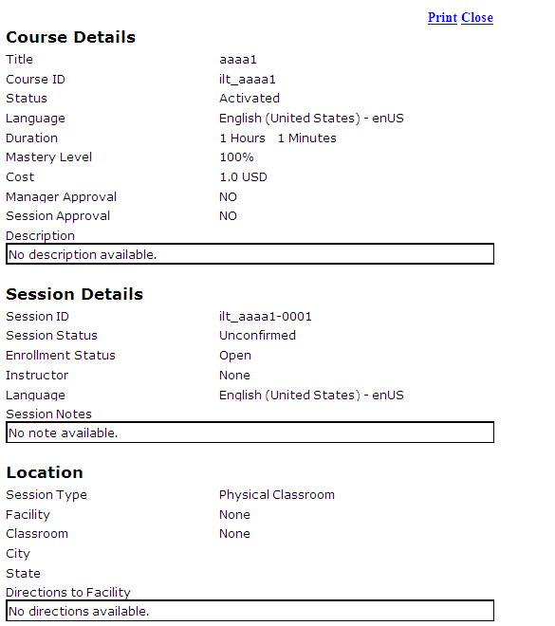
- Click Print to open your printer settings and print the session details.

Email Learners Enrolled in a Session
This enables you to email all enrolled and wait-listed learners. This option emails updates to learners whenever there is a change in the session status or to the schedule. Administrators can manually send messages to enrolled learners and instructors. Instructors can also manually send messages to learners on the roster, including wait-listed learners.
To email a learner
- View Sessions.
- Click on the session you require.
- Click Email. The email dialog box displays.
- Click the To and/or the Cc button to select specific users or groups from a list. Also you can add users to the Bcc list.
Note: To add a Bcc, you can select users from the Session Enrolled List, Session Wait List, Course Wait List and Course Watch List. Do this by selecting the checkbox next to their names and click Submit.
- Click Send to send the mail.

Export a Learner Report
You can generate a report that contains the student results for a selected course. You can then save a Comma Separated Value (CSV) version of the report and open it in other programs such as a spreadsheet or database application.
Note: The Learner Report includes data for both active and deactivated users. There may be a difference in the number of users displayed in this report and on the Roster tab, which only displays active users.

Note: The Learner Report option on the Course Manager tab is only enabled if a course is selected in the grid.
To export a learner report
- View Courses.
- Click the Course ID you wish to use to generate the Learner report.
- Click Learner Report.
- In the File Download prompt, Open or Save the report.
- The following information can be obtained from the resulting .csv document that you download:
- Session ID
- Course ID
- Course Name
- Student Login
- Last Name
- First Name
- Learner Status*
- Email
- Enrollment Date
- Passed
- Attended
- Mastered
- Instructor Login
- Instructor Last Name
- Instructor First Name
- Facility ID
- Facility Name
- Classroom ID
- Classroom Name
- Phone
- Alternate Phone
- Passcode
- URL
- Start
- Finish
- Notes
*Note: Learner Status does not always indicate whether or not the learner has completed the session. This value is related to the status of the ILT session. For instance, if an administrator marks a session as completed, the Learner Status for any users enrolled in the session will be marked as Completed, even if the user did not complete the session. If the session is unconfirmed, the enrolled learner's status will be marked as Pending Session.

ILT Email Notifications
The table below shows the events, triggers, and email recipients for the various ILT email notifications.
Note that the following notifications are sent with an iCal calendar update:
- Enrollment Withdrawal Notification
- Enrollment Request Approved by Administrator/Approver
- Instructor Change Notification
- Enrollment Status Change Notification
- Session Cancelled
- Session Updated

Event | Trigger | Notifications
Course Created | Any of the course attributes are updated:  - Title  - Language  - Active Status  - Description | To:  - Course Administrator(s)  Bcc:  - Watch List Learner  Optional:  - Course Interest List
Course Copied | Any of the course attributes are updated:  - Title  - Language  - Active Status  - Description | To:  - Course Administrator(s)  Bcc:  - Watch List Learner  Optional:  - Course Interest List
Course Deactivated/Removal | A course is deactivated or deleted. | To:  - Course Administrator(s)  Bcc:  - Watch List Learner  Optional:  - Course Interest List
Approval for Enrollment Request by Learner | Learner registers for a course which requires approval | To:  - Approval Manager  - Session Approver
Enrollment Request Approved by Administrator/Approver | Administrator or Approver approves a learner’s request for enrollment. | To:  - Approved Students
Enrollment Request Denied by Administrator/Approver | Administrator or Approver denies a learner’s request for enrollment. | To:  - Declined Learners
Enrollment Request Awaiting Approval | A specified number of days have passed after an enrollment request has been sent to the approver, but the approval has not been granted. | To:  - Approval Manager  - Session Approver Email  - Awaiting Approval Learner
Request for Enrollment Expired | An enrollment request has expired without approval, based on a pre-defined number of days. | To:  - Awaiting Approval Learner
Enrollment Request Approved by Administrator | Administrator, instead of the Approver, approves a learner’s enrollment request. | To:  - Approval Manager  - Session Approver
Enrollment Request Denied by Administrator | Administrator, instead of the Approver, denies a learner’s enrollment request. | To:  - Approval Manager  - Session Approver
Enrollment Status Change Notification | Enrollment status changes for a learner. | To:  - Learner
Enrollment Withdrawal Notification | Approver withdraws a learner from a session of a course. | To:  - Learner Email  Cc:  - Instructor Email  - Session Admin  Bcc:  - Approval Manager  - Session Approver Email
Ad Hoc Email to a Course Watch List | An Administrator with rights to the course’s Watch List members sends an ad hoc message to the group. | To:  - Course Owned By Email  Bcc:  - Watch List Learners
Course Activated | Course is activated. | To:  - Course Administrator(s)  Bcc:  - Watch List Learner
Course Updated | Any of the course attributes are updated:  - Title  - Language  - Active Status  - Description | To:  - Course Administrator(s)  Bcc:  - Watch List Learner  Optional:  - Course Interest List
Course Removal | A course is deactivated or deleted. | To:  - Course Administrator(s)  Bcc:  - Watch List Learners
Instructor Change Notification | An instructor for a session has changed. | To:  - Instructor(New)  - Instructor (Old)  Cc:  - Session Administrator(s)
Notify All Enrolled and Waitlisted Learners in a Session | The "Mail Learners" function is triggered in session view. | To:  - Instructor  - Session Administrator(s)
Session Created | A new session of a course is created. | To:  - Instructor;  - Session Administrator(s)  Bcc:  - Course Watch List Learners
Session Updated | Any of the following session details are updated:  - Facility  - Classroom  - Schedule  - Session Type | To:  - Instructor  - Session Administrator(s)  Bcc:  - Enrolled Learner
Session Deleted | A session of a course is deleted. | To:  - Instructor  - Session Administrator(s)
Session Cancelled | A session of a course is cancelled. | To:  - Instructor  - Session Administrator(s)  Bcc:  - Session Approver  - Approval Manager  - Learners
Session Closed | A session of a course is closed to additional enrollments. | To:  - Instructor;  - Session Administrator(s)  Bcc:  - Approvers/Managers for Pending Approval Learner  - Pending Approval Learner  - Waiting List Learner
Session Closed – Roster Listing | A session of a course is closed to additional enrollments. | To:  - Instructor  - Session Administrator(s)
Session Confirmed | A session of a course is confirmed. | To:  - Instructor  - Session Administrator(s)  Bcc:  - Pending Session Learner  - Approval Manager  - Session Approver
Session Enrollment Limit | Either:  - Enrollments for a session reach or cross a session’s maximum limit, or  - Enrollments for a session reach or cross a session’s threshold minimum limit. | To:  - Session Administrator(s)
Enrollment Request by Learner | In the case where both the Approval Manager and Session Approver must act, this email is sent when one approver has approved the request as a reminder to the remaining approver to act, too. | To:  - Approval Manager  - Session Approver
Session Seats Become Available – Watch List | - A session is at or over capacity, and  - One or more withdrawals occurs to take enrollment below capacity, and  - A session is closed to enrollments (also meaning there is no Wait List), and  - The Parent Course does have a Watch List | To:  - Watch List Learners
Session Re-opened for Enrollment | A course session which was previously closed has been re-opened for additional enrollments. | To:  - Session Admin(s)  - (parent) Course Admin(s)  - Session Instructor

Resources
ILT Resources include Facilities, Classrooms and Contacts. Resources can be added to your ILT site individually or by using the batch upload feature. Administrators can then assign a facility, classroom and contact to courses and sessions.

View Resources
You can create, modify, deactivate or delete a resource using the Resource Management page. The three resources available in ILT are:
- Facilities: Available training locations, such as conference centers or corporate buildings.
- Classrooms: Training rooms available within each facility.
- Contacts: External companies or individuals that an Administrator may want to associate with a facility, course or session. For example, a session is having lunch catered and the Administrator wants to include the catering company contact on the session. The administrator would add the catering contact information to ILT and then assign that contact to the session.
To view resources
- Log in to Skillport as an Administrator and navigate to the Admin area.
- Click Content > ILT > Resource Manager. The Resource Management page displays.
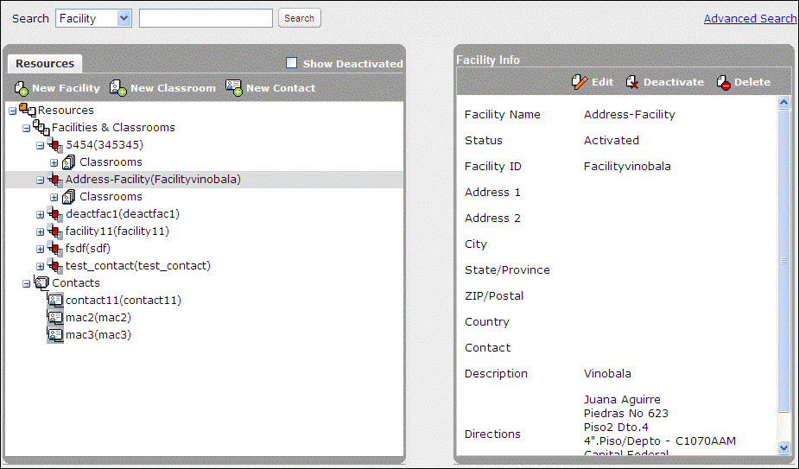
- Resources pane: Displays the list of available resources. Click the expand icon to display the required resource.
Note: You must expand a facility in order to view the list of classrooms available within that facility.
- Info pane: Displays information on the selected resource.

Search Resources
There are two methods of searching for resources i.e. basic search and advanced search.
To do a basic search for a resource
- Log in to Skillport as Administrator and navigate to the Admin area.
- Navigate to the Resource Management page.
- Select the resource type you want to search for by using the drop-down list provided.
- Facility
- Classroom
- Contact
- Enter the name of the resource you are searching for in the text field provided.
- Click Search. The results display in the Resource pane.

To do an advanced search for a resource
- Navigate to the Resource Management page
- Click Advanced Search on the top right hand corner of the page.
- Select the resource type you want to search for by using the drop-down list provided.
- Facility
- Classroom
- Contact
- You can enter details in the following fields for more specific results.
- Facility Name
- Facility ID
- City
- State/Province
- Country
Note: You can choose to include deactivated extended attributes in your results by selecting the Include Deactivated checkbox.
- Enter the name of the resource you are searching for in the text field provided.
- Click Search. The results display in the Resource pane.

Facilities

View Facility Information
To view facility information
- Log in to Skillport as Administrator and navigate to the Admin area.
- Click Content > ILT > Resource Manager. The Resource Management page displays.
- Browse or search for the required facility.
The details of the selected facility display in the Info pane.

Create a New Facility
To create a new facility
- Log in to Skillport and navigate to the Admin area.
- Navigate to the Resource Management page.
- Click New Facility in the Resources pane. The New Facility page appears.
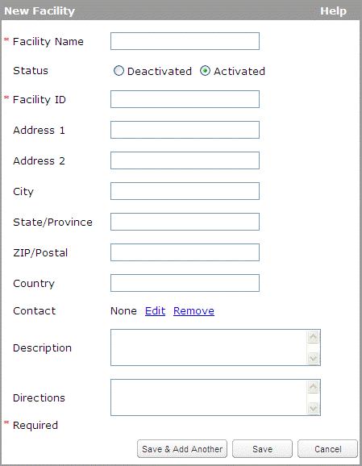
- Enter the required details.
- Click Save. If you want to create another facility, click Save & Add Another.

Edit a Facility
To edit a facility
- Log in to Skillport as Administrator and navigate to the Admin area.
- Navigate to the Resource Management page.
- Display the details of a required facility.
- Click Edit in the Info pane.
The Edit Facility page appears.
- Make the required changes and click Save.

Activate or Deactivate a Facility
You can activate or deactivate a facility by following the steps given below. Alternatively you can also switch to the 'Activated' or 'Deactivated' radio button while in the Edit Facility window and save your changes.
Note: Activating a facility does not activate classrooms attached to that facility. Classrooms have to be activated explicitly. Deactivating a facility results in deactivating all the classrooms.
To activate or deactivate a facility
- Log in to Skillport as Administrator and navigate to the Admin area.
- Navigate to the Resource Management page.
- Display the details of a required facility.
- Click Deactivate in the Info pane. The Resource pane will refresh and the deactivated facility does not display in the Resource pane.
Note: The deactivated facilities will only appear in the Resource pane, if the Show Deactivated check box is selected.
- Make the required changes and click Save.

Delete a Facility
This procedure will enable you to delete the facility permanently and remove it from the Resource pane.
Note: A facility can be deleted only if it is not associated to any course/sessions.
To delete a facility
- Log in to Skillport as Administrator and navigate to the Admin area.
- Navigate to the Resource Management page.
- Display the details of a required facility.
- Click the Delete button in the Info pane.
- Click OK to confirm the action.
The facility is deleted and does not display in the Resource pane.

Classrooms

View Classroom Information
Using the Info pane, you can modify the details of a classroom.
To view classroom information
- Log in to Skillport as Administrator and navigate to the Admin area.
- Navigate to the Resource Management page.
- Browse for the required classroom by expanding the facility to which the classroom is attached.
Note: You can alternatively use the Search utility to find the classroom directly.
- Expand the list of classrooms below the specific facility.
- Select the required classroom.
The details of the classrooms appear in the Info pane.

Create a New Classroom
To create a new classroom
- Log in to Skillport as Administrator and navigate to the Admin area.
- Navigate to the Resource Management page.
- Click New Classroom in the Resources pane. The New Classroom screen appears.
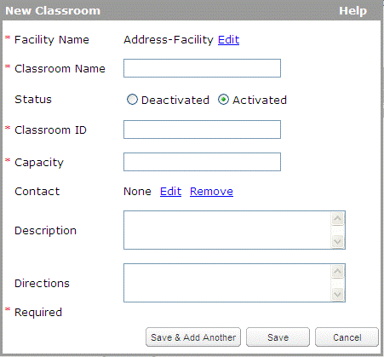
- Enter the required details.
Note: The Classroom ID is unique across Skillport. The Classroom Name must be unique within the facility.
- Click Save. If you want to create another classroom, click Save & Add Another.

Edit a Classroom
To edit a classroom
- Log in to Skillport as Administrator and navigate to the Admin area.
- Navigate to the Resource Management page.
- Display the details of a required classroom.
- Click Edit in the Info pane. The Edit Classroom page appears.
- Make the required changes and click Save.

Activate or Deactivate a Classroom
You can activate or deactivate a classroom by following the steps given below.
Note: Classrooms have to be activated explicitly. Activating a facility does not activate classrooms attached to that facility. Deactivating a facility results in deactivating all the classrooms.
To activate or deactivate a classroom
- Log in to Skillport as Administrator and navigate to the Admin area.
- Navigate to the Resource Management page.
- Display the details of a required classroom.
- Click Deactivate in the Info pane. The Resource pane will refresh and the deactivated classroom does not display in the Resource pane.
Note: The deactivated classrooms will only appear in the Resource pane, if the Show Deactivated check box is selected.
- Make the required changes and click Save.

Delete a Classroom
This procedure will enable you to delete the classroom permanently and remove it from the Resource pane.
Note: A classroom can be deleted only if it is not associated to any course/sessions.
To delete a classroom
- Log in to Skillport as Administrator and navigate to the Admin area.
- Navigate to the Resource Management page.
- Display the details of a required classroom.
- Click Delete button in the Info pane.
- Click OK for the confirmation message that appears.

Contacts
The contacts in the Resources section display external contact information (such as vendors or building owners). Within this view, you can create a hierarchy of contacts (for example, you can create a contact entry for a training vendor and then note all instructors associated with that vendor). You can sort contacts by Code, Name or Status. You can use the ILT Search bar to enter key words to narrow the results on the page.
Note: For your convenience, the ILT system maintains your contacts, but they are not used by Skillport in any way.

View Contact Information
Using the Info pane, you can modify the contact details of a particular owner of a facility. You can also use the Search bar to narrow the results on the page.
To view contact information
- Log in to Skillport as Administrator and navigate to the Admin area.
- Navigate to the Resource Management page.
- Browse or search for the required contact. The details of the selected contact appear in the Info pane.

Create a New Contact
To create a new contact
- Log in to Skillport as Administrator and navigate to the Admin area.
- Navigate to the Resource Management page.
- Click New Contact in the Resources pane. The New Contact page appears.
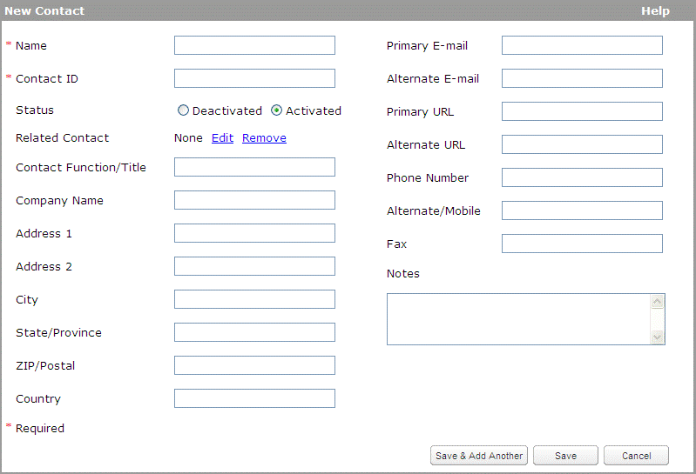
- Enter the required details.
Note: The Contact Name and Contact ID must be unique. If the contact person cannot be reached, the contact entered in the Related Contact field is the next point of contact to get the details about the courses, sessions, facilities and classrooms.
- Click Save. If you want to create another contact, click Save & Add Another.

Edit a Contact
To edit a contact
- Log in to Skillport as Administrator and navigate to the Admin area.
- Navigate to the Resource Management page.
- Display the details of a required contact.
- Click Edit in the Info pane. The Edit Contact page appears.
- Make the required changes and click Save.

Activate or Deactivate a Contact
You can activate or deactivate a contact by following the steps given below.
To activate or deactivate a contact
- Log in to Skillport as Administrator and navigate to the Admin area.
- Navigate to the Resource Management page.
- Display the details of a required contact.
- Click Deactivate in the Info pane. The Resource pane will refresh and the deactivated contact does not display in the Resource pane.
Note: The deactivated contacts will only appear in the Resource pane, if the Show Deactivated check box is selected.
- Make the required changes and click Save.

Delete a Contact
This procedure will enable you to delete the classroom permanently and remove it from the Resource pane.
Note: A contact can be deleted only if it is not associated to any course, session, facility, classroom or contact.
To delete a contact
- Log in to Skillport as Administrator and navigate to the Admin area.
- Navigate to the Resource Management page.
- Display the details of a required contact.
- Click Delete in the Info pane.
- Click OK for the confirmation message that appears.
The contact is deleted and does not display in the Resource pane.

Upload ILT Content
You can use the Batch Add view to bulk-upload contacts, facilities, classrooms, courses, sessions and enrollments. Use it to upload data from another system, spreadsheet, or data from a third party (such as an external session vendor).

Upload a Batch of ILT Content
To upload ILT content
- Click Content > ILT > Batch Add.
The upload screen displays.
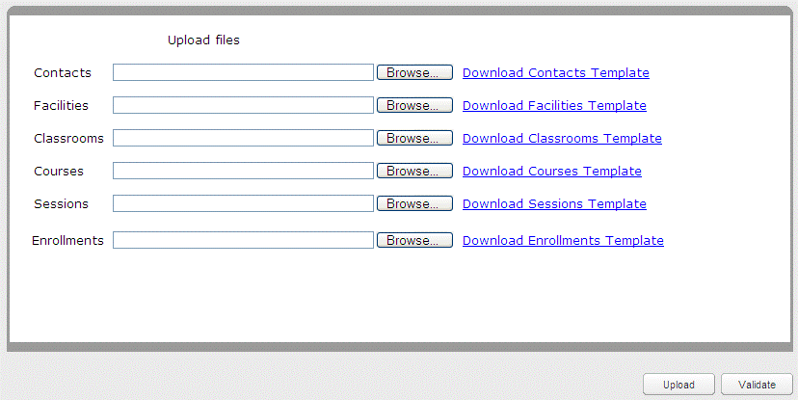
Note: If there is more than 1 file to be uploaded at the same time, the order the uploads are processed follows how they are ordered on the screen.
- Download the correct .csv file for the type of data you wish to upload. For details about each template, see:
- Contacts Template
- Facilities Template
- Classrooms Template
- Courses Template
- Sessions Template
- Enrollments Template
- Once you've completed the .csv file, click Browse next to the file type that you want to upload.
The Choose File window displays.
- Navigate to the .csv file you want to upload.
- Click the .csv file to select it.
- Click Open.
The path to your .csv file displays in the field.
- Repeat these steps for each file type you want to upload.
- Click Validate to validate the .csv file(s).
- Click Upload.
The upload process begins. If you have a valid email address, an email is sent containing the URL of a status report and the date and time of the batch submission.

Contacts Template
Use the Contacts Template to upload contact records quickly and easily. The table below shows the correct data format for each field in the template.
Field Name | Format
Name | Field is required. Field value must be unique. Field must be less than or equal to 80 characters.
Status | The field is required. The field must be one of 0 or 1 where 0 is Deactivated and 1 is Activated.
Contact ID | Field is required. Field value must be unique. Field must not contain any leading or trailing spaces. Field must be less than or equal to 25 characters.
Contact Function/Title | Field is optional. Field must be less than or equal to 80 characters.
Related Contact ID | Field is optional. Field must match an existing contact or one in the contact upload file.
Company Name | Field is optional. Field must be less than or equal to 80 characters.
Primary E-mail | Field is optional. Field must be a valid email address. Field must be less than or equal to 80 characters.
Alternate E-mail | Field is optional. Field must be a valid email address. Field must be less than or equal to 80 characters.
Primary URL | Field is optional. Field must be a legal URL. Field must be less than or equal to 80 characters.
Alternate URL | Field is optional. Field must be a legal URL. Field must be less than or equal to 80 characters.
Phone Number | Field is optional. Field must be a legal phone number. Field must be less than or equal to 50 characters.
Alternate/Mobile | Field is optional. Field must be a legal phone number. Field must be less than or equal to 50 characters.
Fax | Field is optional. Field must be a legal fax number. Field must be less than or equal to 50 characters.
Address 1 | Field is optional. Field must be less than or equal to 80 characters.
Address 2 | Field is optional. Field must be less than or equal to 80 characters.
City | Field is optional. Field must be less than or equal to 50 characters.
State/Province | Field is optional. Field must be less than or equal to 25 characters.
ZIP/Postal | Field is optional. Field must be a valid zip code. Field must be less than or equal to 25 characters.
Country | Field is optional. Field must be less than or equal to 50 characters.
Notes | Field is optional. Field must be less than or equal to 2500 characters.

Facilities Template
Use the Facilities Template to upload facility records quickly and easily. The table below shows the correct data format for each field in the template.
Field Name | Format
Facility Name | Field is required. Field value must be unique. Field must be less than or equal to 80 characters.
Status | Field is required. Field must be one of 0 or 1.
Facility ID | Field is required. Field value must be unique. Field must be less than or equal to 20 characters.
Address 1 | Field is optional. Field must be less than or equal to 80 characters.
Address 2 | Field is optional. Field must be less than or equal to 80 characters.
City | Field is optional. Field must be less than or equal to 50 characters.
State/Province | Field is optional. Field must be less than or equal to 50 characters.
ZIP/Postal | Field is optional. Field must be less than or equal to 25 characters.
Country | Field is optional. Field must be less than or equal to 50 characters.
Contact Name | Field is optional. Field must match an existing contact.
Description | Field is optional. Field must be less than or equal to 2500 characters.
Directions | Field is optional. Field must be less than or equal to 2500 characters.

Classrooms Template
Use the Classrooms Template to upload classroom records quickly and easily. The table below shows the correct data format for each field in the template.
Field Name | Format
Facility ID | Field is required. Field must match an existing facility.
Classroom Name | Field is required. Field value must be unique. Field must be less than or equal to 80 characters.
Status | Field is required. Field must be one of 0 or 1.
Classroom ID | Field is required. Field value must be unique. Field must not contain leading or trailing spaces. Field must be less than or equal to 20 characters.
Capacity | Field is required. Field must be in the range 0-99999.
Contact Name | Field is optional. Field must match an existing contact.
Description | Field is optional. Field must be less than or equal to 2500 characters.
Directions | Field is optional. Field must be less than or equal to 1000 characters.

Courses Template
Use the Courses Template to upload course records quickly and easily. The table below shows the correct data format for each field in the template.
Field Name | Format
Course Title | Field is required. Field must be less than or equal to 255 characters.
Course ID | Field is required. Field must contain only alphanumeric characters or the '_' character and begin with ilt_.  Field must be less than or equal to 40 characters, and spaces are not allowed.
Status | Field is required. Field must be one of 0 or 1.  0 - deactivated  1 - activated
Spoken Language | Field is required. Field must be a valid spoken content code (for example, enUS).  This sets the spoken language of the course (for example, the language spoken by the instructor or the learners).
Content Language | Field is required. Field must be a valid content language code (for example, en-us).  This setting determines where the ILT course displays when a user searches or browses within a selected language. Select und to ensure it displays in all searches regardless of a learner's selected content language, or select a language to include it only when a learner searches within that language.  Example: An admin, Joe, creates an ILT course about leadership and sets the content language to es (Spanish). A learner, Kim, searches for an ILT course about leadership, but her content language in Skillport Learner is set to English (United States). Kim won't see the ILT course because it isn't marked as en-us (English (United States)). If Joe sets the content language to und (Not Specified), Kim would be able to see the ILT course regardless of her set content language.
Duration | Field is optional. Field must be positive integer in the range 0-99999.
Mastery Level | Field is required. Field must be in the range 0-100.
Cost | Field is optional. Field must be a valid amount format according to currency specified and server locale.
Currency | Field is required. Field must be a valid code.
Manager Approval Required | Field is required. Field must be one of 0 or 1.  - 0 - no  - 1 - yes
Session Approval Required | Field is required. Field must be one of 0 or 1.  - 0 - no  - 1 - yes
Course Description | Field is optional. Field must be less than or equal to 3500 characters.
Course Administrator 1 User Name | Field is optional. Field must match an existing course administrator.
Course Administrator 2 User Name | Field is optional. Field must match an existing course administrator.
Course Administrator 3 User Name | Field is optional. Field must match an existing course administrator.
Session Approver User Name | Field is required if Session Approval Required has value 1. Field must match an existing session approver.
Contact Name | Field is optional. Field must match an existing contact or one in the contact upload file.
Instructor Can Manage Roster | Field is required. Field must be one of 0 or 1.  - 0 - no  - 1 - yes
Facility ID | Field is optional. Field must match an existing facility or one in the facility upload file.
Classroom ID | Field is optional. Field must match an existing classroom or one in the classroom upload file.
Close Session (days before/after session start) | Field is optional. Field must be in range {-90 -60 -45 (-30.0 to 30.0) 45 60 90}.
Prohibit Self-Withdrawal (days before session start) | Field is optional and can be one of the following:  - leave blank (renders a value of Never)  - always  - a number from 1 to 31
Late Withdrawal (days before session start) | Field is optional and can be one of the following:  - leave blank (renders a value of Never)  - a number from 1 to 31
Minimum Enrollment | Field is optional. Field must be in range 0-99999.
Low Enrollment Alert (days before session start) | Field is optional. Field must be (never) or from 0 to 31.
san1 | Field is required. Field must match an existing item in the extended attribute list.
san2 | Field is required. Field must be less than or equal to 250 characters.
san3 | Field is required. Field must match an existing item in the extended attribute list.
2 | Field is optional. Field must match an existing item in the extended attribute list.

Currency Codes for the ILT Course Batch Add CSV File
Use the table below to determine the correct currency abbreviation that corresponds to your country.
Currency Code | Country | Currency Type
AED | United Arab Emirates | Dirhams
ALL | Albania | Leke
ARM | Armenia | Dram
ARS | Argentina | Pesos
AUD | Australia | Dollars
BAM | Bosnia, Herzegovina | Convertible Marka
BGN | Bulgaria | Leva
BHD | Bahrain | Dinars
BOB | Bolivia | Bolivianos
BRL | Brazil | Brazil Real
BYR | Belarus | Rubles
CAD | Canada | Dollars
CHF | Switzerland | Francs
CLP | Chile | Pesos
CNY | China | Yuan Renminbi
COP | Colombia | Pesos
CRC | Costa Rica | Colones
CSD | Serbia | Dinars
CZK | Czech Republic | Koruny
DKK | Denmark | Kroner
DOP | Dominican Republic | Pesos
DZD | Algeria | Algeria Dinars
EEK | Estonia | Krooni
EGP | Egypt | Pounds
EUR | Euro Member Countries | Euro
GBP | United Kingdom | Pounds
GTQ | Guatemala | Quetzales
HKD | Hong Kong | Dollars
HNL | Honduras | Lempiras
HRK | Croatia | Kuna
HUF | Hungary | Forint
ILS | Israel | New Shekels
INR | India | Rupees
IQD | Iraq | Dinars
ISK | Iceland | Kronur
JOD | Jordan | Dinars
JPY | Japan | Yen
KES | Kenya | Shilling
KRW | Korea (South) | Won
KWD | Kuwait | Dinars
LBP | Lebanon | Pounds
LTL | Lithuania | Litai
LVL | Latvia | Lati
LYD | Libya | Dinars
MAD | Morocco | Dirhams
MDL | Moldova | Leu
MGA | Madagascar | Ariary
MGF | Madagascar | Franc
MKD | Macedonia | Denars
MUR | Mauritius | Rupee
MXN | Mexico | Pesos
MYR | Malaysia | Ringgit
NGN | Nigeria | Naira
NIO | Nicaragua | Cordobas
NOK | Norway | Krone
NZD | New Zealand | Dollars
OMR | Oman | Rials
PAB | Panama | Balboa
PEN | Peru | Nuevos Soles
PHP | Philippines | Pesos
PLN | Poland | Zlotych
PYG | Paraguay | Guarani
QAR | Qatar | Rials
RON | Romania | New Lei
RSD | Serbia | Dinars
RUB | Russia | Rubles
SAR | Saudi Arabia | Riyals
SDG | Sudan | Pounds
SEK | Sweden | Kronor
SGD | Singapore | Dollars
SKK | Slovakia | Koruna
SVC | El Salvador | Colones
SYP | Siyria | Pounds
THB | Thailand | Baht
TND | Tunisia | Dinars
TRY | Turkey | New Lira
TWD | Taiwan | New Dollars
UAH | Ukraine | Hryvnia
UGX | Uganda | Shilling
USD | United States of America | Dollars
UYU | Uruguay | Pesos
VEF | Venezuela | Bolivares Fuertes
VND | Viet Nam | Dong
XAF | Communauté Financière Africaine (BEAC) CFA | Francs
XOF | Communauté Financière Africaine (BCEAO) | Francs
XPF | Comptoirs Français du Pacifique (CFP) | Francs
YER | Yemen | Rials
ZAR | South Africa | Rand

Content Language Codes for the ILT Courses Template
The content language setting determines where the ILT course displays when a user searches or browses within a selected language. Use und (Not Specified) to ensure it displays in all searches regardless of a learner's selected content language, or select a language to include it only when a learner searches within that language.
For example:
An admin, Joe, creates an ILT course about leadership and sets the content language to es (Spanish). A learner, Kim, searches for an ILT course about leadership, but her content language in Skillport Learner is set to English (United States). Kim won't see the ILT course because it isn't marked as en-us (English (United States)). If Joe sets the content language to und (Not Specified), Kim would be able to see the ILT course regardless of her set content language.
Use the table below to determine the correct content language code for your ILT course.
Note: These codes are not case-sensitive.
Language | Code
Not Specified | und
Arabic | ar
Chinese | zh
Czech | cs
Danish | da
Dutch | nl
English (India) | en-in
English (United Kingdom) | en-gb
English (United States) | en-us
Finnish | fi
French | fr
German | de
Greek | el
Hebrew | he
Hindi | hi
Hungarian | hu
Indonesian | id
Italian | it
Japanese | ja
Korean | ko
Norwegian | no
Norwegian Bokmål | nb
Norwegian Nynorsk | nn
Polish | pl
Portuguese (Brazil) | pt-br
Russian | ru
Spanish | es
Swedish | sv
Thai | th
Turkish | tr

Spoken Language Codes for the ILT Courses Template
The spoken language setting is used to indicate the language spoken by the instructor or the learners. Use the table below to determine the correct spoken language code for your ILT course.
Note: These codes are case-sensitive.
Language | Code
Albanian | sq
Albanian (Albania) | sqAL
Arabic | ar
Arabic (Algeria) | arDZ
Arabic (Bahrain) | arBH
Arabic (Egypt) | arEG
Arabic (Iraq) | arIQ
Arabic (Jordan) | arJO
Arabic (Kuwait) | arKW
Arabic (Lebanon) | arLB
Arabic (Libya) | arLY
Arabic (Morocco) | arMA
Arabic (Oman) | arOM
Arabic (Qatar) | arQA
Arabic (Saudi Arabia) | arSA
Arabic (Sudan) | arSD
Arabic (Syria) | arSY
Arabic (Tunisia) | arTN
Arabic (United Arab Emirates) | arAE
Arabic (Yemen) | arYE
Belarusian | be
Belarusian (Belarus) | beBY
Bulgarian | bg
Bulgarian (Bulgaria) | bgBG
Catalan | ca
Catalan (Spain) | caES
Chinese | zh
Chinese (China) | zhCN
Chinese (Hong Kong) | zhHK
Chinese (Singapore) | zhSG
Chinese (Taiwan) | zhTW
Croatian | hr
Croatian (Croatia) | hrHR
Czech | cs
Czech (Czech Republic) | csCZ
Danish | de
Danish (Denmark) | daDK
Dutch | nl
Dutch (Belgium) | nlBE
Dutch (Netherlands) | nlNL
English | en
English (Australia) | enAU
English (Canada) | enCA
English (India) | enIN
English (Ireland) | enIE
English (Malta) | enMT
English (New Zealand) | enNZ
English (Philippines) | enPH
English (Singapore) | enSG
English (South Africa) | enZA
English (United Kingdom) | enGB
English (United States) | enUS
Estonian | et
Estonian (Estonia) | etEE
Finnish | fi
Finnish (Finland) | fiFI
French | fr
French (Belgium) | frBE
French (Canada) | frCA
French (France) | frFR
French (Luxembourg) | frLU
French (Switzerland) | frCH
Greek | el
Greek (Cyprus) | elCY
Greek (Greece) | elGR
Hebrew | iw
Hebrew (Israel) | iwIL
Hindi (India) | hiIN
Hungarian | hu
Hungarian (Hungary) | huHU
Icelandic | is
Icelandic (Iceland) | isIS
Indonesian | in
Indonesian (Indonesia) | inID
Irish | ga
Irish (Ireland) | gaIE
Italian | it
Italian (Italy) | itIT
Italian (Switzerland) | itCH
Japanese | ja
Japanese (Japan) | jaJP
Korean | ko
Korean (South Korea) | koKR
Latvian | lv
Latvian (Latvia) | lvLV
Lithuanian | lt
Lithuanian (Lithuania) | ltLT
Macedonian | mk
Macedonian (Macedonia) | mkMK
Malay | ms
Malay (Malaysia) | msMY
Maltese | mt
Maltese (Malta) | mtMT
Norwegian | no
Norwegian (Norway,Nynorsk) | noNO
Polish | pl
Polish (Poland) | plPL
Portuguese | pt
Portuguese (Brazil) | ptBR
Portuguese (Portugal) | ptPT
Romanian | ro
Romanian (Romania) | roRO
Russian | ru
Russian (Russia) | ruRU
Serbian | sr
Serbian (Bosnia and Herzegovina) | srB
Serbian (Montenegro) | srME
Serbian (Serbia and Montenegro) | srCS
Serbian (Serbia) | srRS
Slovak | sk
Slovak (Slovakia) | skSK
Slovenian | sl
Slovenian (Slovenia) | slSI
Spanish (Argentina) | es
Spanish (Bolivia) | esBO
Spanish (Chile) | esCL
Spanish (Colombia) | esCO
Spanish (Costa Rica) | esCR
Spanish (Dominican Republic) | esDO
Spanish (Ecuador) | esEC
El Salvador) | esSV
Spanish (Guatemala) | esGT
Spanish (Honduras) | esHN
Spanish (Mexico) | esMX
Spanish (Nicaragua) | esNI
Spanish (Panama) | esPA
Spanish (Paraguay) | esPY
Spanish (Peru) | esPE
Spanish (Puerto Rico) | esPR
Spanish (Spain) | esES
Spanish (United States) | esUS
Spanish (Uruguay) | esUY
Spanish (Venezuela) | esVE
Swedish | sv
Swedish (Sweden) | svSE
Thai | th
Thai (Thailand) | thTH
Turkish | TR
Turkish (Turkey) | trTR
Ukrainian | uk
Ukrainian (Ukraine) | ukUA
Vietnamese | vi
Vietnamese (Vietnam) | viVN

Sessions Template
Use the Sessions Template to upload session records quickly and easily. The table below shows the correct data format for each field in the template.
Field Name | Format
Session ID | Field is required. Field must be less than or equal to 50 characters.
Status | Field is required. Field must be one of the following:  - Unconfirmed  - Confirmed  - Completed  - Canceled
Facility ID | Field is optional. Field must match an existing facility.
Classroom ID | Field is optional. Field must match an existing classroom or one in the classroom upload file.
Course ID | Field is required. Field must match an existing course or one in the course upload file.
Capacity | Field is required. Field must be in the range 0-99999.
Instructor User Name | Field is optional. Field must match an existing instructor.
Time Zone | Field is required. Field must be a legal time zone (for example, America/New_York).
Contact ID | Field is optional. Field must match an existing contact.
Notes | Field is optional. Field must be less than or equal to 2500 characters.
Schedule Time | Field is required if Status is Confirmed. Field must be of the format mm/dd/yyyy hh:mm (for example, 10/12/1972 13:54).
Duration | Field is required if Status is Confirmed. Field must be a valid float in range 0.0-24.0.
Session Administrator 1 User Name | Field is optional. Field must match an existing session administrator.
Session Administrator 2 User Name | Field is optional. Field must match an existing session administrator.
Session Administrator 3 User Name | Field is optional. Field must match an existing session administrator.
Manager Approval Required | Field is required. Field must be either 0 or 1.  - 0 - Not required  - 1 - Required
Session Approval Required | Field is required. Field must be either 0 or 1.  - 0 - Not required  - 1 - Required
Session Approver User Name | Field is required if Session Approval Required has value 1. Field must match an existing session approver.
Instructor Can Manage Roster | Field is required. Field must be either 0 or 1.  - 0 - Not required  - 1 - Required
Type | Field is optional. Field must be :  - 0 for Physical Classroom, or  - 1 for Dialogue Live, or  - 2 for Other
Phone | Field is optional. Field must be less than or equal to 50 characters.
Alt Phone | Field is optional. Field must be less than or equal to 50 characters.
Passcode | Field is optional. Field must be less than or equal to 20 characters.
URL | Field is optional. Field must be less than or equal to 255 characters.
Open to Enrollment | Field is required. Field must be either 0 or 1.  - 0 - closed to enrollment  - 1 - open to enrollment
Close Session (days before/after session start) | Field is optional. Field must be in range {-90 -60 -45 (-30.0 to 30.0) 45 60 90}.
Prohibit Self-Withdrawal (days before session start) | Field is optional and can be one of the following:  - leave blank (renders a value of Never)  - always  - a number from 1 to 31
Late Withdrawal (days before session start) | Field is optional and can be one of the following:  - leave blank (renders a value of Never)  - a number from 1 to 31
Minimum Enrollment | Field is optional. Field must be in range 0-99999.
Low Enrollment Alert (days before session start) | Field is optional. Field must be (never) or from 0 to 31.
san1 | Field is required. Field must match an existing item in the extended attribute list.
san2 | Field is required. Field must be less than or equal to 250 characters.
san3 | Field is required. Field must match an existing item in the extended attribute list.
2 | Field is optional. Field must match an existing item in the extended attribute list.

Enrollments Template
Use the Enrollments Template to upload registrations quickly and easily. The table below shows the correct data format for each field in the template.
Field Name | Format
Session ID | Field is required. Field must match an existing session ID.
Student Login | Field is required. Field must be a Skillport login id.
Send Notification | Field is required. Field must be one of 0 or 1 where 0 is not send and 1 is send.

ILT Event Journals
Use the Event Journals view to run journals (reports) on various ILT functions, such as enrollments, approval decisions, sessions, and courses.
Note: When an ILT Administrator changes a session schedule after the session has been set to Completed, Skillport reporting and ILT Event Journals do not reflect this change. Only the data as recorded in the database at the time the session is marked as complete is reflected; additional changes do not render.
To view and generate event journals
- Click Reports > ILT Event Journals.
The ILT Event Journal page displays:
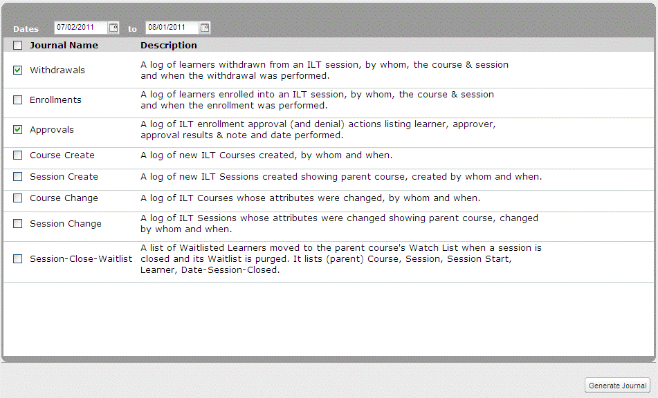
- Select the journals you wish to view using the checkboxes available.
- Withdrawals: A log of learners withdrawn from an ILT session, by whom, the course and session and when the withdrawal was performed. Withdrawal data includes Withdrawn For, Withdrawn By, Title, Session ID, Withdrawal Date and Withdrawal Time.
- Enrollments: A log of learners enrolled into an ILT session, by whom, the course and session and when the enrollment was performed. Enrollment data includes Learner Name, Enrolled By, Title, Session ID, Enrollment Date and Enrollment Time
- Approvals: A log of ILT enrollment approval (and denial) actions listing learner, approver, approval results and notes and date performed. This report lists the Learner, Approver, Approval Results, Notes, Date and Time.
- Course Create: A log of new ILT Courses created, by whom and when. Course Create data includes Course Created By, Course ID, Title, Date and Time.
- Session Create: A log of new ILT Sessions created showing parent course, created by whom and when. Session Create data includes Session Created By, Session ID, Title, Date and Time.
- Course Change: A log of ILT Courses whose attributes were changed, by whom and when. Course Change data includes Course Changed By, Course ID, Title, Attribute Changed, Date and Time.
- Session Change: A log of ILT Sessions whose attributes were changed showing parent course, changed by whom and when. Session Change data includes Session Changed By, Session ID, Title, Attribute Changed, Date and Time.
- Session-Close-Waitlist: A list of Waitlisted Learners moved to the parent course's Watch List when a session is closed and its Waitlist is purged. It lists Title, Session ID, Session Start Date, Session Start Time, Wait List Learner, Session Close Date and Session Close Time.
- Click Generate Journal to download the specified journals. A .zip file downloads.
- Extract the contents of the .zip file.
- Open the .csv file(s) to view the contents of each journal.
Note: The .csv file(s) can be opened in spreadsheet programs (such as Microsoft Excel).

Chapter 2

ILT for Instructors
As an instructor, you can manage most of the ILT sessions details you deliver and also manage the session roster.

In This Chapter
Sessions I am Teaching 75
Manage Enrollments 77
View Attendance 80
Entering Results 80
Quiz Results 81

Sessions I am Teaching
As an instructor, you can manage many of the details related to the ILT sessions you deliver. You can view a list of sessions you are teaching, including session number, status, type, catalog number and title, and also manage the session roster.
To view the session information
- Log in to Skillport as an Instructor and navigate to the Admin area.
- Click Content > ILT > Sessions I Am Teaching. The Sessions I Am Teaching page displays:
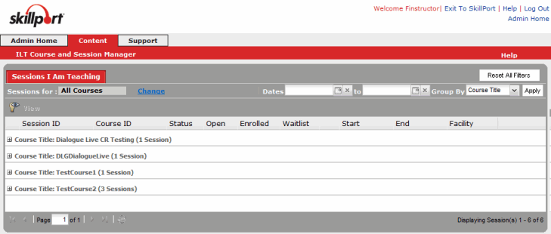
- Select the session you want to view. The session details display.
- Click Cancel to return to Skillport.
You can click a session ID to view session details on your upcoming sessions, edit session information, and, once completed, input student progress results.
When you are assigned a session to teach, you will receive an email notification with the session details, or if a session you are teaching is canceled, you will receive an email notification of the cancelation.

Manage Enrollments

Enroll Learners in a Session
An Instructor has to be assigned to the specific session in order to enroll learners into a session.
To enroll learners manually in a session
- Click Content > ILT > Course and Session Manager.
- Click the Session Manager tab.
- Click the Session ID you wish to view.
The View Session window displays.
- Click Manage Enrollments.
The following screen displays:
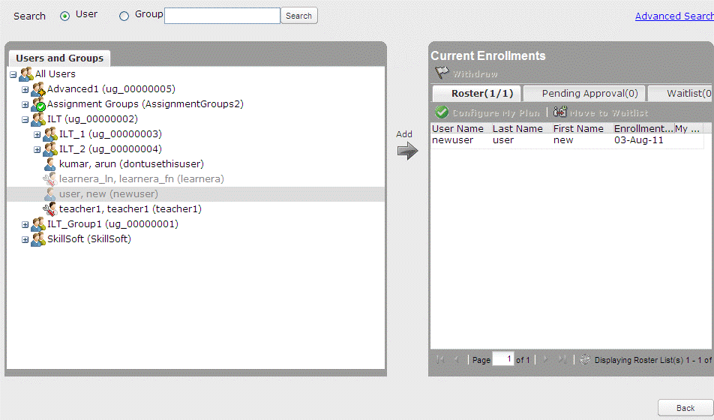
- Find the user or group you wish to assign to the session by using the search or find the user name or group name on the list.
The Search Bar is available on top of the screen, allowing you to search for a user or group in basic and advanced modes. The Search fields in Advanced mode for users are:
- Group
- Email
- User Name
- Last Name
- First Name
- City
- State
- Include Ineligible to Enroll
The Search fields in Advanced mode for groups are:
- Group Name
- Org Code
The Users and Groups pane refreshes to show the search results.
- Once you have found the user or group that you require, select it and click Add to add to the current enrollments.
The user or group will be added to the Roster of that session.

Withdraw Learners from a Session
The following are the procedures followed to withdraw a learner from a session.
To withdraw learners manually when managing enrollments
- Click Content > ILT > Course and Session Manager.
- Click the Session Manager tab.
- Click the Session ID you wish to view.
The View Session window displays.
- Click Manage Enrollments.
- Click the name of the learner in the roster found in the right hand window pane that you want to withdraw.
- Click Withdraw.
- The learner is withdrawn from the session.
To withdraw learners directly from the roster
- Click Content > ILT > Course and Session Manager.
- Click the Session Manager tab.
- Click the Session ID you want to view.
The View Session window displays.
- Click the Roster tab.
The list of learners enrolled in the session displays.
- Click the Withdraw learner button next to the learner you want to withdraw.
- Click Yes in the confirmation message that displays.
- The learner is removed from the roster of the session.

Moving Learners to the Waitlist
The following is the procedure followed to move a learner to the waitlist.
To move a learner to the waitlist
- Click Content > ILT > Course and Session Manager.
- Click the Session Manager tab.
- Click the Session ID you wish to view.
The View Session window displays.
- Click Manage Enrollments.
The following screen displays:
- Click the name of the learner in the roster and click Move to Waitlist.

View Attendance
To view attendance of Learners in a session
- Click Content > ILT > Course and Session Manager.
- Click the Session Manager tab.
- Click the Session ID you wish to view.
The View Session window displays.
- Click the Roster tab.
The list of learners enrolled in the session appears.
- Click Attendance Sheet.
The attendance sheet opens in a new window. This sheet contains the following details:
- Instructor: Name of the Instructor.
- Session ID: ID of the session that the Learner has enrolled for.
- Course ID: ID of the course which contains the session.
- Title: Title of the session.
- Facility: Facility which the session is conducted in.
- Classroom: Classroom which the session is conducted in.
- Start: Date and time that the session starts.
- End: Date and time that the session ends.
- Name: Name of the Learner.
- User Name: User name of the Learner
- Email: Email address of the Learner
- Student Signature: Space for signature of the student.
- Click Print to print out the attendance sheet, or click Close to close the window.

Entering Results
When the scheduled session is complete, you can enter results for enrolled learners.
An ILT Course is considered a Completion for a learner when both of the following conditions are met:
- the learner's session record has a Passed value of Yes, AND
- the session has been marked as Completed
A learner’s Actual Duration gets its value from the parent ILT Course record’s Duration value. The Actual Duration value is populated when the learner has completed an ILT Session for that ILT Course.
Note: The results can only be modified after the session is marked complete. A Learner's results appear in a Learner's My Report.
To enter results for a Learner in a session
- Click Content > ILT > Sessions I am Teaching.
- Click the Session ID you wish to view.
The View Session window displays.
- Click the Roster tab.
The list of learners enrolled in the session displays.
- Click the Enter Results button.
The following screen displays.
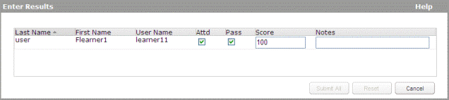
- Click the relevant check boxes and enter details for the following fields:
- Attd (Attended)
- Pass
- Score
- Notes
- Click Submit All to save the changes and enter the results. Reset clears all changes made.

Quiz Results
The quiz results can be viewed in this section. The average score can be imported and the quiz results can be exported from this page.
To view quiz results for a Learner in a session
- Click Content > ILT > Course and Session Manager.
- Click the Session Manager tab.
- Click the Session ID you wish to view.
The View Session window displays.
- Click the Roster tab.
The list of Learners enrolled in the session displays.
- Click the Quiz Results button. The following screen displays.
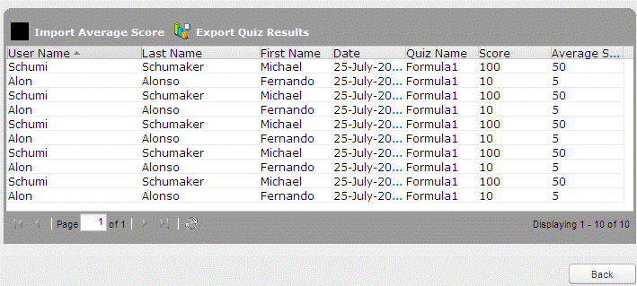

Chapter 3

ILT Configuration
In This Chapter
ILT Workflow 83
Extended Attributes 84
ILT Site Settings 88

ILT Workflow
Workflow for ILT Admin
- Configure ILT Site Settings. This enables you to customize ILT default values and actions to meet your organization's needs.
- Configure Email Templates. You can determine whether each template is used or not, and whether to customize the text in any/all of the templates.
- Configure Extended Attributes. This enables you to set up extended fields or attributes for sessions.
- Assign roles to the Skillport users who function as administrators or instructors. If necessary, create these users.
- Set up the Resources as follows:
- Manually create contacts or batch upload contacts; This is not just for facilities but can be "stand alone" contacts. Examples of contacts are vendors or facility managers who are used in putting on an ILT session.
- Manually create facilities or batch upload facilities; Facilities are physical structures where an ILT session can be held, like a conference center or onsite building.
- Manually create classrooms or batch upload classrooms; These classrooms are attached to the facility in which they reside.
- Create ILT courses. You can create new courses by using the form available. Once the course has been created it is displayed in the grid.
- Create ILT sessions for the courses created.
- Manage Sessions.
- Confirm an ILT Session; By confirming a session, you are saying that the session will take place. There is an option in ILT system settings that allows any new session you create to automatically be marked as confirmed. By keeping this setting off, confirming a session is a manual process.
- Enrollments/Roster on page 77; This section is inclusive of enrolling and withdrawing learners to the roster for a session.
- Close to new enrollment; You can close a session to new enrollment if it is open.
- Complete a session; After a session has been held, an administrator or instructor must mark it as complete in order for students to receive credit.
- Archive old sessions.
- View the ILT Event Journal. Event Journals are ILT-specific reports you can use to see all ILT activity.

Workflow for ILT Instructor
- View Sessions I am Teaching.
- Choose a specific session with which to work:
- Mail All Enrolled and Wait-listed Users (if desired – what to bring to class, location, etc.).
- Create Session Sign-in Sheet (if desired).
- Enter the Session Results (needed, but can also be done by an admin).
- Mark Session as Complete (finalize results - needed, but can also be done by an admin).
- Create Session Learner Report (if desired).
- Managing Virtual Sessions - If you are conducting an online/virtual classroom session, chose that option, and then specify the criteria such as phone number, passcode, and URL to join the virtual session.

Extended Attributes

Understanding Extended Attributes
ILT courses and sessions have a default set of fields or “attributes”. ILT Extended Attributes allow you to customize courses and sessions to better fit the requirements of your organization. By going through this section, you can set up additional attributes for courses and sessions to include properties of your choosing, appropriate for your training program.
For example, if your organization assigns continuing education credits to ILT courses, you can add a single-select extended attribute called “CE Credits” that contains the credit choices available. When an ILT Admin creates a course, they will select the correct number of credits from the multi-select extended attribute field.
Note: Extended Attributes is an optional feature and may not be enabled on your system; to enable it, contact your Skillsoft representative.
Attributes can be of three types:
- Enter a simple text value - presented as a text field in the edit form
- Select a single value from a list of values - presented as a single select list (drop-down menu) in the edit form
- Select multiple values from a list of values - presented as a list box in the edit form
Any number of attributes can be created and they will be available on all courses and sessions. Attribute fields can be designated as required or optional. New attributes are not applied to existing sessions until an existing session is edited, but they are applied to subsequently created sessions.

View Extended Attributes
The extended attributes are displayed in a list.
To view extended attributes
- Log in to Skillport.
- Click Configuration > Features > ILT > Extended Attributes on the navigation bar. The extended attributes display.
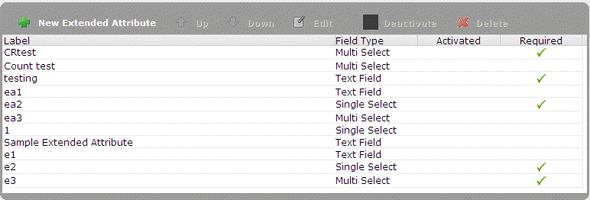
The created attributes are displayed in the grid. If the attributes are activated, then those attributes can be viewed/used in New/Edit/Copy Course/Session window. You can Activate or Deactivate an Extended Attribute.

Create a New Extended Attribute
Use this process to create and enter details of a new extended attribute.
To create an extended attribute
- View Extended Attributes
- Click the New Extended Attribute button. The New Extended Attribute dialog box displays.
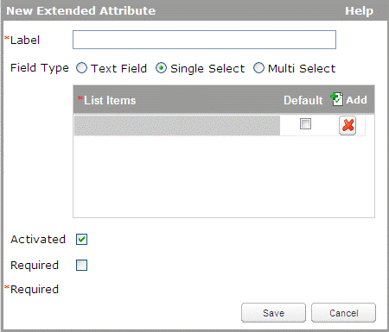
- Enter the extended attribute details.
- Label: You can enter the label of the new attribute. The label must be unique.
- Field Type: You can select either Text Field, Single Select or Multi Select. For Single Select or Multi Select, the Default can be set by selecting the checkbox next to the relevant List Item. There can be more than one default if the Field Type is Multi Select. If you switch the field type from single/multi select to text field, the item list specified is removed permanently if you submit that change.
- Activated: Select the checkbox to mark the extended attribute as activated.
- Required: Select the checkbox to mark the extended attribute as required.
- Click Save.

Edit an Extended Attribute
You can edit the details of an extended attribute if any changes are required.
To edit an extended attribute
- View Extended Attributes list and select the attribute you want to edit.
- Click the Edit button. The Edit Extended Attribute window displays. This has all the details from the New Extended Attribute window.
- Edit the extended attribute details.
- Click Save.

Reorder an Extended Attribute
You can modify the order in which an extended attribute appears in the list of extended attributes.
To reorder an extended attribute
- View Extended Attributes.
- Click on the extended attribute to select it.
- Click the Up or Down button. The extended attribute moves up or down in the list.
Note: This order is reflected in the course/session window.

Activate or Deactivate an Extended Attribute
You can activate or deactivate an extended attribute if required.
To deactivate an extended attribute
- View Extended Attributes.
- Click on an extended attribute to select it.
- Click the Deactivate button. This deactivates the extended attribute.
Note: When an extended attribute is deactivated, you cannot use this attribute for any future course/sessions. However, this attribute remains the same for already associated courses/sessions.
To activate an extended attribute
- View Extended Attributes.
- Click on the deactivated extended attribute to select it.
- Click the Activate button. This activates the extended attribute.
Note: Reactivating the extended attribute will bring the attribute to the course/session window.

Delete an Extended Attribute
You can delete an extended attribute if required. When you confirm the deletion, the system removes the extended attribute, as well as all of its instances throughout the system.
Note: An extended attribute cannot be deleted if the attribute is associated with a course/session until the respective course/session is deleted.
To delete an extended attribute
- View Extended Attributes.
- Click on the extended attribute you want to delete.
- Click the Delete button. A confirmation box displays.
- Click Yes to confirm.

ILT Site Settings
If you have Company Admin privileges, you can access the Site Settings view, where you can configure some ILT site-specific settings for your company.
Note: This menu option is only available if ILT is enabled on the site.
To view the site settings
- Log in to Skillport as an admin.
- Click Configuration > Features > ILT > Site Settings. The Site Settings page displays.
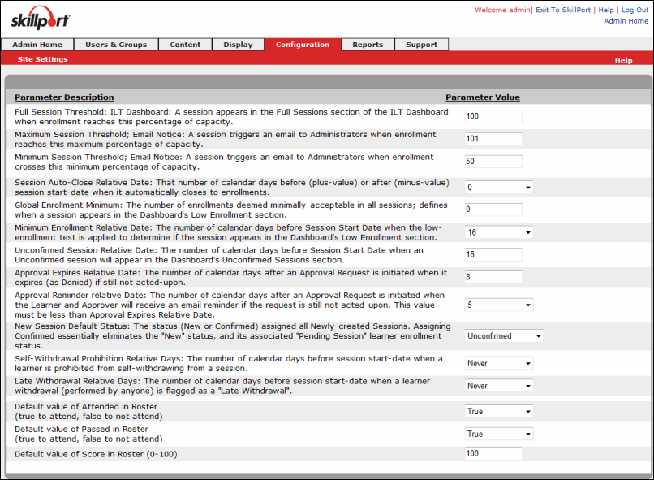
- Set the desired site settings:
Site Settings | Required Field? | Description | Value
Full Session Threshold; ILT Dashboard: A session appears in the Full Sessions section of the ILT Dashboard when enrollment reaches this percentage of capacity | yes | This controls when a session is listed in the "Sessions at or above Capacity" section of the Dashboard. | An integer between 0 and 100 (inclusive)
Maximum Session Threshold; Email Notice: An email is triggered when a session has enrollments above this percentage of capacity, then a withdrawal causes enrollment to go below this percentage of capacity | yes | The value selected is based on the value of the 'Full Session Threshold' field. When the session capacity reaches this specified percentage, an email is automatically sent to the Session Administrator detailing that the session is full.  Note: This email is only sent to the Session Administrator, not the ILT Administrator. If no Session Administrator is assigned, then the email is not sent. | An integer between 101 and 300 (inclusive)
Minimum Session Threshold; Email Notice: A session triggers an email to Administrators when enrollment crosses this minimum percentage of capacity | yes | When a withdrawal from a full session results in the roster going below the minimum capacity, an email is sent to the Session Administrator.  This email is sent based on very specific criteria:  - - The session is full.  - - The session is closed to enrollment.  - - A withdrawal results in a roster that is less than or equal to the percentage full designated by this field.  Note: This email is only sent to the Session Administrator, not the ILT Administrator. If no Session Administrator is assigned, then the email is not sent. | An integer between 0 and 99 (inclusive)
Session Auto-Close Relative Date: That number of calendar days before (plus-value) or after (minus-value) session start-date when it automatically closes to enrollments | no | This setting determines the number of days to automatically close a session before (positive number) or after (negative number) it is scheduled to begin. The value entered in this field controls the default value for the “Close session” field in a new course. The value can be changed at either the course or session level when creating them. Course level changes will not affect existing sessions, only new sessions.  For example, if you want to close a session to further enrollments 2 days prior to the start of the session, select 2 from the drop-down list. If you want to close the session 2 days after the start of the session, select -2 from the drop-down list. | Never, 90, 60, 45, 30 through -30, -45, -60, -90 and is chosen from a drop-down box.
Global Enrollment Minimum: The number of enrollments deemed minimally-acceptable in all sessions; defines when a session appears in the Dashboard's Low Enrollment section | yes | When a session is at or below this value by the day specified in the "Display low-enrollment alert X days before session start" setting, the session is displayed in the Low Enrollment Sessions section of the Dashboard.  The value entered in this field controls the default value for the “Minimum Enrollments” setting in a new course. The value can be changed at either the course or session level. | An integer between 0 - 99999 (inclusive)
Minimum Enrollment Relative Date: The number of calendar days before Session Start Date when the low-enrollment test is applied to determine if the session appears in the Dashboard's Low Enrollment section | no | This value determines how many days in advance of a session start date that a session must meet the minimum enrollment. If the session is at or below the minimum enrollment criteria on that day, then that session is in "low enrollment". The default minimum enrollment is defined in the Global default applied to all sessions defining the minimum number of enrollments desired.  The value entered in this field controls the default value for the “Low Enrollment Alert” field in a new course. The value can be changed at either the course or session level. | Never or an integer between 0 and 31. The selection is chosen from a drop-down box.  - Never: There is no minimum enrollment requirement, and the session will never be listed in the Low Enrollment Sessions section of the Dashboard.  - 0 to 31: Number of days prior to session start when low enrollment sessions are listed in the Low Enrollment Sessions section of the Dashboard.
Unconfirmed Session Relative Date: The number of calendar days before Session Start Date when an Unconfirmed session will appear in the Dashboard's Unconfirmed Sessions section | yes | This setting determines how many days in advance of the session start date to list an unconfirmed session in the Unconfirmed Sessions section of the Dashboard.  When a learner enrolls in a session with an "Unconfirmed" status, they receive a confirmation email, but it does not include a calendar attachment. The learner’s enrollment status is “Pending Session”. After an administrator marks the session "Confirmed", all enrolled learners will receive another email noting that the status is now Confirmed, and that email will have the calendar attachment. Any learners who enroll after the session has been confirmed will receive an email with a calendar attachment.  For more information on "Unconfirmed" and "Confirmed" see the "The default status for all newly created sessions".  The setting provides a quick and easy method for an ILT Administrator to see which sessions are still “pending” (meaning they have a status of "Unconfirmed") and then take action to confirm the sessions.  Note: If the Default status for all newly created sessions is changed to "Confirmed" and existing sessions have an "Unconfirmed" status, those sessions will appear in the Unconfirmed Sessions section until their status is changed to "Confirmed". | An integer between 0 and 99 (inclusive)
Approval Expires Relative Date: The number of calendar days after an Approval Request is initiated when it expires (as Denied) if still not acted-upon | yes | If a session requires approval (either Session Approval or Manager Approval), this setting determines the number of days that the approval request remains open. If the request is not acted upon during this period, it is automatically deleted and the learner is not enrolled.  If an enrollment is not approved by this date, the approval request is deleted, an expiration notification is sent to the learner, and the learner is not enrolled in the session. If the learner still wishes to enroll, he or she must open the session and click "Enroll" again to initiate a new approval request. | An integer between 2 and 99 (inclusive)
Approval Reminder relative Date: The number of calendar days after an Approval Request is initiated when the Learner and Approver will receive an email reminder if the request is still not acted-upon. This value must be less than Approval Expires Relative Date | no | If a session requires approval (either by a Session Approver or Manager), this setting determines the number of days after an approval request is initiated to send a reminder email to the Approver or Approvers. This is only sent if the Approver has not taken action on the request. | n integer between 1 and 7, inclusive (and should be less than the Approval Expires Relative Date setting)
New Session Default Status: The status (New or Confirmed) assigned all Newly-created Sessions. Assigning Confirmed essentially eliminates the "New" status, and its associated "Pending Session" learner enrollment status | no | An organization can use the Unconfirmed status for sessions that may run, and the Confirmed status for sessions that will run. | Confirmed or Unconfirmed
Self-Withdrawal Prohibition Relative Days: The number of calendar days before session start-date when a learner is prohibited from self-withdrawing from a session | no | The value entered in this field controls the default value for the "Prohibit Self-Withdrawal" field in a new course. The value can be changed at either the course or session level. | Never, Always or a number between 1 and 31 (inclusive)  - Never: A learner can self-withdraw from the session at any time, even on the day that the session takes place.  - Always: A learner can never self-withdraw from a session. The withdraw button is removed from the session, and is replaced with the following text "You are enrolled in this session. To withdraw from this session, please contact your Training Manager."  - 1 to 31: Number of days before the session start date that a learner can self-withdraw. When the prohibit self-withdrawal date is reached, the withdraw button is removed from the session and replaced with the following text: "You are enrolled in this session. To withdraw from this session, please contact your Training Manager."
Late Withdrawal Relative Days: The number of calendar days before session start-date when a learner withdrawal (performed by anyone) is flagged as a "Late Withdrawal" | no | The learner is still withdrawn, but his enrollment status is "late withdrawal". The value entered in this field controls the default value for the “Late Withdrawal” field in a new course. The value can be changed at either the course or session level. | Never or an integer from 1 to 31 (inclusive), chosen from a drop-down box  - Never: No withdrawals are ever flagged as a "late withdrawal".  - 1 to 31: Number of days prior to session start date when a withdrawal is flagged as a "late withdrawal".
Default value of Attended in Roster (true to attend, false to not attend) - | no | Learners’ Attended value is Null until the first time an authorized user enters Session Results.  When entering Session Results for the first time, all enrolled Learners get their Attended values populated in the Site Settings. You can then edit changes if desired.  When you mark the session as complete, if any Learners record still contains NULL values for Attended, a warning message appears.  If any Learners are added to a session after it is marked complete, their Attended values are auto-populated with the defaults. | True or false
Default value of Passed in Roster (true to attend, false to not attend) | no | Learners’ Passed value is Null until the first time an authorized user enters Session Results.  When entering Session Results for the first time, all enrolled Learners get their Passed values populated in the Site Settings. You can then edit changes if desired.  When you mark the session as complete, if any Learners record still contains NULL values for Passed, a warning message appears.  If any Learners are added to a session after it is marked complete, their Passed values are auto-populated with the defaults. | True or false
Default value of Score in Roster (0-100) - | no | Learners’ Score value is Null until the first time an authorized user enters Session Results.  When entering Session Results for the first time, all enrolled Learners get their Score values populated in the Site Settings. You can then edit changes if desired.  Scores are final when an authorized user marks the session as complete.  When you mark the session as complete, if any Learner's record still contains NULL values for Score, a warning message appears.  If any Learners are added to a session after it is marked complete, their Score values are auto-populated with the defaults. | An integer between 0 - 100 (inclusive)
- Click Submit to save your ILT Site Settings.
- Click Reset to revert to the previously saved settings.

