User Guide
For Learners
Published: Wednesday March 06, 2024

Contents
Contents 1
Sign In 2
Explore the Home Page 3
Job Role 6
To add your job role from My Learning 6
To add or change your job role: 6
Select Your Skills 7
To edit your skill choices 7
Explore the Library 8
Library organization 10
Search for Content 11
To search for content 13
Refine your search results 13
To use filters 14
Add Content to the Playlist 15
Learning Goals 16
Set a learning goal 16
Track goal progress 17
Learning streak 17
Reminders 18
Schedule time 18

Sign In
- In a browser, navigate to your Percipio sign in page.
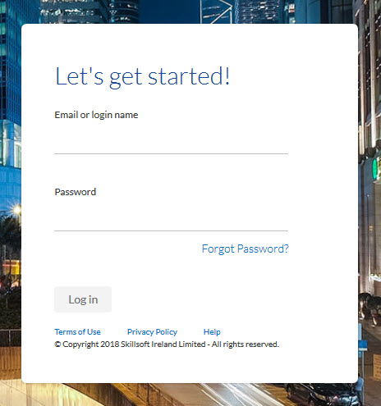
- Enter your user name and password, this maybe your network or corporate credentials if your organization configured Percipio single sign-on.
Note: Passwords are case-sensitive
- Select Log in.

Explore the Home Page
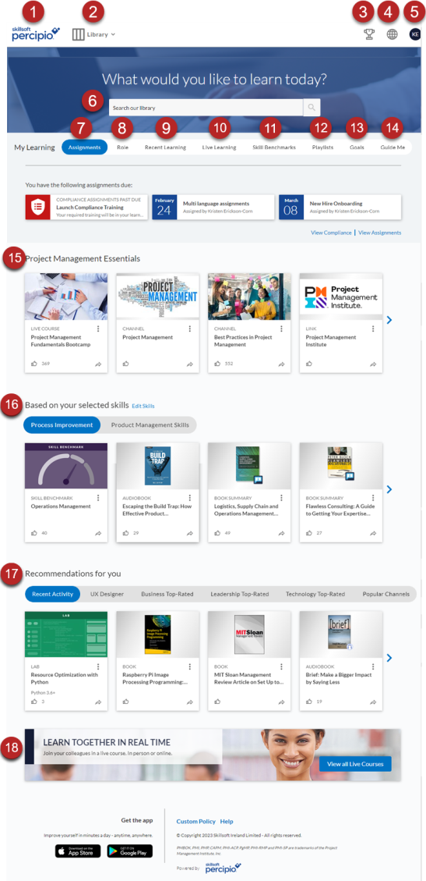
Use the Percipio home page to find and access content.
- Logo: Select to access the Percipio home page.
- Library: The library contains all of your available content. This is where you can browse by topic.
- My Achievements: Get insights about their achievements, goals, and other activity you are doing in Percipio.
- Language selector: Select to change your Percipio site language.
- My Profile: Select to access your assignments, playlist, activity, skills, and Digital Badges.
- Search: Enter keywords or let the auto fill guide you to the learning content you want.
- Assignments: View details and access all of your upcoming content assignments.
- Role: Select or change your job role to get recommendations on skills needed to advance in that role
- Recent Learning: Access the content you've started but not yet completed.
- Live learning: If you are entitled, you can see the schedule of upcoming live courses. Find one and register for it.
- Skill Benchmarks: Skill Benchmarks are a way for you to gauge your proficiency in a particular skill.
- Playlist: View content you've added to your Playlist. Playlists provide a quick and easy way for you to organize content that is of interest to you.
- Goals: Set the amount of time you want to spend learning in a given week, track your progress, get reminders, and see your streaks.
- Guide me: If you are not sure where to start, this section provides links to frequently accessed starting points.
- Promotion strip: If your company chooses to, they can add a strip of recommended content.
- Selected Skills: Percipio recommends content based on what you selected for skills and job role. Each skill you selected shows on a different tab.
- Recommendations for you: View recommendations based on your Recent activity and see what content is trending across Percipio in Popular Channels. You can also see recommendations for achieving skills associated with your job role and view Top-Rated content, those with the highest customer ratings. Select to remove the content you're not interested in.

Job Role
If available on your site and if your administrator has not provided a job role for you, you can specify your job role or a job role you aspire to become from a pre-defined list of roles. When you specify a role, you see recommendations for learning skills associated with that role on your home page on the Top picks for your role strip and from the My Learning section under the Role tab. From the Role tab, you can also access Role Advisor for a full set of skills, recommendations, and skill benchmarks.
You can find the full list of job roles, here.
If your role is added by your administrator, you cannot change it. Otherwise, you can change your job role to the next-level job role or a different role at any time.

To add your job role from My Learning
- If your administrator did not add one for you, you can add your job role. From the My Learning section of the home page, locate and select the Role tab.
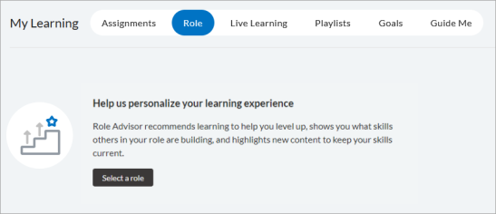
- Select Select a role if you never specified a role before or Change role to update your current selection.
- Enter a new job role and select Save.

To add or change your job role:
- If your administrator did not add one for you, you can add or change your job role. Go to My Profile > Role.
- Select Select a role if you never specified a role before, or Change role to update your current selection.
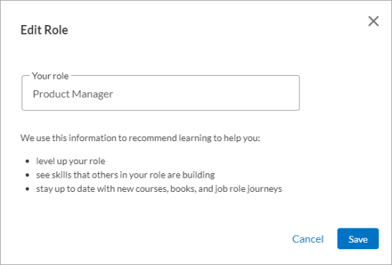
- In the Your role field, enter your new role. Enter at least three consecutive letters to see available options.
- Select Save to save the change. When you go to your Top picks for your role strip, you now see the new role and new recommendations. You can only have one active role at a time.

Select Your Skills
The first time you sign into Percipio, you are prompted to select the skills you want to develop. Based on your selections, Percipio shows you personalized recommendations for content available to you in your library that you are likely to find the most interesting and relevant. The content displays in a navigable strip on the home page, making it easier to discover content important to you.

To edit your skill choices
- Select Skills in the My Profile menu.
- Choose the skills you want to develop
- Select Next.
- Optionally, select additional details about the skills.
- Select Done.

Explore the Library
The Percipio Library contains all of the learning assets available to you. These assets are organized into a hierarchy to help you find content quickly and easily. You can explore the library, search for content, and add your favorite assets to your Playlist.
Note: You can explore the library in the selected Percipio language only. To see more content offerings you may be entitled to, change your language setting, then explore again.

To explore the Library
- At the top of the home page, select Library.
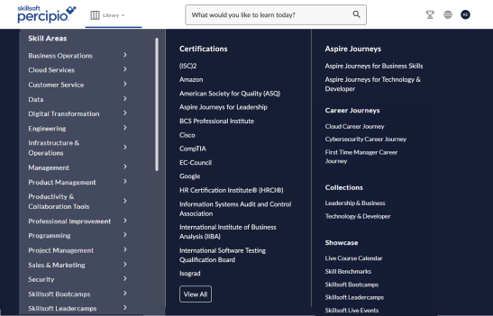
- Choose your way to explore:
  - Select Skill Areas to open the Library home page, then select the area and subject under What would you like to learn today.
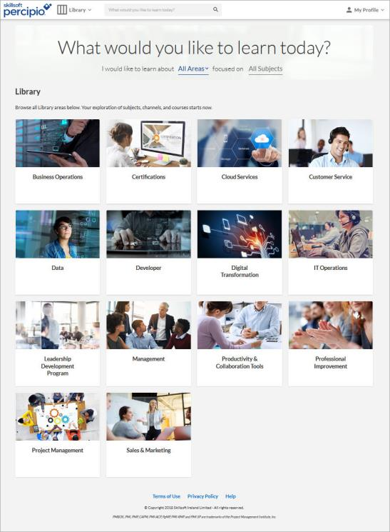
  - From the menu directly, select the specific area and subject, a Certification, an Aspire Journey, or something from the Showcase.

Library organization
- Category: the top-level label in the Percipio library. By default you see the standard menu category: Skill Areas, where you can add your custom areas and subjects. You also see other categories for Certifications, Aspire Journeys, Career Journeys, Showcase, and Collections which are maintained solely by Skillsoft. You may also see a custom category for your company.
  - Custom category: If you configure a custom menu category, you can add custom areas and subjects specific to your organization.
  - Skill Areas: The main category that contains all Skillsoft areas and any custom areas you configure.
  - Certifications:Certifications are a unique category within the Library. You can browse certifications from various vendors and select channels focused on presenting targeted content for a particular certification path. You only see certifications in the library if you are entitled to them.
  - Aspire Journeys: This category groups all Aspire journeys for easy access.
  - Showcase: This category contains the Live Course Calendar, Skill Benchmarks, Skillsoft Bootcamps, Leadercamps and Live Events that display if you are entitled to the content.
- Areas: broad groupings of content that display under the standard or custom categories. Areas are listed alphabetically in the library under their category.
- Subject: topic-level grouping of content that display under an area.Select an area to see its subjects.
- Channels: Channels are the core building blocks of the library. A channel further refines the subject into sub-topics of related content presented in an organized way.
- Aspire journeys: Journeys are structured learning paths which provide content to achieve the skills for a specific job role or function.
- Content: Content includes courses, videos, books, book summaries, audiobooks, audio summaries, live courses, Skill Benchmarks, Practice Labs, TestPreps, and any custom content your admin adds.

Search for Content
Use Percipio search to quickly find content, such as courses, videos, books, skill benchmarks, channels and journeys. Percipio uses an intelligent search engine that displays suggested search queries as you enter text into the search field to help you quickly narrow your search.
From the initial search results, you can further filter or scroll to see top matches. As you scan the top matches, you see specific content item details.
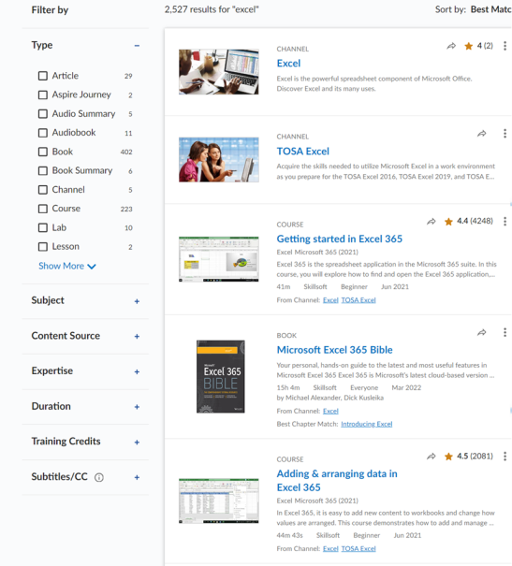
Depending on the type of item, you might see:
- Content type: Located above the title, this indicates the type of item such as course, video, book, etc
- Status: Located to the right of content type, this indicates whether you started or completed the item previously. If nothing shows, you have not yet accessed the item.
- Action icons: Located to the right of status, these allow you to share the item with colleagues, rate, or save the item to your playlist.
- Title: Indicated by bold text, this shows the title of the item.
- Description: Located below the title and technology version, indicates what you can expect to learn from the content item.
- Duration: Located below the description when applicable, this shows the estimated time needed to complete the item in hours, minutes, and seconds.
- by: Located below the description when applicable, this shows the name of the author or instructor. You can select the name to view results for all of the content available by the author or instructor.
- Technology title and version: Located below the title when applicable, indicates the specific technology, such as Excel, and the technology version, such as Microsoft 365, that this item covers.
- Content source: Located to the right of duration when applicable, this indicates where the content comes from such as, Skillsoft, a partner, vendor, or custom content specification.
- Expertise level: Located to the right of content source, this indicates the level of content contained in the item such as, for everyone, beginner, intermediate or expert.
- Published date: Located to the right of expertise level, this indicates when the item was published in Percipio or for books, the actual publisher's publish date. Skillsoft does not update the date when content is republished.
- If an item in the search results is:
- part of a course, the From Course field links back to the associated course.
- part of a channel, the From Channel field links back to the associated channel(s).
- part of a journey, the From Journey field links back to the associated channel(s).
- part of a career journey, to which the learner is entitled, the From Career Journey field links back to the associated Career Journey.
- a book, the Best Chapter match field links directly to a chapter in the book that best matches your search terms.
The Percipio Search returns 20 results per page. To see additional results, click Show More at the bottom of the Search results page.

To search for content
- In the top search bar, enter your search term.
- 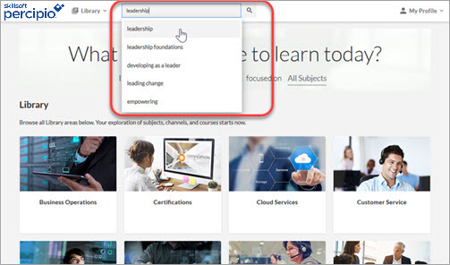Select or press Enter. The search results display.

Refine your search results
Use filters to refine your search results. These may vary based on the content returned in the original search results and on filters selected.
- Sort by: select Best Match to view the closest results based on your entered search terms, or use Newest to see the most recently-released content that matches your entered search terms.
- Type: provides all asset types available that match your search terms. Select the types of content for how you want to learn. The most commonly searched for content types are types pinned to the top of the list.
- Ratings: Use these filters to limit the results to content that has the selected rating. Content with that has not yet been rated is excluded from the search results.
- Duration: provides various search options for time to complete the content.
Note: The Duration filter is not available in ELSA.
- Language: only displays when the search results contain more than one language in the results. Use this filter to limit the results to the selected language.
- Subject: allows the learner to filter results by the Library subject(s) to which the content belongs. This can help learners narrow in on the topics they are targeting.
- Content Source: provides the vendor or provider who created and maintains the content.
- Expertise: provides various search options for level of knowledge.
Note: Books are tagged as Everyone and are only included in filtered Expertise results if you select Everyone as one of your filters. Channels do not have an explicit Expertise level, and are included in filtered results regardless of the Expertise filter selection.
- Training Credits: provides the option to search by training certifications.
- Subtitles/CC: when turned on, allows learners to see content in search results that have subtitles or closed captions. This is also important for users who are searching English courses and are looking for courses with subtitles that are translated into other languages.

To use filters
You can select multiple filters to narrow your search results.
The selected search filters display on the left of the Search page and the search results update with each selection.
Note: When using the filters, the counts update to reflect the new filtered results. If all of the selections are filtered out, the filter value is removed from the list. To get it back, unselect filters.
The filter options vary based on the content returned in the original search results.
Example: If you search for Java, then select Course from the Type filter, you will notice that Codecademy and Cybervista disappear from the Content Source filter. This happens because there are no Java courses for those sources. If you unselect Course from the Type filter, Codecademy and Cybervista re-appear under the Content Source filter.

Add Content to the Playlist
Playlists provide a quick and easy way for you to save content that is of interest so you can it take at a later time. By default everyone has a Save for later playlist where they can add items. Your organization may choose to offer you the option to create multiple playlists so you can organize and categorize your content into different playlists. With multiple playlists you have more control to create, edit, remove, and share them.
You can add content to your Playlist from almost anywhere in Percipio, including the home page, your search results, the library, and when accessing the content itself.
- From any content card, select the More action menu . Select either:
  - Playlist add/remove: This allows you to put the item in an existing playlist or a new playlist that you can create.
- To access your Playlist, click Playlist in the My Profile menu.
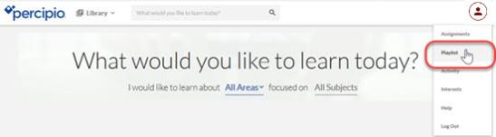

Learning Goals
If your Percipio site administrators have the learning goals feature turned on, you can use Percipio to help you sustain a growth mindset through weekly learning in the following ways:
- Set weekly goals: learners can set a weekly goal to reflect the time they want to invest in learning.
- Track goal progress: learners can track the progress made against their weekly goal.
- Get learning reminders: learners can opt to receive reminders to help stay on track
- Schedule time: learners can schedule an appointment in their calendar to learn

Set a learning goal
Get started by determining how many minutes you want to commit to learning each week. Then specify it:
- You can set a learning goal when you first start using Percipio. Or, if you're already using Percipio, you can find the Goal tab from the My Learning section of the home page.
From the web, select Set learning goal:
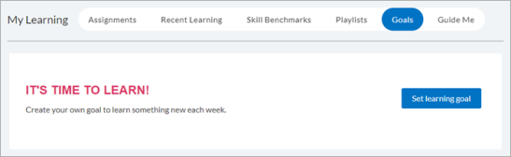
From the mobile app, select Set a learning goal:
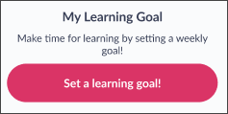
- Choose one of the following options for your weekly goal: 15, 30, 45, or 60 minutes. A learning week in Percipio starts on Monday and ends on Sunday.
- Select Save and continue.
- Select one or more days and a time that is best for you to learn regularly.
- Select Add to calendar and choose the calendar software where the event displays. Your options are Google (online), Microsoft Outlook, or Apple Calendar.
- Open the downloaded calender item and save it to your calendar.

Track goal progress
After you set your goal, Percipio tracks your progress. You can view your progress on the Percipio home page. You can also track your progress from My Achievements.
Content that is tracked for your goal includes: courses, videos, books, audio books, book summaries, audio summaries, live events, labs, TestPreps, custom MP3 and MP4, and Wintellect. It also includes time spent in Skillsoft course knowledge checks and course tests.
Some content cannot be tracked against a goal because Percipio can't track its duration. This mostly occurs for items that are linked outside of Percipio. If you launch an item that Percipio can't track, Percipio displays a message telling you that consuming this content won't count toward your weekly learning goal.

Learning streak
If you complete your learning goal for more than one week in a row, you're on a learning streak. You stop your streak if there is a week where you don't achieve your goal. You can see your current and best streak on the home page or from My Achievements.
From the web:
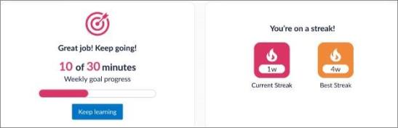
From the mobile app:
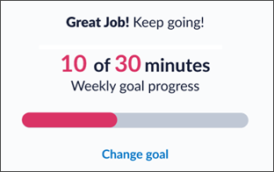

Reminders
When you set a learning goal, reminders can help you complete your goal each week. To get reminders, allow notifications for Percipio in the mobile app. The reminders appear on Thursdays if you haven't completed your weekly learning goal yet.

Schedule time
Learners can schedule learning time on their calendar to complete their weekly learning goal. To schedule time:
- From the Goals tab in the My Learning section, select either Set learning goal if you have not yet set a learning goal, or Change your learning goal, if you have.
- Choose one of the following options for your weekly goal: 15, 30, 45, or 60 minutes.
- Select Save and continue.
- Select the desired days and time.
- Select Add to calendar and choose the calendar software where the event displays. Your options are Google (online), Microsoft Outlook, or Apple Calendar.
- Open the calender item and save it to your calendar.

