Quick Start Guide
For Learners

Contents
Contents 7
Sign In 20
Select Your Skills 25
To edit your skill choices 31
Browse the Library 37
Library organization 51
Search for Content 64
To search for content 76
Refine your search results 79
To use filters 92
Add Content to the Playlist 99

Sign In
- In a browser, navigate to your Percipio sign in page.
- 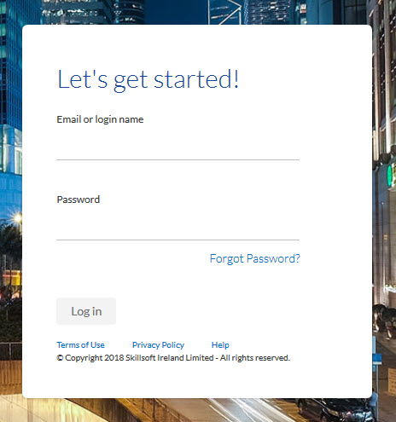Enter your user name and password.
Note: Passwords are case-sensitive
- Click Log in.

Select Your Skills
The first time you sign into Percipio, you are prompted to select the skills you want to develop. Based on your selections, Percipio shows you personalized recommendations for content available to you in your library that you are likely to find the most interesting and relevant. The content displays in a navigable strip on the home page, making it easier to discover content important to you.

To edit your skill choices
- Click Skills in the My Profile menu.
- Select the skills you want to develop
- Click Next.
- Optionally, select additional details about the skills.
- Click Done.

Browse the Library
The Percipio Library contains all of the learning assets available to you. These assets are organized into a hierarchy to help find content quickly and easily. You can browse the library, search for content, and add your favorite assets to your Playlist.
Note: You can browse the library in the selected Percipio language only. To see more content offerings you may be entitled to, change your language setting, then browse again.

To open the Library home page
- At the top of the home page, click Library > Browse Library.
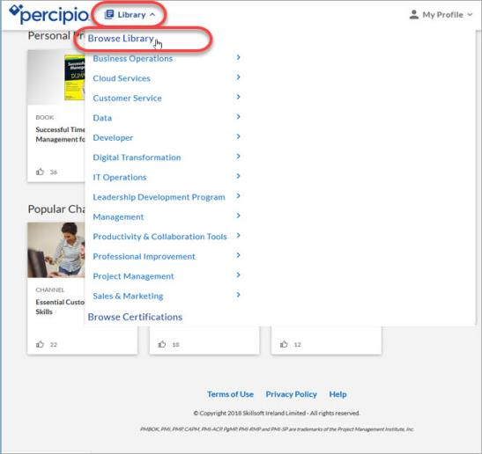
The Library page opens.
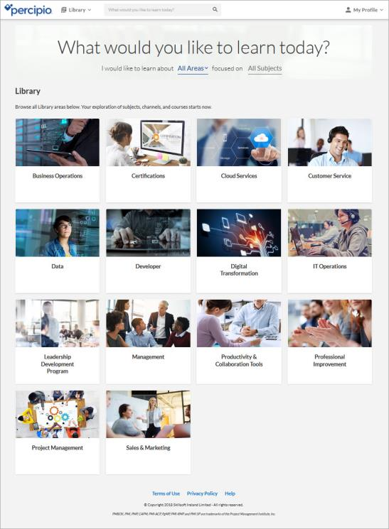
You can select areas and subjects from the Library page, but you can also navigate deeper into the library to select specific learning content.

Library organization
- Area: Top level of the library. Areas are broad categories relating to a particular business or technical functions.
- Subject: An area is broken into several subjects, each relating to a particular branch or course of study.
- Channels: Channels are the core building blocks of the library. A channel is where you go to learn everything and anything about a particular subject area that interests you.
- Certifications: Certifications are a unique area within the Library. You can browse certifications from various vendors and select channels focused on presenting targeted content for a particular certification path. You only see certifications in the library if you are entitled to them.
- Content: Content includes courses, videos, books, book summaries, audiobooks, audio summaries, Practice Labs, and TestPreps.

Search for Content
Use the Percipio search to quickly find content, such as courses, videos, or subjects. Percipio uses an intelligent search engine that auto-completes recommendations as you enter text into the search field. Depending on the terms you enter, search results can include any of your available content types, such as courses or books, and specific asset details, such as author, duration, expertise levels, technology versions, description, and more.
If an asset in the search results is part of a course, the From Course field links back to the associated course.
If an asset in the search results is part of a channel, the From Channel field links back to the associated channel(s).
The Percipio Search returns 20 results per page. To see additional results, click Show More at the bottom of the Search results page.

To search for content
- In the top search bar, enter your search term.
- 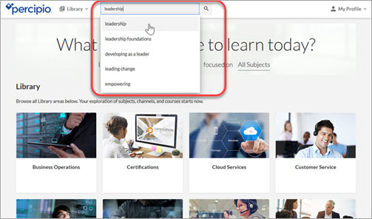Click . The search results display.

Refine your search results
Use filters to refine your search results. These may vary based on the content returned in the original search results.
- Sort by: select Best Match to view the closest results based on your entered search terms, or use Newest to see the most recently-released content that matches your entered search terms.
- Type: provides various assets to search by.
- Expertise: provides various search options for level of knowledge.
Note: Books are tagged as Everyone and are only included in filtered Expertise results if you select Everyone as one of your filters. Channels do not have an explicit Expertise level, and are included in filtered results regardless of the Expertise filter selection.
- Duration: provides various search options for time to complete the content.
Note: The Duration filter is not available in ELSA.
- Training Credits: provides the option to search by training certifications.
- Digital Badges: provides the option to search by Digital Badges.

To use filters
Select the types of content you want to include in your refined results. You can select multiple filters to narrow your search results.
The selected search filters display on the top of the Search page and the search results update with each selection.
Note: When using the filters, the counts update to reflect the new filtered results. If all of the selections are filtered out, the count shows 0 and is disabled.
The filter options vary based on the content returned in the original search results.

Add Content to the Playlist
Playlists provide a quick and easy way for you to organize content that is of interest to you. Save content to your Playlist so you can view it later or share it with others.
You can add content to your Playlist from almost anywhere in Percipio, including the home page, your search results, the library, and when accessing the content itself.
- To add content to your Playlist, click the action menu and select Add to playlist.
- To access your Playlist, click Playlist in the My Profile menu.
